Covenant
The United Church of Canada
a safe place for all people to worship
Ministers: All the People
Presiding: Rev. Laura Hutchison

Sunday, October 18th, 2026

(Ring the chime once)

LIGHTING THE CHRIST CANDLE – We light this light, in gratitude for Jesus, the Light of the World.
(the Christ Candle is lit)

WELCOME & ANNOUNCEMENTS
Welcome to Covenant United Church. Today, we are meeting on land that, traditionally, has been cared for by Mattagami, Flying Post, and Matachewan First Nations, and Métis people, and is covered by Treaty #9.
Grateful for the care of all who have come before us, we seek to be good stewards of the land, and good neighbours with all people.
You are welcome here.


COFFEE HOUR VOLUNTEERS: If you are willing to help out for this fellowship opportunity, please contact Heather.

SOCKTOBER-We will be collecting sock donations for the Kinettes this October.



COMMUNITY COFFEE
Covenant will be hosting Coffee/Tea and Muffins the last Tuesday of every month. Our next coffee will be Oct 27th 10-11:30 am. All are welcome. Bring a friend, No charge.



PRAYER SHAWL
Prayer Shawl is on Oct. 29th, 2026 from 1-3 pm.



TIMMINS FOOD BANK- The food bank is asking for donations of cookies, crackers, canned fruit, canned meat, and cereal. Pick up an extra, for donation, while shopping this week. Food will be collected on the cart in the foyer until Nov 1st. Thank you!



COMFORT SOUPS
For those in need or for a friend help yourself to frozen homemade soups in Kitchen freezer. No cost.


CHILI AND BEANS LUNCHEON- will be held on Wednesday, Nov 4th 2026 from 11:30am-1:00pm. Cost is $10. Take out is available! Call the office at 705-264-5518. We are also looking for Volunteers to help make Chilli, beans, or desserts. Please contact Joy to volunteer.


The office is open Wednesday Oct. 21st from 9:00am-3:30pm.
(ring the chime)

WORD FOR ALL AGES – The First Two Commandments
CHILDREN’S SONG –
Songs for a Gospel People #43 Love, Love, Love your God

Love, love, love your God
The commandment’s word is love
Love your neighbour as yourself
For God is love.

PRAYER – (repeat after me)
Thank you, Jesus,
For teaching me to love
By loving me.
Amen.

GATHERING HYMN – More Voices #79 Spirit, Open My Heart
https://www.youtube.com/watch?v=TUy4kas8WR8

Refrain: Spirit, open my heart
to the joy and pain of living.
As you love may I love,
in receiving and in giving,
Spirit, open my heart.

- God, replace my stony heart
with a heart that’s kind and tender.
All my coldness and fear
to your grace I now surrender. R.

- Write your love upon my heart
as my law, my goal, my story.
In each thought, word, and deed,
may my living bring you glory. R.

- May I weep with those who weep,
share the joy of sister, brother.
In the welcome of Christ,
may we welcome one another. R.

CALL TO WORSHIP

Welcome to this time of worship.
Years ago, there was an ad, it was for a fast food restaurant,
And in the ad they repeated,
“Hop in the car!
Come as you are!”

In the car, or on foot
However you enter into worship today, come!
Come whether you are troubled, or grieving –
Come, even if you are anxious about anything –
Come if you are celebrating, excited, and happy.

Come as you are, and may the peace of God, that surpasses all understanding, guard your hearts and your minds, and may you know God’s Spirit with you as we sing and pray.

PRAYER OF APPROACH–
O Gracious Lord of mysterious abundance,
as we enter into a new season,
a new month, a time of spiritual renewal,
may our voices express
and sing praises that are worthy of your eternal love.
Let the ray of sunshine
that is shining through the clouds
point us in the right direction. Amen.

CENTERING

MINUTE FOR MISSION- A CIRCLE OF TWELVE
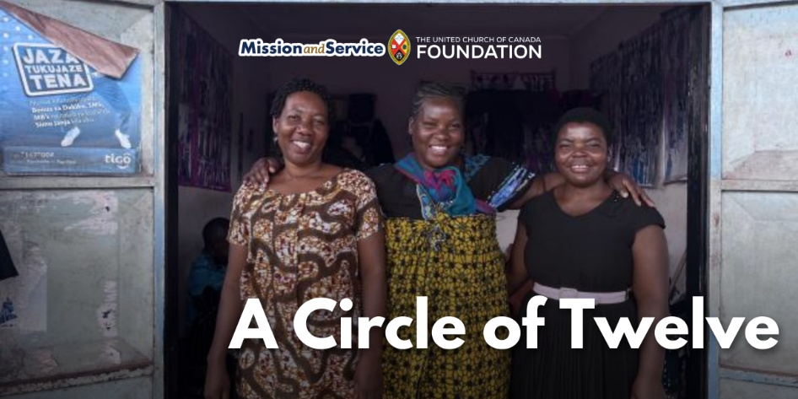

Morogoro Women’s Training Centre in Tanzania is helping mothers of children with disabilities build confidence, skills, financial independence, and community. Since 1979, The United Church of Canada has been accompanying the work of the Morogoro Women’s Training Centre (MWTC), a unit of the Christian Council of Tanzania, in Tanzania, supporting their locally-led efforts that empower women.

One of those efforts, run in 2023 with the support of Mission and Service, included a holistic training for mothers of children with disabilities. The program wove together self‑esteem and confidence building, small business and entrepreneurship skills, financial literacy, emotional support, and practical knowledge about caring for children. It was a space where women learned, but also where they were seen, heard, and held by one another.

There were twelve women in the training the week when I visited—twelve stories and twelve journeys being strengthened in community. I couldn’t help but notice the echo of another circle of twelve. Jesus’ first disciples. God has always used small groups of ordinary people to carry hope into the world. These women, too, are bearers of that hope.

Among the twelve, three shared that their husbands had left after their child was born with a disability. It was a quiet grief woven into their stories, shaped by the stigma that still surrounds disability in many communities. In the absence of that support, the women leaned even more on one another, finding in community what had been withdrawn at home.

Agness Mduma is a widowed mother of four, and for sixteen years she has been raising her youngest child, who lives with a disability. When her husband died, that baby was just over a month old. The grief, the responsibility, the uncertainty of how she would provide for her family all arrived at once.

Before she connected with MWTC, her income‑generating activities brought in very little. Opportunities were scarce. And like so many mothers of children with disabilities in Tanzania, she carried the weight of it alone.

The training she received didn’t erase the hardship, but it opened a door. With startup capital and new skills, Agness began selling charcoal, at first in small amounts. She added local chickens and started selling eggs. Then she opened a small grocery shop, and started baking cakes. Each step was modest, but each one widened the circle of possibility.

The training gave her tools, but it also strengthened her confidence. She talked about learning to save, to plan, to trust her own decisions. She talked about raising her child with renewed courage. Her story is one of resilience unfolding in real time.

Each of these stories are reminders of what accompaniment makes possible. Not quick fixes. Not tidy narratives. But the slow, steady work of walking together. The kind of work that honors dignity, nurtures resilience, and allows women to discover strength in one another.”
—Amy Zavitz is Global Partnership Program Coordinator, Africa Partnerships, with The United Church of Canada General Council Office

SCRIPTURE READINGS
1 Thessalonians 2:1-8 – Good News Translation
Paul's Work in Thessalonica

Our friends, you yourselves know that our visit to you was not a failure. You know how we had already been mistreated and insulted in Philippi before we came to you in Thessalonica. And even though there was much opposition, our God gave us courage to tell you the Good News that comes from GOD. Our appeal to you is not based on error or impure motives, nor do we try to trick anyone. Instead, we always speak as God wants us to, because our God has judged us worthy to be entrusted with the Good News. We do not try to please people, but to please God, who tests our motives. You know very well that we did not come to you with flattering talk, nor did we use words to cover up greed—God is our witness! We did not try to get praise from anyone, either from you or from others, even though as apostles of Christ we could have made demands on you. But we were gentle when we were with you, like a mother taking care of her children. Because of our love for you we were ready to share with you not only the Good News from God but even our own lives. You were so dear to us!

Matthew 22:34-40 – Good News Translation
The Great Commandment

When the Pharisees heard that Jesus had silenced the Sadducees, they came together, and one of them, a teacher of the Law, tried to trap him with a question. “Teacher,” he asked, “which is the greatest commandment in the Law?”

Jesus answered, “‘Love the Lord your God with all your heart, with all your soul, and with all your mind.’ This is the greatest and the most important commandment. The second most important commandment is like it: ‘Love your neighbor as you love yourself.’ The whole Law of Moses and the teachings of the prophets depend on these two commandments.”

RESPONSE: Let us respond by singing a hymn of praise!
Voices United #260 God Who Gives to Life It’s Goodness
https://www.youtube.com/watch?v=Fnc5rHKJmXA
- God who gives to life its goodness,
God creator of all joy,
God who gives to us our freedom,
God who blesses tool and toy;
Teach us now to laugh and praise you,
Deep within your praises sing,
Till the whole creation dances
For the goodness of its King.
- God who fills the earth with beauty,
God who binds each friend to friend,
God who names us co-creators
God who wills that chaos end;
Grant us now creative spirits,
Minds responsive to your mind,
Hearts and wills your rule extending
All our acts by Love refined.

REFLECTION
O Lord, take my lips and speak through them;
Take our minds and think through them;
Take our hearts and set them on fire with love for Yourself,
Lord Jesus, and for all of Creation. Amen.

RESPONSE – Voices United #299 Teach Me, God, To Wonder
https://www.youtube.com/watch?v=hiPu9NCSZis

Teach me, God, to wonder,
teach me, God, to see.
Let your world of beauty capture me.
Praise to you be given.
Love for you be lived.
Life be celebrated, joy you give!

Let me, God, be open,
let me loving be.
Let your world of people speak to me.
Praise to you be given.
Love for you be lived.
Life be celebrated, joy you give!

Let me, God, be ready,
let me be awake.
In your world of loving, my place take.
Praise to you be given.
Love for you be lived.
Life be celebrated, joy you give!

Teach me, God, to know you,
hear you when you speak,
see you in my neighbour when we meet.
Praise to you be given.
Love for you be lived.
Life be celebrated, joy you give!



OFFERING INVITATION –
The life we’re invited to live is one where we do reap what we sow. We’re invited to sow love and harvest more love than we can imagine from the little seeds we scatter. So let us commit to investing in one another. Let us commit to loving
each other and being loved. Let us dedicate our offerings to the work of Christ.

DOXOLOGY – More Voices #196 We Will Take What You Offer (repeat as many times as Tim plays it) https://www.youtube.com/watch?v=wt06gCz6rTI
We will take what you offer,
we will live by your word;
We will love one another
and be fed by you, Lord.

PRAYERS OF THANKSGIVING AND DEDICATION

You have called us to live a life of love.
We are called to love you with all of our being and
to love our neighbour as ourselves.
We pray that these gifts may enable this
community and the wider church to express that
love in tangible ways.
This we pray through the Christ whose call
informs and guides our lives. Amen.

PRAYERS OF THE PEOPLE
HYMN – Voices United #595 We Are Pilgrims https://www.youtube.com/watch?v=hbnFjAdF1i8
- We are pilgrims on a journey,
fellow travellers on the road;
We are here to help each other
walk the mile and bear the load.

- Sister, let me be your servant,
let me be as Christ to you;
Pray that I may have the grace
to let you be my servant too.

- I will hold the Christ-light for you
in the night-time of your fear;
I will hold my hand out to you,
speak the peace you long to hear.

- I will weep when you are weeping,
when you laugh I’ll laugh with you;
I will share your joy and sorrow,
till we’ve seen this journey through.

- When we sing to God in heaven,
we shall find such harmony,
Born of all we’ve known together
of Christ’s love and agony.

- Brother, let me be your servant,
let me be as Christ to you;
Pray that I may have the grace to
let you be my servant too.

COMMISSIONING AND BLESSING

EXTINGUISH THE CHRIST CANDLE

SENDING SONG – Voices United #424 May the God of Hope Go With Us, Verse 1, with refrain https://www.youtube.com/watch?v=gHAAHIzhQuM

May the God of hope go with us every day,
Filling all our lives with love and joy and peace.
May the God of justice speed us on our way,
Bringing light and hope to every land and race.
Refrain: Praying, let us work for peace,
Singing, share our joy with all,
Working for a world that’s new,
Faithful when we hear Christ’s call.

Resources used in this service are from gatheringworship.ca

Call to Worship is adapted from Mary Anderson, Glen Abbey U.C., Oakville, Ont.
Prayer of Approach: Scott Martin, St. Andrew’s U.C., Georgetown, Ont.
Offering Inv.: Whitney Bruno, Little Current and Sheguiandah U.C., Little Current, Ont.
Dedication: for Matthew 23:34–46; Beth W Johnston, Collaborative Ministry, River
Philip and Springhill, N.S.



