Covenant
The United Church of Canada
a safe place for all people to worship
Ministers: All the People
Presiding: Rev. Laura Hutchison

Sunday, October 11, 2026
Thanksgiving


(Ring the chime once)

LIGHTING THE CHRIST CANDLE – We light this light, in gratitude for Jesus, the Light of the World.
(the Christ Candle is lit)

GATHERING HYMN – Voices United #516 Come, You Thankful People, Come! https://www.youtube.com/watch?v=IPSbLq2Hk6k (verses 1,2)

- Come, you thankful people, come,
raise the song of the harvest home!
All is safely gathered in,
safe before the storms begin;
God, our maker, does provide
for our needs to be supplied:
come to God’s own temple, come,
raise the song of the harvest home!

- All the world is God’s own field,
harvests for God’s praise to yield;
wheat and weeds together sown,
here for joy or sorrow grown;
first the blade, and then the ear,
then the full corn shall appear:
Harvest giver, grant that we
wholesome grain and pure may be.

WELCOME & ANNOUNCEMENTS
Welcome to Covenant United Church.


COFFEE HOUR VOLUNTEERS: If you are willing to help out for this fellowship opportunity, please contact Heather.

SOCKTOBER-We will be collecting sock donations for the Kinettes this October.



COMMUNITY COFFEE
Covenant will be hosting our first Coffee/Tea and Muffins the last Tuesday of every month. Our next coffee will be Oct 27th 10-11:30 am. All are welcome. Bring a friend, No charge.



PRAYER SHAWL
Prayer Shawl is on Oct. 15th. We invite all crafters or folks who want to chat. We have great conversations and laugh a lot. 1-3 pm



TIMMINS FOOD BANK- The food bank is asking for donations of cookies, crackers, canned fruit, canned meat, and cereal. Pick up an extra, for donation, while shopping this week. Food will be collected on the cart in the foyer. Thank you!



CHILI AND BEANS LUNCHEON- will be held on Wednesday, Nov 4th 2026 from 11:30am-1:00pm. Cost is $10. Take out is available! Call the office at 705-264-5518. We are also looking for Volunteers to help make Chilli, beans, or desserts. Please contact Joy to volunteer.

Finances – Heather Laverdiere & Susan Boisvert
January 1, 2026 to September 30, 2026
- General Fund: Revenue $ 76,412.87
Expenses $ 77,214.97
From Investment $ 0
- Building Funds: Revenue $ 6,012.68
Expenses $ 5,277.64
- M&S: Revenue $ 4,540

Account balances are now: General Fund: $ 27,110 Building Fund $ 10,842 Outreach $ 77.00
Investments $121,642.15 (as of June 30, 2026)


The office is open Wednesday Oct. 14th from 9:00am-3:30pm.
(ring the chime)

WORD FOR ALL AGES

GOD LOVES A CHEERFUL GIVER
Practice with the guitar or ukelele
Refrain: God loves a cheerful giver, give it all you've got
He loves to hear you laughing when you're in an awkward spot
When the odds add up against you, it's time to stop and sing
Praise God to praise Him is a joyous thing

CALL TO WORSHIP

In the songs of birds
and the warmth of sunshine,
we welcome the presence of God.

In fields of grain, growing gardens,
and flowers blooming,
we welcome the presence of God.

In the wave of a neighbour
and the phone call of a friend,
we welcome the presence of God.

In the bustle of the day
and the quiet of the evening,
we welcome the presence of God.

In the work we do
and the games we play,
we welcome the presence of God.

In the lessons we’ve learned
and the opportunities to come,
we welcome the presence of God.

In the memories we hold
and the love we have known,
we give thanks for the presence of God.

Come, let us worship in the presence of God.

Let us join together singing our
PRAYER OF APPROACH– Voices United #227 For the Fruit of All Creation https://www.youtube.com/watch?v=7FDx-MwLdt0
For the fruit of all creation,
thanks be to God;
for the gifts of every nation,
thanks be to God;
for the ploughing, sowing, reaping,
silent growth while we are sleeping,
future needs in earth's safe-keeping,
thanks be to God.

In the just reward of labour,
God's will is done;
in the help we give our neighbour,
God's will is done;
in our world-wide task of caring
for the hungry and despairing,
in the harvests we are sharing,
God's will is done.

For the harvests of the Spirit,
thanks be to God;
for the good we all inherit,
thanks be to God;
for the wonders that astound us,
for the truths that still confound us,
most of all that love has found us,
thanks be to God.

CENTERING

MINUTE FOR MISSION-THE HOUSE OF FRIENDSHIP
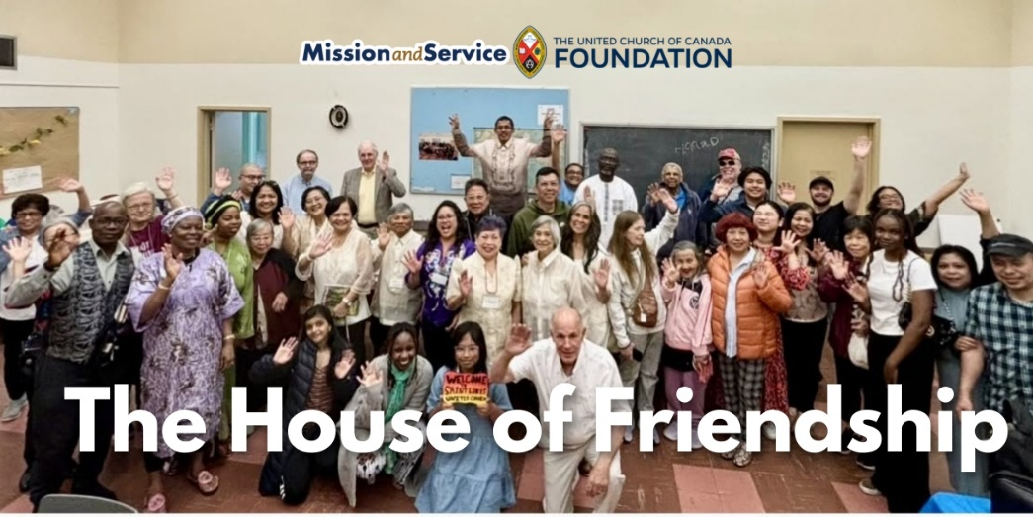

At St. Luke’s United Church, a strong sense of belonging for newcomers is being expressed through intentional welcome, shared meals, and community. Here is the Mission and Service Story for October 11, 2026.
The congregation at Saint Luke’s United Church in Toronto, ON understands that belonging rarely happens by accident. It grows through deeply intentional acts of welcome that are joyfully offered to every single person.

Arriving in Canada is only the beginning of the journey for many newcomers. While there is relief in finding safety, there’s also the daunting task of building a new life – finding housing and work, learning unfamiliar systems and languages, making new connections, and carrying the weight of experiences that don’t disappear at the border. For some, those experiences include extremely persecution and trauma. Finding a comfortable place to truly and deeply belong, while facing other challenges, can be a long and exhausting process.

Every Sunday, the congregation at St. Luke’s is prepared for someone new to come through the doors. Of course, there are warm greetings, name tags, and introductions. There is also time in the service where people will leave their seats to offer a hug, handshake, and friendly conversation to all.

“Our Passing of the Peace tradition is that early in the service, we get up, and we move around. We’re hugging each other, and we’re fist bumping, all while our music director is playing music in the background. It’s very crowded, as you can imagine, and people are leaning over pews and such. At that point, people who have been introduced as new, our members of the congregation are reaching out to them and welcoming them and quite intentionally. And this also continues at lunchtime.”

After the service, everyone gathers downstairs for what they affectionately call “coffee hour” – a name that hardly captures the generous meal waiting around the tables. People find a full, warm meal awaiting them.

The food is important, but it’s conversation that nourishes the community. Around the table, people who might never have met elsewhere find themselves sharing a meal and learning about one another. A newcomer to Canada sits beside someone who has worshipped at Saint Luke’s for decades. Someone rebuilding their life after escaping persecution discovers neighbours who are genuinely interested in their story, without expecting them to tell it all at once.

One newcomer, who had fled severe persecution before coming to Canada, described finding more than a church. They found people who journeyed with them. As they joined groups, celebrated milestones, and continue to build a new life, the congregation is celebrating alongside them. The community at St. Luke’s understands that healing takes time, and trust is built through consistency, kindness, and simply showing up for one another.

This is the ministry of hospitality at Saint Luke’s. It’s not just about opening church doors and having a sign, but about opening a community – one where people are known by name, welcomed with care, and reminded that they do not have to face life’s next chapter alone.

Through Mission and Service, we help support ministries like Saint Luke’s United Church that create spaces of belonging for newcomers and neighbours alike. Together, we are helping to build communities where God’s welcome is lived, shared, and experienced every day. Let’s give generously.

SCRIPTURE READINGS

Deuteronomy 8:7-18 – Good News Translation
2 Corinthians 9:6-15 – Good News Translation

RESPONSE:
This is the Word of the Lord!
Thanks be to God!

Luke 17:11-19 – Good News Translation

RESPONSE: Let us respond together, saying:
May God bless to our learning and understanding
these words from the scriptures.
REFLECTION

O Lord, take my lips and speak through them;
Take our minds and think through them;
Take our hearts and set them on fire with love for Yourself,
Lord Jesus, and for all of Creation. Amen.

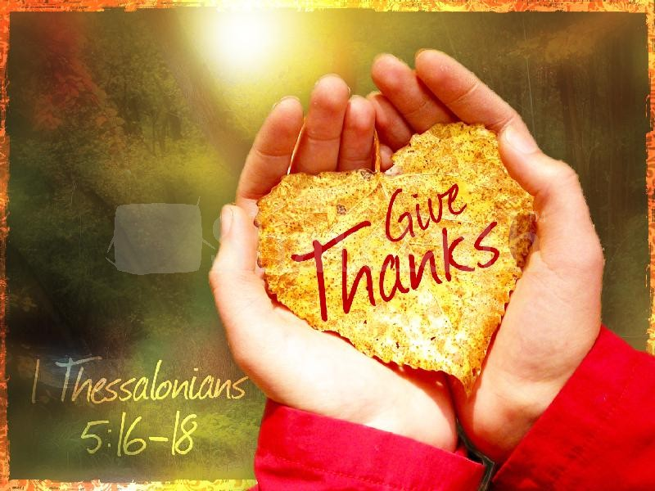

HYMN – Voices United #291 All Things Bright and Beautiful
https://www.youtube.com/watch?v=C0R0mqyOHEA

Refrain: All things bright and beautiful,
all creatures great and small,
All things wise and wonderful
in love, God made them all.

- Each little flower that opens,
each little bird that sings,
God made their glowing colours,
God made their tiny wings.

- The purple-headed mountains,
the river running by,
the sunset and the morning
that brightens up the sky.

- The cold wind in the winter,
the pleasant summer sun,
the ripe fruits in the garden:
God made them every one.

- The rocky mountain splendor,
the lone wolf’s haunting call,
the great lakes and the prairies,
the forest in the fall.

- God gave us eyes to see them,
and lips that we might tell
how great is God our maker,
who has made all things well.
INVITATION TO THE OFFERING – (in unison)
As an act of thanksgiving,
we respond to God’s love by bringing our gifts of time,
energy, and skills, our offerings of life and love.

DOXOLOGY – VU #538 For the Gift of Creation
https://www.youtube.com/watch?v=iIdQaBbIfEE

For the gift of creation, the gift of your love,
And the gift of the Spirit by which we live,
We thank you and give you the fruit of our hands.

PRAYERS OF THANKSGIVING AND DEDICATION

Loving and gracious God,
we offer these gifts in thanksgiving
for the gift of new life
we have received in Jesus Christ.
May these gifts
strengthen our witness to the gospel,
here in our community,
and also in the wider church and world.
We pray in Jesus’ name. Amen.

PRAYERS OF THE PEOPLE

HYMN – More Voices # 185 Ev’ry Day is a Day of Thanksgiving
(as many times as our musician plays it) https://www.youtube.com/watch?v=DrOaM8HCiqQ
Ev’ry day is a day of thanksgiving.
God you’ve been so good to me.
Ev’ry day you’re blessing me.
Ev’ry day is a day of thanksgiving.
I will glorify you, O my Lord, today!

You keep blessing me, blessing me, blessing me.
You opened the door that I might see,
you’re blessing me.
And you keep blessing me,
blessing me, blessing me.
I will glorify you, O my Lord, today!

COMMISSIONING AND BLESSING

EXTINGUISH THE CHRIST CANDLE

SENDING SONG – More Voices #156 Dance with the Spirit (twice) https://www.youtube.com/watch?v=fz8q-UNkZ54
Dance with the Spirit early in the mornin’
Walk with the Spirit throughout the long day.
Work and hope for the new life abornin’,
Listen to the Spirit to show you the way.

Resources used in this service are available on request

Covenant United Church
230 Eighth Ave
Timmins, ON
(705) 264-5518
covenanttimmins@ntl.sympatico.ca

