Covenant
The United Church of Canada
a safe place for all people to worship
Ministers: All the People
Presiding: Rev. Laura Hutchison

Sunday, November 1 2026
All Saints Day
With celebration of
The Sacrament of Communion

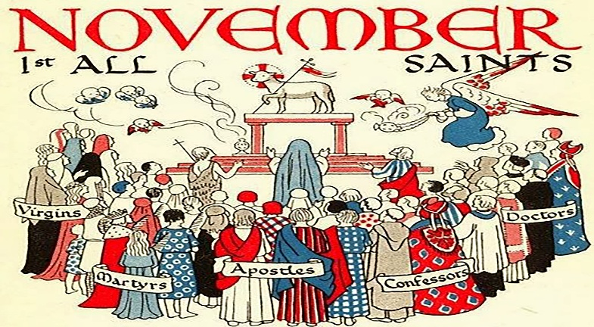

(Ring the chime once)

LIGHTING THE CHRIST CANDLE – We light this candle to remind us that God is present in all things. As surely as the smallest of lights transforms the deepest shadows of any room, God is here, with us, always.
(the candle is lit)

WELCOME & ANNOUNCEMENTS
Welcome to Covenant United Church. Today, we are meeting on land that, traditionally, has been cared for by Mattagami, Flying Post, and Matachewan First Nations, and Métis people, and is covered by Treaty #9.
Grateful for the care of all who have come before us, we seek to be good stewards of the land, and good neighbours with all people.
You are welcome here.


COFFEE HOUR VOLUNTEERS: If you are willing to help out for this fellowship opportunity, please contact Heather.


THANK YOU to everyone for their donations to the Timmins Food Bank! Also, thank you for the sock donations! The socks and winter hats and neck warmers have been donated to the Lord’s Kitchen.



PRAYER SHAWL
Prayer Shawl is on Nov. 12th and the 26th, 2026 from 1-3 pm.



COMFORT SOUPS
For those in need or for a friend help yourself to frozen homemade soups in Kitchen freezer. No cost.


CHILI AND BEANS LUNCHEON- will be held this Wednesday, Nov 4th 2026 from 11:30am-1:00pm. Cost is $10. Take out is available! Call the office at 705-264-5518. We are also looking for Volunteers to help make Chilli, beans, or desserts. Please contact Joy to volunteer.


Our fundraiser for the church sign has to date raised $1700.00 of the $2300.00 needed. I cannot thank those enough who have donated to date. Your generosity is greatly appreciated! 🙏


CONGREGATION CHRISTMAS TURKEY DINNER – Sunday, Dec 6th 2026 at 5:30pm. Includes appetizers and desserts. Everyone welcome. Tickets are available for purchase for $25.00. Deadline to purchase tickets is Sunday, Nov 29th, 2026.


The office is open Wednesday Nov. 4th from 9:00am-3:30pm.

(ring the chime)

WORD FOR ALL AGES – SAINTS

CHILDREN’S HYMN - VU #575 I’m Gonna Live So God Can Use Me
I’m gonna live so God can use me anywhere, Lord, any time.
I’m gonna live so God can use me anywhere, Lord, any time.

I’m gonna work so God can use me anywhere, Lord, any time. (repeat)

I’m gonna pray so God can use me anywhere, Lord, any time. (repeat)

I’m gonna sing so God can use me anywhere, Lord, any time. (repeat)

PRAYER

Let’s pray together in the familiar words we call “The Lord’s Prayer”:
Our Father, who art in heaven,
hallowed be thy name;
thy kingdom come;
thy will be done;
on earth as it is in heaven.
Give us this day our daily bread.
And forgive us our trespasses,
as we forgive those who trespass against us.
And lead us not into temptation;
but deliver us from evil.
For thine is the kingdom,
the power, and the glory
for ever and ever.
Amen.

CALL TO WORSHIP-

We gather on this Sunday closest to
All Hallows’ Eve and All Saints’ Day
to remember saints, past and present;

to receive the teachings they have passed down to us;
and to offer thanksgiving for their legacy of faith.

We gather on this Sunday closest to
All Hallows’ Eve and All Saints’ Day
to worship the God of all generations!

PRAYER OF APPROACH
We are in the long line of faithful people who turn to you with our questions and our prayers.
Lead us to a deeper understanding of and a freer trust in your life in us, which we know through the life of Jesus.
We are your church. Bless us as we gather in your name. Amen.

CENTERING

PRAYER OF CONFESSION

MINUTE FOR MISSION-

SCRIPTURE READINGS
1 Thessalonians 2:9-13 – The Voice
Matthew 23:1-12 – The Voice

RESPONSE: VU #595 We are Pilgrims
https://www.youtube.com/watch?v=hbnFjAdF1i8

- We are pilgrims on a journey,
fellow travellers on the road;
We are here to help each other
walk the mile and bear the load.

- Sister, let me be your servant,
let me be as Christ to you;
Pray that I may have the grace
to let you be my servant too.

- I will hold the Christ-light for you
in the night-time of your fear;
I will hold my hand out to you,
speak the peace you long to hear.

- I will weep when you are weeping,
when you laugh I’ll laugh with you;
I will share your joy and sorrow,
till we’ve seen this journey through.
- When we sing to God in heaven,
we shall find such harmony,
Born of all we’ve known together
of Christ’s love and agony.

- Brother, let me be your servant,
let me be as Christ to you;
Pray that I may have the grace to
let you be my servant too.

REFLECTION


COMMUNION HYMN – VU #469 We Gather Here
https://www.youtube.com/watch?v=859FLVIbwq4

- We gather here in Jesus' name,
his love is burning in our hearts like living flame;
for through the loving son God fashions us as one:
Come take the bread, come drink the wine,
come, share the Lord.
No one is a stranger here, - everyone belongs;
finding our forgiveness here,
we in turn forgive all wrongs.

- He joins us here, he breaks the bread,
the One who pours the cup is risen from the dead;
the One we love the most is now our gracious host:
Come take the bread, come drink the wine,
come, share the Lord.
We are now a family of which Christ is the head;
though unseen he meets us here
in the breaking of the bread.

- We'll gather soon where angels sing;
we'll see the glory of our Lord and coming King;
now we anticipate the feast for which we wait:
Come take the bread, come drink the wine,
come, share the Lord.

INVITATION to the TABLE

OFFERING –
Let us take a moment to receive and dedicate our offerings:

DOXOLOGY – Voices United #541 Praise God from Whom All Blessings Flow
Praise God from whom all blessings flow;
Praise God, all creatures high and low;
Give thanks to God in love made known:
Creator, Word and Spirit, One.

PRAYERS OF THANKSGIVING AND DEDICATION

Generous God, we bring these offerings this day, and also the offerings given by PAR* and the work of our hands and hearts.
We dedicate the cups of coffee shared, the jars of peanut butter donated, the listening hearts, the drives to appointments, and the other kindnesses we lovingly share in other ways. We ask that you multiply our efforts so that the world can be more the way you created it to be. Amen.

THE GREAT THANKSGIVING
God be with us.
God is here among us.
Let us open our hearts to God.
We open them to God and to each other.

Creator, you separated land from water to create the skies and seas and to make a home for all people. You created cycles of life that would sustain all creatures.
Through our faith traditions, you offered us stories that teach us to care for each other and for the earth.
But we let you down, Holy One. Instead of sharing the earth and its resources, we put systems in place that hurt your people and creation.
You sent your son to live with us and bring us back to you.
Jesus assured us of your forgiveness and love.
When he returned to you, Jesus sent the Spirit to help us bring your kingdom on earth as it is in heaven.
We share in communion today to remember your hope for all creation.

All Sing: MV #203
O holy, holy, holy God, O God of time and space
All earth and sea and sky above bear witness to your grace
Hosanna in the highest heaven Creation sings your praise
And blessed is the one who comes and bears your name always.

PRAYERS OF THE PEOPLE

On the night…
All Sing: MV #204 Memorial Acclamation
Sing Christ has died, and Christ is risen,
Christ will come again! (repeat)

BREAKING THE BREAD AND FILLING THE CUP
Jesus, the Christ, the bread of life!
ALL: Amen.
Jesus, the Christ, the true vine!
All: Hallelujah!

PRAYER AFTER COMMUNION

All Sing: MV #205 The Great Amen
Amen, amen, O holy One, hosanna and amen. (repeat)

HYMN: MV #199 When at This Table
https://www.youtube.com/watch?v=C8lszLOYkWk

- When at this table I receive a blessing,
the broken bread, the wine of life for me,
then let me share the peace with you, my neighbor,
and let the Spirit set our spirits free.

- If at this table I have need of healing,
unbidden grief, relationship gone wrong,
then let me know the hands of God enfolding,
and let lament become believing song.

- If at this table I forget the hungry,
the dispossessed and warfare's spreading stain,
then let this bread become the bread of judgment,
this wine the sharp awareness of that pain.

- If at this table I make dedication
to give my life in serving what is good,
then let my center be where God invites me,
and show the words of Jesus understood.

- What faith I have, I bring to join this table,
what hope I hold, in Christ is taught and true;
with brothers, sisters, I will share the blessing,
the feast where God is making all things new.
COMMISSIONING AND BLESSING -
May the Spirit of our God bless you
- Equip you
- Unite you with others
- And lead you to build God’s kingdom among us
Go now in joy and peace!

EXTINGUISH THE CHRIST CANDLE

SENDING SONG – VU #884 Isaiah 55, You Shall Go Out with Joy https://www.youtube.com/watch?v=up3AKJ2PxiU
You shall go out with joy and be led forth with peace;
The mountains and the hills will break forth before you,
There’ll be shouts of joy, and all the trees of the field
Will clap, will clap their hands!

And all the trees of the field with clap their hands,
The trees of the field will clap their hands,
The trees of the field will clap their hands
While you go out with joy!

RESOURCES used in this service are from gatheringworship.ca.



