Covenant
The United Church of Canada
a safe place for all people to worship
Ministers: All the People
Presiding: Rev. Laura Hutchison

Sunday, September 27th, 2026
Season of Creation 4
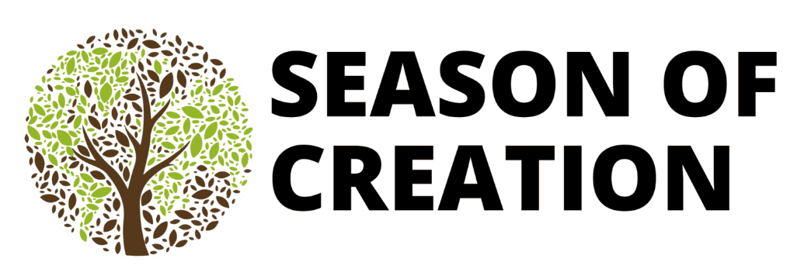
(Ring the chime once)

LIGHTING THE CHRIST CANDLE

VU #588 Many are the Lightbeams (verse 1, twice)
https://www.youtube.com/watch?v=gjBmojRsNeY

Many are the lightbeams from the one light.
Our one light is Jesus.
Many are the lightbeams from the one light;
We are one in Christ.
(the candle is lit during the singing of the verse)

WELCOME & ANNOUNCEMENTS

Welcome to Covenant United Church. This sanctuary where we are meeting is built on land that, traditionally, has been cared for by Mattagami, Flying Post, and Mattachawan First Nations, and Métis people, and is covered by Treaty #9.
Grateful for the care of all who have come before us, we seek to be good stewards of the land, and good neighbours with all people.
Everyone is welcome here.


Coffee Hour Volunteers: Looking for someone to host coffee hour for one Sunday in October. If you are willing to help out for this fellowship opportunity, please contact Heather.


Socktober-We will be collecting sock donations for the Kinettes this October.



COMMUNITY COFFEE
Covenant will be hosting our first Coffee/Tea and Muffins the last Tuesday of every month. Our first coffee will be Sept 29th 10-11:30 am. All are welcome. Bring a friend, No charge.

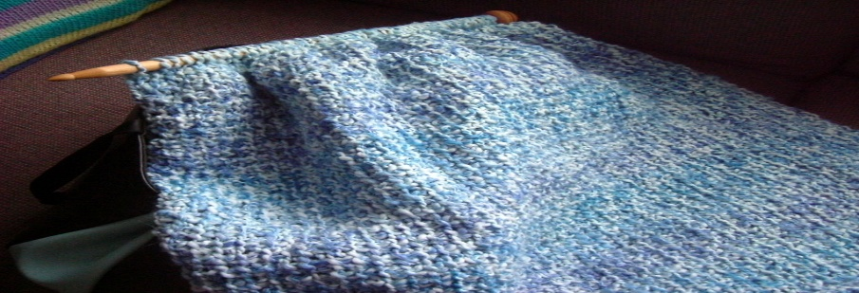

PRAYER SHAWL
Prayer Shawl is on Thursday Oct. 1st and Oct. 15th. We invite all crafters or folks who want to chat. We have great conversations and laugh a lot. 1-3 pm


The office is open Wednesday Sept 30th from 9:00am-3:30pm.
(ring the chime)

WORD FOR ALL AGES

GATHERING HYMN – MV #131 You, Creator God, Have Searched Me https://www.youtube.com/watch?v=GfH76wYKXJQ

- You, Creator God, have searched me
and you know my ways.
You perfectly understand me,
It’s my cause of praise.
I cannot escape your presence
in air, land or sea.
Your arms of love and protection
are always with me.

Refrain:
You know me, O God, you have made me.
I am proud I’m the work of your hand.
In my waking and sleeping moments,
With my being I will praise your name.

- You created light and darkness
and you love them both.
You blessed the womb of my mother,
you brought me to birth.
In your image and your likeness
wonderfully made.
I will lift my voice to praise you,
you are God indeed. R

CALL TO WORSHIP
God calls us to worship and welcomes us with abundant grace.
All Sing: MV 62 There is room for all
https://www.youtube.com/watch?v=N4FjK9gZ_LQ

There is room for all in the shadow of God’s wing;
There is room for all, sheltered in God’s love,
And I rejoice and sing,
“My refuge and my rock, in whom I trust.”
There is room for all, There is room for all!

God calls us into community and welcomes us with forgiveness and joy.
All Sing: MV 62 “There is room for all”

God calls us to love and to serve, with heart, soul, mind, and strength!
All Sing: MV 62 “There is room for all”

God says:
Welcome one another!
If you’re over 90, under nine, or in between, God says:
Welcome one another!
If you’re a regular, reluctant, just visiting, or not sure, God says:
Welcome one another!
If you’d rather be golfing, or camping, or sleeping in, God says:
Welcome one another!
In this time and place, as people of the one Creator, we gather to worship, to pause in the swirls or silence of our lives, and to know ourselves as beloved and part of the company of saints. We come because God calls us, and God says:
Welcome one another!

PRAYER OF APPROACH

God of the heavens and of the earth, Creation sings of the good you have done! As birds migrate and squirrels store up, we too prepare for what autumn brings. We resume familiar patterns that follow the school year, no matter when we took our last class. We harvest vegetables and wait for leaves to turn their beautiful array of colours. Shorter days mean more hours to enjoy the stars, and so we gather to celebrate everything you have given to us.
Open our hearts to notice the abundant blessings of this time and this place, and guide us to ways that expand that blessing for others. Amen.

CENTERING

MINUTE FOR MISSION- Restoring Sacred Connections
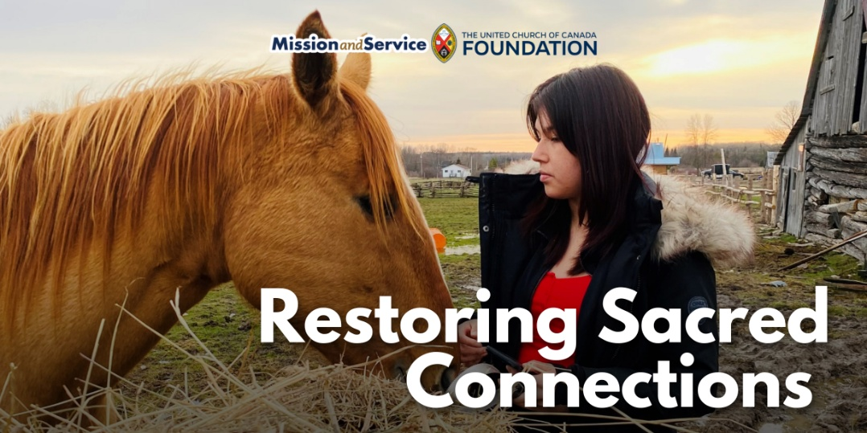

Traditional teachings, the Medicine Wheel, and the importance of relationships create a foundation for emotional, spiritual, and cultural healing.

In Wiikwemkoong Unceded Territory, healing happens in many forms. The Healing with Horses program brings people together to connect with one another, the land, and the gentle and powerful strength of horses. Among them are four Ojibwe Spirit Horses, a rare and sacred breed with a powerful connection to the community. Their story is one of survival and return.

At one point in history, the Ojibwe Spirit Horses were stolen from the community. Their return to the land and the people who have always known and cherished them is an act of resilience and reconciliation. Today, their presence offers a living reminder that what has been disrupted can be restored, and that healing can begin with reconnecting to what has been lost.

That spirit is at the heart of Healing with Horses. Supported by our Mission and Service gifts, the program brings equine therapy together with Indigenous and Anishinaabe ways of knowing and being. Traditional teachings, the Medicine Wheel, and the importance of relationships create a foundation for emotional, spiritual, and cultural healing.

Over the winter, participants ride through the snowy bush, sketched horses outdoors, and learned about emotional regulation, boundaries, and self-compassion. Some walked beside the horses or brushed their coats. Others gathered in circle and found a place to listen and be heard.

For some participants, sharing feelings was difficult. Through the program, they began to find their voices. Children learned ways to understand and manage their emotions, adults reconnected with their inner strength, and together, participants discovered that healing doesn’t have to happen alone.

The horses help create that space. Their calming presence invites people to slow down, pay attention, and connect in a different way.

There’s growing interest in expanding Healing with Horses so more people can take part throughout the year. Plans for a barn or indoor structure would allow this work to continue in every season.

Our Mission and Service gifts help make this possible. Our gifts support Indigenous-led programs that create opportunities for cultural reconnection, community, and healing. The Ojibwe Spirit Horses have found their way home. Through Healing with Horses, they are helping others find their way, too. Let’s give generously.

SCRIPTURE READING
1 Thessalonians 1:1–10 – NRSV (Updated Edition)

RESPONSE:
This is the Word of the Lord!
Thanks be to God!

Matthew 22:15-22 – NRSV (Updated Edition)

RESPONSE: More Voices #37 Each Blade of Grass
https://www.youtube.com/watch?v=wCmdN7aiC_E

- Each blade of grass, ev’ry wing that soars,
The waves that sweep across a distant shore,
Make full the circle of God.
Each laughing child, ev’ry gentle eye,
a forest lit beneath a moon-bright sky,
Make full the circle of God.

- Each silent paw, ev’ry rounded stone,
the buzz that echoes from a honeyed comb,
Make full the circle of God.
Each fire-brimmed star, ev’ry outstretched hand,
The wind that leaps and sails across the land,
Make full the circle of God.
- Each icy peak, ev’ry patterned shell,
the joyous chorus that the dawn foretells,
Make full the circle of God.
Each cosmic hue, ev’ry creature’s way,
all form the beauty of this vast array,
Making full the circle of God.

REFLECTION


A MOMENT FOR SILENT REFLECTION

HYMN – More Voices #120 My Soul Cries Out
https://www.youtube.com/watch?v=BBEQECxs8bQ

- My soul cries out with a joyful shout
that the God of my heart is great,
And my spirit sings of the wondrous things
that you bring to the ones who wait.
You fixed your sight on your servant’s plight,
and my weakness you did not spurn,
So from east to west shall my name be blest.
Could the world be about to turn?

Refrain: My heart shall sing of the day you bring.
Let the fires of your justice burn.
Wipe away all tears, for the dawn draws near,
and the world is about to turn!

- Though I am small, my God, my all,
you work great things in me,
And your mercy will last from the depths
of the past to the end of the age to be.
Your very name puts the proud to shame,
and to those who would for you yearn,
You will show your might, put the strong to flight,
for the world is about to turn. R.

- From the halls of power to the fortress tower,
not a stone will be left on stone.
Let the king beware for your justice tears
ev’ry tyrant from his throne.
The hungry poor shall weep no more,
for the food they can never earn;
There are tables spread, ev’ry mouth be fed,
for the world is about to turn. R.

- Though the nations rage from age to age,
we remember who holds us fast:
God’s mercy must deliver us
from the conqueror’s crushing grasp.
This saving word that our forebears heard
is the promise which holds us bound,
‘Til the spear and rod can be crushed by God,
who is turning the world around.

INVITATION TO THE OFFERING

DOXOLOGY – VU #538 For the Gift of Creation
https://www.youtube.com/watch?v=iIdQaBbIfEE

For the gift of creation, the gift of your love,
And the gift of the Spirit by which we live,
We thank you and give you the fruit of our hands.
May your grace be proclaimed by the gifts that we give.

PRAYERS OF DEDICATION AND THANKSGIVING

In thanksgiving for the many blessings we have received, we bring these our gifts. May they be used to further your presence, O God, in the midst of your Creation.
Open our hearts to notice needs around us and, without complaint, find ways to respond, for we know of your great love and hope, offered through Jesus Christ. May we bring alive Christ’s mission to this world. Amen.

PRAYERS OF THE PEOPLE

HYMN – Voices United #330 Jesus Shall Reign
https://www.youtube.com/watch?v=ljcGW6V_oDQ

Jesus shall reign where’er the sun
Does his successive journeys run;
His kingdom stretch from shore to shore,
Till moons shall wax and wane no more.

People and realms of every tongue
Dwell on His love with sweetest song;
And infant voices shall proclaim
Their early blessings on His name.

Blessings abound where’er He reigns;
The prisoner leaps to lose his chains;
The weary find eternal rest,
And all the sons of want are blest.

Let every creature rise and bring
Peculiar honors to our king;
Angels descend with songs again,
And earth repeat the loud amen.

COMMISSIONING AND BLESSING

EXTINGUISH THE CHRIST CANDLE
Although we extinguish the light of this candle, we carry the light of Christ with us everywhere. We are not alone. And all God’s people said, “Amen!”

SENDING SONG – More Voices #218 May the Love of the Lord (twice) https://www.youtube.com/watch?v=NWi8rt3P6A0

May the love of the Lord rest upon your soul.
May God's love dwell in you, throughout every day.
May God's countenance shine upon you and be gracious to you.
May God's Spirit be upon you as you leave this place.

Resources used in this service are from gatheringworship.ca

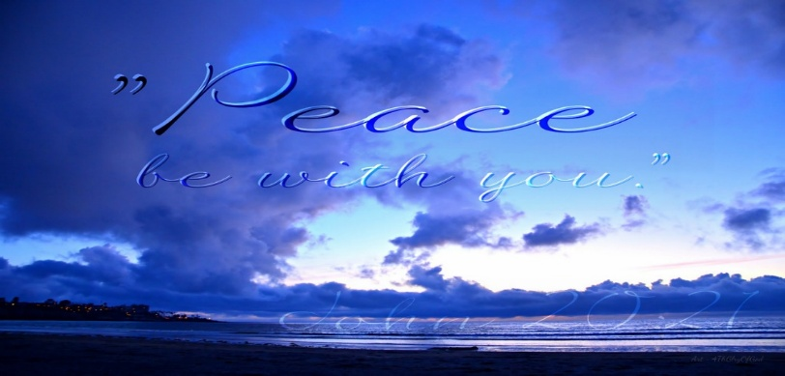
Covenant United Church
230 Eighth Ave
Timmins, ON
(705) 264-5518
covenanttimmins@ntl.sympatico.ca

