Covenant
The United Church of Canada
a safe place for all people to worship
Ministers: All the People
Presiding: Rev. Laura Hutchison

Sunday, September 20th, 2026
Season of Creation 3

(Ring the chime once)

LIGHTING THE CHRIST CANDLE

We light this candle recalling the wisdom of God. God gives us wisdom in plants and animals as well as in taught knowledge and experienced knowledge. God invites us to question, to ponder, to learn, to test, to be full of wisdom. We welcome the wisdom of God revealed in all of Creation.

WELCOME & ANNOUNCEMENTS

Welcome to Covenant United Church. This sanctuary where we are meeting is built on land that, traditionally, has been cared for by Mattagami, Flying Post, and Mattachawan First Nations, and Métis people, and is covered by Treaty #9.
Grateful for the care of all who have come before us, we seek to be good stewards of the land, and good neighbours with all people.
Everyone is welcome here.



COMMUNITY COFFEE
Covenant will be hosting our first Coffee/Tea and Muffins the last Tuesday of every month. Our first coffee will be Sept 29th 10-11:30 am. All are welcome. Bring a friend, No charge.



PRAYER SHAWL
Prayer Shawl is on Thursday Oct. 1st and Oct. 15th. We invite all crafters or folks who want to chat. We have great conversations and laugh a lot. 1-3 pm


There will be an ADHOC meeting at 7pm in the South Room on Sept. 23rd 2026.

Finances – Heather Laverdiere & Susan Boisvert
January 1, 2026 to August 31, 2026
- General Fund: Revenue $ 67675.48
Expenses $ 71198.43
From Investment $ 0

- Building Funds: Revenue $ 5385.00
Expenses $ 5277.64

- M&S: Revenue $ 3820

Account balances are now: General Fund: $24,336 Building Fund $ 10,170 Outreach $ 77
Investments: $121,642.15 (as of June 30, 2026)

The office is open Wednesday Sept 23rd from 8:30-3:00pm and Sept 30th from 9:00am-3:30pm.
(ring the chime)

WORD FOR ALL AGES – Exodus 16:2-15

GATHERING HYMN – VU #179 Hallelujah, Hallelujah, Give Thanks https://www.youtube.com/watch?v=MY20S6ezV6g

Hallelujah, hallelujah. Give thanks to the risen Christ.
Hallelujah, hallelujah. Give praise to God’s name.

Jesus is Lord of all the earth,
Firstborn of all creation.
Hallelujah, hallelujah. Give thanks to the risen Christ.
Hallelujah, hallelujah. Give praise to God’s name.

Spread the good news o’er all the earth:
Jesus has died and is risen.
Hallelujah, hallelujah. Give thanks to the risen Christ.
Hallelujah, hallelujah. Give praise to God’s name.

We have been crucified with Christ,
Now we shall live forever.
Hallelujah, hallelujah. Give thanks to the risen Christ.
Hallelujah, hallelujah. Give praise to God’s name.
Come let us praise the living God,
Joyfully sing to our Saviour.
Hallelujah, hallelujah. Give thanks to the risen Christ.
Hallelujah, hallelujah. Give praise to God’s name.

CALL TO WORSHIP

Based on images from Psalm 29, Psalms for Praying.
In the quiet wonders of nature,
give praise to God.
Majestic is the Voice of Love.
God is present through every storm,
we cry unto You
May Love give strength to all Earth.
Let us worship with a heart of care.

PRAYER OF APPROACH AND THANKSGIVING

For the breath of morning and the hush of evening,
for wind in trees and water’s song,
for earth that shelters and sky that beckons,
we give you thanks, O God.
By your wisdom all things are made.

For the Spirit stirring our longing,
speaking in fire and silence,
who meets us in brokenness and wonder,
we give you thanks, O God.
By your wisdom all things are made.

For the gift of Christ,
Bread of Life,
who teaches us to see the world as sacred,
and to walk gently in it,
we give you thanks, O God.
By your wisdom all things are made.

For the practice of paradise—
for every act of reverence,
every moment of stillness,
every turning of the heart toward healing,
we give you thanks, O God.
By your wisdom all things are made.

For communities of care,
for those who teach, tend, and make beauty,
for stories that awaken and prayers that sustain,
we give you thanks, O God.
By your wisdom all things are made.

For the mystery of your presence in all things,
and the promise of renewal still unfolding,
we give you thanks, O God.
By your wisdom all things are made.

All Sing: VU 400 “Lord, listen to your children praying” (3 times)
https://www.youtube.com/watch?v=k9s5Mw-e_Z8
Lord, listen to your children praying,
Lord, send your Spirit in this place;
Lord, listen to your children praying,
Send us love, send us power, send us grace!

CENTERING

MINUTE FOR MISSION-CROSSING CLASS LINES
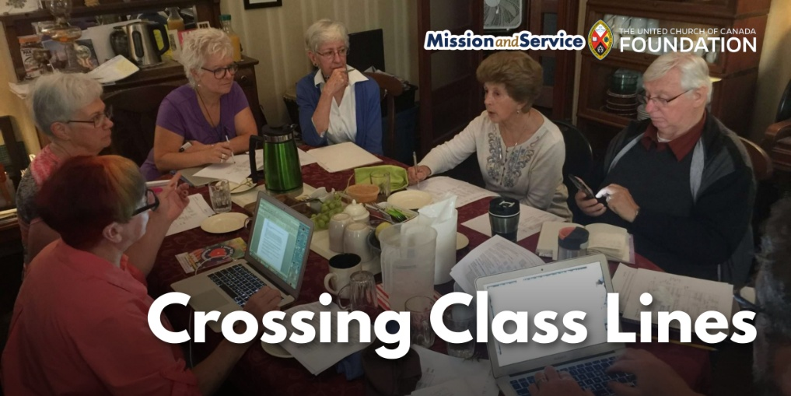

One of the most meaningful parts of our small group Crossing Class Lines: 12-Week Bridging Team program, which ran from February to April this year in Peterborough, Ontario, was something very simple: we shared a meal together before we did anything else.

Each week began around the table with a hearty, home-cooked meal prepared by one of our co-facilitators. Our facilitation team included four facilitators—three with lived experience of poverty and one middle-class staff member—and the meals reflected the care and hospitality they brought to the program. We planned menus that accommodated dietary needs so everyone could feel welcome. Some weeks we shared homemade beef stew with fresh buns; other weeks it was baked macaroni and cheese with vegetarian lentil soup. A few participants also chose to bring food to share, offering what they could as a way of contributing to the community we were building together.
The meal did far more than fill empty stomachs. It created a level playing field. Before conversations about poverty, privilege, and social class began, everyone gathered around the same table, eating the same food. It reminded us that we all have basic human needs, and that sharing food has a remarkable way of breaking down barriers and helping strangers become neighbours. The meal was never about serving one group and helping another. It wasn’t an act of charity – it was mutual hospitality. It was about creating a space where everyone could both give and receive, and where relationships could grow across economic differences with dignity and mutual respect.

More than half of the participants in this program were living in poverty. Many spoke openly about the rising cost of groceries and how difficult it had become to afford healthy food. One participant, who rents a room in a shared house, quietly shared that our weekly meal was the most vegetables she ate all week. She looked forward to coming each Wednesday, not only for the learning and relationships, but because she knew she would receive a nourishing, home-cooked meal prepared with care.

Once we had eaten together, we spent the afternoon learning from one another about the realities of poverty and privilege – the importance of stable housing, access to education, meaningful relationships, and mental health support. The conversations were richer because trust had already begun to grow around the table.

At the end of each week, participants living on low incomes received a $50 grocery gift card in recognition of the invaluable expertise they brought through their lived experience. Their stories and insights were not simply welcomed—they were essential to the learning of the entire group.

In a time when many people feel increasingly isolated and divided, we have witnessed how something as ordinary as sharing a meal can become an extraordinary act of community building. Around a table, people from very different economic backgrounds discover one another’s humanity. They listen more deeply, build relationships across differences, and begin imagining what a more connected and compassionate community could look like, together.

The views contained within these blogs are personal and do not necessarily reflect those of The United Church of Canada or United Church of Canada Foundation.

This work also forms the foundation of Bridging Poverty & Privilege, a new self-study course offered through CHURCHx. Developed by Bedford House and shaped by the lived experience of people who have navigated poverty, the course invites participants to explore how social class shapes our relationships and how we can build communities rooted in dignity, mutuality, and belonging.

Our gifts through Mission and Service make this work possible. Let’s give generously so people can continue learning and growing.

SCRIPTURE READINGS
Philippians 1:21-30 – NRSV(UE)

RESPONSE:
This is the Word of the Lord!
Thanks be to God!

Matthew 20:1-16 – Good News Translation

RESPONSE: MV #127 I Saw the Rich Ones
https://www.youtube.com/watch?v=Mp5ei9jyks0

- I saw the rich ones, I saw what they gave;
the widow who offered two pennies she’d saved;
and I saw she was smiling and I knew she was glad;
and I wondered because she gave all that she had…
But with God the world is turned upside down;
the poor are embraced and the lost they are found.
Let’s work for a world where all people are free;
where it’s good to feel good about God loving you and me.

- I saw Zaccheus, a sinner they said,
but to his house I saw Jesus go to break bread;
and I knew something special had happened that day
when Zaccheus gave half of his riches away…
But with God the world is turned upside down;
the poor are embraced and the lost they are found.
Let’s work for a world where all people are free;
where it’s good to feel good about God loving you and me.

- The men in the vineyards were grumbling one day;
I knew they weren’t happy with what they’d been paid;
for the ones who came later were paid just the same
as the workers who greeted the dawn when they came…
But with God the world is turned upside down;
the poor are embraced and the lost they are found.
Let’s work for a world where all people are free;
where it’s good to feel good about God loving you and me.

REFLECTION


A MOMENT FOR SILENT REFLECTION

INVITATION TO THE OFFERING
We have received much from God and God’s Creation. Let us give thanks and share so that this abundance may equip all disciples for their work.

DOXOLOGY – VU #538 For the Gift of Creation
https://www.youtube.com/watch?v=iIdQaBbIfEE

For the gift of creation, the gift of your love,
And the gift of the Spirit by which we live,
We thank you and give you the fruit of our hands.
May your grace be proclaimed by the gifts that we give.

PRAYERS OF DEDICATION AND THANKSGIVING

In thanksgiving for the many blessings we have received, we bring these our gifts. May they be used to further your presence, O God, in the midst of your Creation.
Open our hearts to notice needs around us and, without complaint, find ways to respond, for we know of your great love and hope, offered through Jesus Christ. May we bring alive Christ’s mission to this world. Amen.

PRAYERS OF THE PEOPLE

HYMN – People’s Choice

COMMISSIONING AND BLESSING
EXTINGUISH THE CHRIST CANDLE
Even though we extinguish the light of this particular candle in this sanctuary, we carry the light of Christ with us everywhere, and every moment. We are not alone. And all God’s people said, “Amen!”

SENDING SONG – More Voices #218 May the Love of the Lord (twice) https://www.youtube.com/watch?v=NWi8rt3P6A0

May the love of the Lord rest upon your soul.
May God's love dwell in you, throughout every day.
May God's countenance shine upon you and be gracious to you.
May God's Spirit be upon you as you leave this place.

Resources used in this service are from gatheringworship.ca and from prayerbench.ca
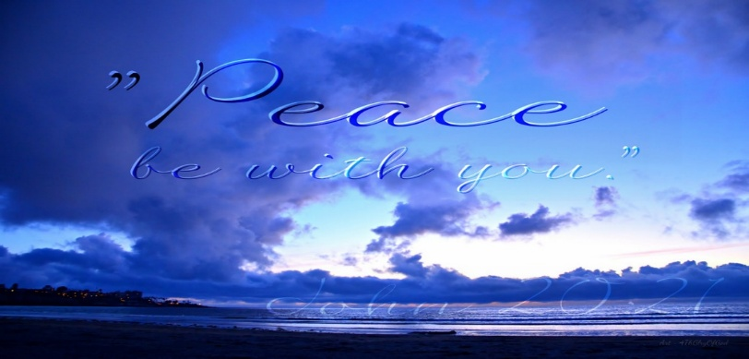
Covenant United Church
230 Eighth Ave
Timmins, ON
(705) 264-5518
covenanttimmins@ntl.sympatico.ca

