Covenant
The United Church of Canada
a safe place for all people to worship
Ministers: All the People
Presiding: Rev. Laura Hutchison

Sunday, October 4, 2026
Season of Creation 5
World Communion Sunday 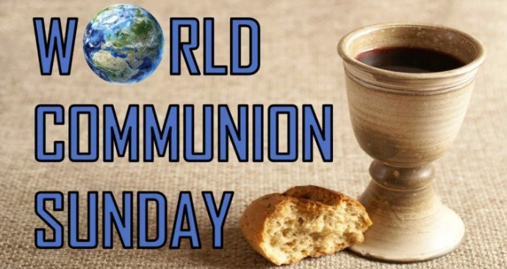
(Ring the chime once)

LIGHTING THE CHRIST CANDLE – We light this candle to remember that God is present in all things. As surely as the smallest of lights transforms the deepest shadows of any room, God is here, with us, always.

WELCOME & ANNOUNCEMENTS

Welcome to Covenant United Church. This sanctuary where we are meeting is built on land that, traditionally, has been cared for by Mattagami, Flying Post, and Matachewan First Nations, and Métis people, and is covered by Treaty #9.
Grateful for the care of all who have come before us, we seek to be good stewards of the land, and good neighbours with all people.
Everyone is welcome here.


Coffee Hour Volunteers: Thank you to Evelyn Glazier and Carol Third for hosting coffee this morning. If you are willing to help out for this fellowship opportunity, please contact Heather.


Socktober-We will be collecting sock donations for the Kinettes this October.



COMMUNITY COFFEE
Covenant will be hosting our Coffee/Tea and Muffins the last Tuesday of every month. Our next coffee will be Oct 27th 10-11:30 am. All are welcome. Bring a friend, No charge.



PRAYER SHAWL
Prayer Shawl is on Oct. 15th. We invite all crafters or folks who want to chat. We have great conversations and laugh a lot. 1-3 pm


The office is open Wednesday Oct. 7th from 9:00am-3:30pm.
(ring the chime)

WORD FOR ALL AGES

GATHERING HYMN –
https://www.youtube.com/watch?v=2k5v3ZgqQeE

- I come with joy, a child of God,
forgiven, loved and free,
The life of Jesus to recall
in love laid down for me,
In love laid down for me.

- I come with Christians far and near
to find, as all are fed,
The new community of love
in Christ’s communion bread,
In Christ’s communion bread.

- As Christ breaks bread, and bids us share,
each proud division ends
The love that made us, makes us one,
and strangers now are friends,
And strangers now are friends.

- The Spirit of the risen Christ,
unseen, but ever near,
Is in such friendship better known,
alive among us here,
Alive among us here.

- Together met, together bound
by all that God has done,
We’ll go with joy, to give the world
the love that makes us one,
The love that makes us one.

CALL TO WORSHIP (from Diane Trollope)

PRAYER OF APPROACH

O Gracious Lord of mysterious abundance,
as we enter into a new season, a new month,
a time of spiritual renewal,
may our voices express and sing praises
that are worthy of your eternal love.
Let the ray of sunshine
that is shining through the clouds
point us in the right direction. Amen.

PRAYER OF CONFESSION
WORDS OF ASSURANCE
We believe God’s love and grace is infinite, meaning God forgives us.
We are a forgiven people! Thanks be to God.

CENTERING

MINUTE FOR MISSION-BREAKFAST CLUB
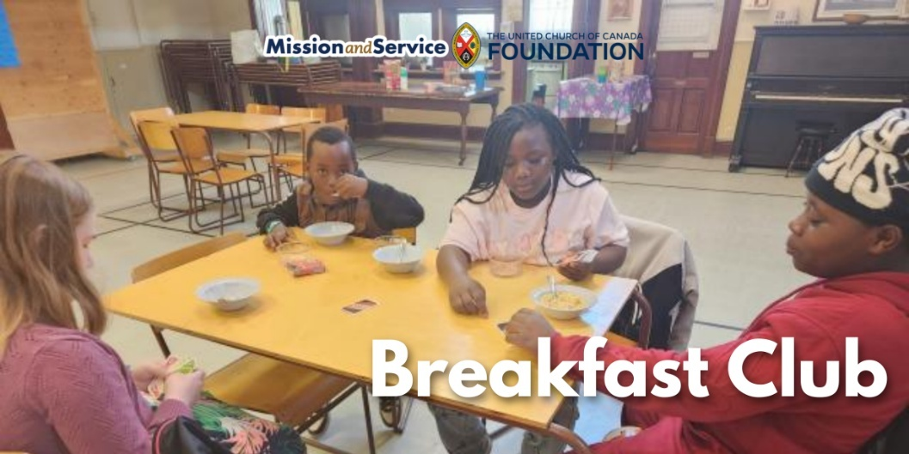

At Plymouth-Trinity United Church, the weekly breakfast program helps families and community members feel welcome and connected before worship.Here is the Mission and Service Story for October 4, 2026.

At Plymouth-Trinity United Church in Sherbrooke, QC, a Sunday morning breakfast is helping families connect with their church community, and creating opportunities for the congregation to build new partnerships in the neighbourhood.

“Breakfast Club” started in January 2025 after Pastor Samuel Vauvert Dansokho and members of the congregation started thinking about how they could better support families who were often arriving late for worship. For families with several young children, getting everyone ready and out the door on a Sunday morning can be quite difficult. Rather than seeing that as a problem, the congregation decided to try something different by inviting everyone to come early for a free breakfast.

The first Breakfast Club welcomed more than 25 people, about half of them children. Attendance has since steadied at 10-15 people each Sunday.

The program is intentional and straightforward. Breakfast might include cereal, toast, oatmeal, fruit, and baked goods. Sometimes even hot dogs! But beyond nourishment for the body, the program has also become an opportunity for people to spend time together and nourish their souls in community.

Our gifts through Mission and Service help the initiative sustain and grow, alongside significant contributions from the congregation and local partners. Community members have donated baked goods, fruit, and money, while a local international grocery store provides day-old bread. Any extras are sent home with community members.

There are plans to consider opening the program more widely to the surrounding neighbourhood as capacity allows.

For Shanna Bernier, who helped plan the initiative, the success of Breakfast Club is already clear. Families are being fed, food is being diverted from waste, a local business has become a partner, and people are spending time together at church.

“Generosity has been abundant, not only in the form of a grant but in baked goods and fruit prepared by community members, in financial donations, and in fundraising through a Shrove Tuesday Pancake supper. Pastor Samuel made a connection with a local international grocery store, securing an ongoing donation of “day-old” breads, which can be eaten at a Toast Bar. When there have been larger donations, loaves of bread are frozen and shared throughout the community.”

Our gifts to Mission and Service help congregations respond to the needs they see in their own communities. At Plymouth-Trinity United Church, that support has helped turn a practical idea into an ongoing ministry that brings families, volunteers, local businesses, and the wider community together. Let’s give generously.

SCRIPTURE READINGS

Philippians 3:1a, and 4b-14 NRSV

RESPONSE:
This is the Word of the Lord!
Thanks be to God!

Matthew 21: 33-46 NRSV

RESPONSE: May God bless to our learning and understanding
These words from the scriptures.

REFLECTION

O Lord, take my lips and speak through them;
Take our minds and think through them;
Take our hearts and set them on fire with love for Yourself,
Lord Jesus, and for all of Creation. Amen.



A MOMENT FOR SILENT REFLECTION

HYMN – Voices United #460 All Who Hunger
https://www.youtube.com/watch?v=TjpQscEueB4

All who hunger, gather gladly, holy manna is our bread.
Come from wilderness and wandering. Here, in truth, we will be fed.
You that yearn for days of fullness, all around us is our food.
Taste and see the grace eternal. Taste and see that God is good.

All who hunger, never strangers; seeker, be a welcome guest.
Come from restlessness and roaming. Here, in joy, we keep the feast.
We that once were lost and scattered in communion’s love have stood.
Taste and see the grace eternal. Taste and see that God is good.

All who hunger, sing together; Jesus Christ is living bread.
Come from loneliness and longing. Here, in peace, we have been led.
Blest are those who from this table live their lives in gratitude.
Taste and see the grace eternal. Taste and see that God is good.”

INVITATION TO THE OFFERING

Let us give thanks, and dedicate our offerings of time, talent, and treasure.
With joy let us offer our Creator this portion of all we have received.
As we give from our hearts, let these offerings be blessed.
Praise and thanks be to God. Amen.

DOXOLOGY – VU #538 For the Gift of Creation
https://www.youtube.com/watch?v=iIdQaBbIfEE

For the gift of creation, the gift of your love,
And the gift of the Spirit by which we live,
We thank you and give you the fruit of our hands.
May your grace be proclaimed by the gifts that we give.

PRAYERS OF THANKSGIVING AND DEDICATION

Giver of Great Gifts, we pray surrounded by family, friends, and neighbours. We bring our offerings to celebrate the goodness of community and all that being community entails. We lift up our hearts in gratitude to become part of the gift that we give. This we pray with sincerity and hope. Amen.

COMMUNION LITURGY
INVITATION TO COMMUNION -

Friends, God in Christ prepares a feast for all of us. It is a banquet of good things for our hearts and souls.
All are welcome at this gathering—no matter who you are or what you have done; no matter your age or gender or who you love.

Come and taste. Eat and be filled.
Drink deeply and never thirst again.

This is the table of Jesus Christ who invites us all to this feast that can change our lives.

COMMUNION HYMN – For Everyone Born, a Place at the Table https://www.youtube.com/watch?v=cdOvOXEiss0

- For everyone born, a place at the table,
for everyone born, clean water and bread,
a shelter, a space, a safe place for growing,
for everyone born, a star overhead,

- For all who have life, a place at the table,
revising the roles, deciding the share,
with wisdom and grace, dividing the power,
for all who have life, a system that’s fair, (Refrain)

Refrain: and God will delight when we are creators
of justice and joy, compassion and peace: yes, God will delight when we are creators of justice, justice and joy!

- For young and for old, a place at the table,
a voice to be heard, a part in the song,
the hands of a child in hands that are wrinkled,
for young and for old, the right to belong,

- For just and unjust, a place at the table,
abuser, abused, with need to forgive,
in anger, in hurt, a mindset of mercy,
for just and unjust, a new way to live, (Refrain)

- For everyone born, a place at the table,
to live without fear, and simply to be,
to work, to speak out, to witness and worship,
for everyone born, the right to be free, (Refrain)

One: May God be with us.
All: God is here among us.
One: Let us open our hearts to God.
All: We open them to God and to one another.
One: Let us give thanks to God.
All: It is right to give our thanks and praise.

All: Why do we give thanks and praise at this table?
One: We give thanks because God is always with us.

One: We thank you, God, Creator of us all; from the beginning you made the world and all its creatures. You made people to live for you and for one another. We praise you, O God.
All: We praise you, O God.

One: Jesus came as one of us, first an infant, then a child, later a youth, then an adult. He rejoiced with those who rejoiced, and wept with those who wept. To the despairing, he spoke a word of hope. To the sick, he gave healing. To the hurting, he was a friend.

One: Still, people turned away from you. They betrayed Jesus and nailed him to a cross. But he was lifted from the grave and restored to life, that he might be with us and we with him, alive for evermore! Therefore with all the saints of every time and place, we join the angels in their praise:
All: Holy, holy, holy Lord, God of power and might,
heaven and earth are full of your glory. Hosanna in the highest.
Blessed is the one who comes in the name of the Lord.
Hosanna in the highest.

All: Why do we eat bread at this table?
One: We gather at this table to remember that on the night before he died, Jesus ate with his friends, he took a loaf of bread, and after blessing it, he broke it and gave it to them, saying: “Take, eat. This is my body, given for you. Each time you do this, remember me.”

All: Why do we drink from the cup at this table?
One: That same night, Jesus also took a cup, and after giving thanks, passed it to his friends, saying: “Drink. This cup, poured out for you, is the promise of God. Whenever you drink it, remember me.”

All: What do we remember at this table?
One: We remember Jesus’ death and celebrate his resurrection; we await with hope his coming again to bring peace and justice to the earth; and we proclaim the mystery of our faith.

All: Christ has died. Christ is risen. Christ will come again.

All: For whom to we pray at this table?
One: We pray for God’s world…
(Prayers of the People)

One: As our Saviour taught us, let us pray together, saying
All: Our Father, who art in heaven
hallowed be thy name. Thy kingdom come,
thy will be done on earth as it is in heaven.
Give us this day our daily bread;
and forgive us our trespasses,
as we forgive them that trespass against us.
And lead us not into temptation but deliver us from evil;
for thine is the kingdom and the power and the glory,
forever and ever. Amen.

One: The gifts of God for the people of God…Come for all things are now ready.
(We partake of the elements)

PRAYER AFTER COMMUNION

Life-giving God, may we, who share Christ’s body, live his risen life;
we, who drink his cup, bring new life to others;
we, whom the spirit lights, give light to the world.
Keep us firm in the hope you have set before us,
so that we and all your children shall be free,
and all creation will live to praise your name.
Let all of God’s people say “Amen.”
AMEN!

HYMN – More Voices #182 Grateful
https://www.youtube.com/watch?v=4cNT8NSG2QE

Refrain - Grateful for the life you give us,
thankful for your holy Word,
joyful in your Spirit flowing
over all, O God of love.
Grateful for the bread of heaven,
thankful for your holy word,
joyful in your mercy flowing,
we will praise you.

- You are more than we imagine,
ancient, holy, living Lord.
Even when we doubt your presence,
you are faithful to your word.
R.

- May our lives proclaim your justice,
may our voices sing your praise.
May our hands work in your service
to the glory of your name. R.

COMMISSIONING AND BLESSING

EXTINGUISH THE CHRIST CANDLE
Although we extinguish the light of this candle, in this sanctuary, we carry the light of Christ with us everywhere. We are not alone.

SENDING SONG – More Voices #218 May the Love of the Lord (twice) https://www.youtube.com/watch?v=NWi8rt3P6A0

May the love of the Lord rest upon your soul.
May God's love dwell in you, throughout every day.
May God's countenance shine upon you and be gracious to you.
May God's Spirit be upon you as you leave this place.

Resources used in this service are from gatheringworship.ca
Christ Candle: Christine Leblanc, East End United Regional Ministry
Prayer of Approach: Scott Martin, St. Andrew’s U.C., Georgetown, Ont.
Commissioning: Walter Murray, adapted
Call to Worship: Diane Trollope, Sudbury, Ont.
Offering: Jani Francis, Indian Head, Sask., and Jim McKean, Orillia, Ont.
Communion Liturgy: Rosemary Godin, Sydney, NS


Covenant United Church
230 Eighth Ave
Timmins, ON
(705) 264-5518
covenanttimmins@ntl.sympatico.ca

