Covenant
The United Church of Canada
a safe place for all people to worship
Heather Laverdiere

COVENANT UNITED CHURCH
Sunday, Aug 9th, 2026
11th After Pentecost


(Ring the chimes once)

WELCOME & ANNOUNCEMENTS
Welcome to Covenant United Church. In the midst of summer, we remember that this sanctuary where we are meeting is built on land that, traditionally, has been cared for by First Nations including Mattagami, Flying Post, and Mattachawan, and Métis, and is covered by Treaty #9.
Grateful for the care of all who have come before us, we seek to be good stewards of the land, and good neighbours with all peoples.
All are welcome here.


Office hours are Wednesdays from 9:30am – 4:00pm.

LIGHT THE CHRIST CANDLE

The light of Christ
inspires our prayers.
The light of Christ
brings joy to our singing.
The light of Christ
finds purpose in God’s word.
The light of Christ
illumines the needs of the world.
So we will
(all sing)
let it shine, let it shine, let it shine!

(ring the chime)

WORD FOR ALL AGES – INTERRUPTIONS – Genesis 37:1-4; 16-22

HYMN – Voices United #691 Though Ancient Walls
https://www.youtube.com/watch?v=3-sjxytT4sI

Though ancient walls may still stand proud and racial strife be fact;
Though boundaries may be lines of hate, proclaim God’s saving act!
Walls that divide are broken down; Christ is our unity!
Chains that enslave are thrown aside; Christ is our liberty!

When vested power stands firm entrenched and breaks another’s back,
When waste and want live side by side, it’s Gospel that we lack.
Walls that divide are broken down; Christ is our unity!
Chains that enslave are thrown aside; Christ is our liberty!

The truth we seek in varied scheme, the life that we pursue,
Unites us in a common quest for self and world made new.
Walls that divide are broken down; Christ is our unity!
Chains that enslave are thrown aside; Christ is our liberty!

The church divided seeks that grace, that newness we proclaim;
A unity of serving love that lives praise to God’s name!
Walls that divide are broken down; Christ is our unity!
Chains that enslave are thrown aside; Christ is our liberty!

This broken world seeks lasting health and vital unity.
God’s people by God’s Word renewed, cast off all slavery!
Walls that divide are broken down; Christ is our unity!
Chains that enslave are thrown aside; Christ is our liberty!
PRAYER OF APPROACH –

PRAYER OF CONFESSION – from Liturgies From Below
Loving Parent God, forgive us for the many times that we cannot see and feel. I pray for all who cannot pray and for those who don’t know how to pray.
I pray for those who do not believe. I also pray for my unbelief.
Forgive us for the many times we depend so much on praying that we forget to actualize our prayer.

For the roads that we have blocked
For the bridges that we didn’t build
For the empty table that we didn’t fill
Forgive us.

Every time we close our eyes in prayer,
help us to open them again
To see the many injustices
And the oppression around us

Every time we raise our hands in praise to God
Help us to stretch them out again
that we may help those who are in need.

Forgive us,
and every time we kneel in prayer,
Help us to stand again with our brothers and sisters in struggle;
Help us to stand in solidarity with them.

WORDS OF ASSURANCE

God is with us
We are not alone
Thanks be to God!

CENTERING

PRAYER FOR ILLUMINATION– in unison

Living God, in hopeful prayer, we ask that you open our spirits, our minds, and our hearts as we listen with all of our senses for your life-giving message in scripture today. Amen.



MINUTE FOR MISSION
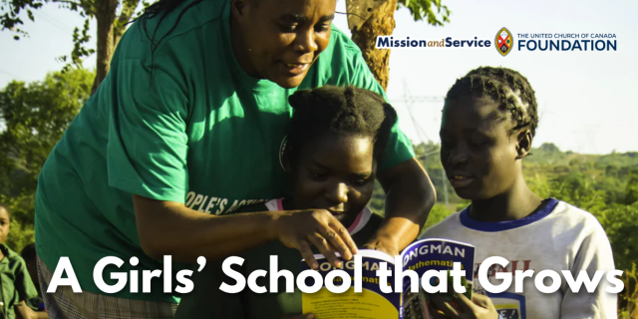
In Zambia, People’s Action Forum (PAF) has been supporting girls’ education through its Girls’ Action Forum program. Through our ongoing support of Mission and Service, we are part of a partnership that helps girls stay in school, access mentorship, and build pathways toward a brighter future. This work is now growing through the development of a new girls’ school in Shimabala, Zambia.

For many girls in the area, completing their education can be a challenge. When girls begin menstruating, become pregnant, marry, or are needed at home to support their families, they may be forced to leave school. Without access to continued education, these girls will face fewer opportunities and a heightened risk of lifelong poverty.

Since 2014, PAF’s Girls’ Action Forum has worked to support girls, particularly those from rural communities, by helping them remain in school or return to continue their education. Through mentorship and encouragement, the program has helped girls recognize their potential and continue pursuing their goals.

Building on this important work, PAF is developing a girls’ school that will provide education and scholarships for students from rural communities. The school is being developed on two hectares of land in Shimabala. The long-term vision is for a comprehensive girls’ school that will eventually grow to include secondary education and boarding facilities.

As part of creating a sustainable future for this project, PAF has started agricultural activities on the land to help generate income that supports the organization’s ongoing work. The project has established a water system, built caretaker lodging, and joined a local farming cooperative to increase opportunities for sustainable income.

The school’s growth will happen in stages. It began by serving younger children through nursery and kindergarten programs, with plans to expand to include preschool and eventually secondary education. Each step brings PAF closer to creating a learning environment where girls can access education regardless of their circumstances.

Through our gifts to Mission and Service, we support long-term partnerships that create lasting opportunities for communities around the world. Together with organizations like PAF, we help nurture education, leadership, and hope for the next generation.
Our gifts help sustain partnerships that support education and create opportunities for girls and young people around the world. Together, we can help ensure that more girls have the chance to learn, grow, and shape their own futures. Let's give generously.

SCRIPTURE READING

Romans 10:5-15 – NRSV(Updated Edition)
Salvation Is for All

RESPONSE: Let us respond together, saying:
May God bless to our learning and understanding
These words from the scriptures.

GOSPEL READING
Matthew 14: 22-33 – Jesus Walks on the Water

RESPONSE:
Thanks be to God for the word!
Let us respond together saying:
Let all who have ears to hear,
Rejoice in all we have heard!

HYMN – More Voices #18 Lord, Prepare Me to be a Sanctuary
https://www.youtube.com/watch?v=48WpmdUUZxY

Lord, prepare me to be a sanctuary,
Pure and holy, tried and true;
With thanksgiving, I'll be a living
Sanctuary for You.

REFLECTION



HYMN – More Voices #161 I Have Called You by Your Name, You are Mine
https://www.youtube.com/watch?v=I0R35mVzftE

I have called you by your name, you are mine;
I have gifted you and ask you now to shine.
I will not abandon you;
all my promises are true.
You are gifted, called, and chosen; you are mine.

I will help you learn my name as you go;
read it written in my people, help them grow.
Pour the water in my name,
speak the word your soul can claim,
offer Jesus' body, given long ago.

I know you will need my touch as you go;
feel it pulsing in creation's ebb and flow.
Like the woman reaching out,
choosing faith in spite of doubt,
hold the hem of Jesus' robe, then let it go.

I have given you a name, it is mine;
I have given you my Spirit as a sign.
With my wonder in your soul,
make my wounded children whole;
go and tell my precious people they are mine.

OFFERING INVITATION – in unison

With joy and gratitude we present and dedicate our offerings of time, talent and treasure to God’s work here, and through all of creation.

DOXOLOGY – VU #541 Praise God from Whom All Blessings Flow

Praise God from whom all blessings flow
Praise God all creatures high and low
Give thanks to God in love made known
Creator, Word and Spirit one.

PRAYERS OF THANKSGIVING AND DEDICATION

Holy Giver,
you have given all that you are, to bring us life
and to bring us into relationship with you and with one another.
We give you now of ourselves and our gifts
to be used to spread your words of truth, life, and love.
We are grateful for you, for one another, for our families and friends,
and for this world you love so much. Amen!

PRAYERS OF THE PEOPLE –
HYMN – Voices United #409 Morning Has Broken
https://www.youtube.com/watch?v=Sh5gvW0ny-Q

Morning has broken like the first morning,
Blackbird has spoken like the first bird.
Praise for the singing! Praise for the morning!
Praise for them, springing fresh from the Word!

Sweet the rain’s new fall sunlit from Heaven,
Like the first dewfall on the first grass.
Praise for the sweetness of the wet garden,
Sprung in completeness where God’s feet pass.

Ours is the sunlight! ours is the morning
born of the one light Eden saw play.
Praise with elation, praise every morning,
God’s re-creation of the new day!

COMMISSIONING AND BLESSING– Liturgies from Below, p.53
God sees each of us and calls us by name.
Calling us to stand firm in the face of oppression and injustice.
May we stand firm then as the Holy Spirit enlivens our hope,
as Jesus Christ renews our faith,
as God enfolds us in love as we go from this sanctuary, in peace.

EXTINGUISH THE CHRIST CANDLE

SENDING SONG – GO NOW IN PEACE
https://www.youtube.com/watch?v=YubJLU7N1Ug

Go now in peace. Never be afraid.
God will go with you each hour of every day.
Go now in faith, steadfast, strong and true.
Know He will guide you in all you do.
Go now in love, and show you believe.
Reach out to others so all the world can see.
God will be there watching from above.
Go now in peace, in faith, and in love.
Amen. Amen. Amen.

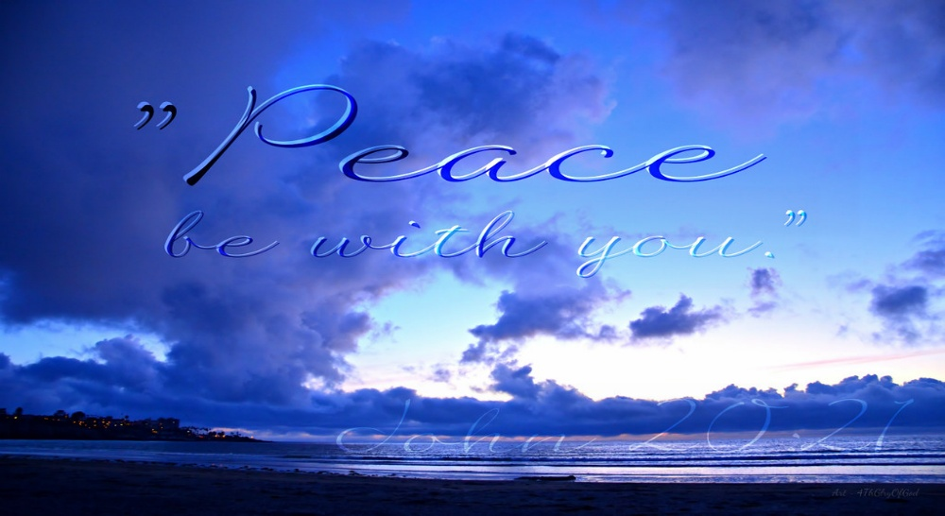Resources adapted for and used in this service are available on request.

Covenant United Church
230 Eighth Ave
Timmins, ON
(705) 264-5518
covenanttimmins@ntl.sympatico.ca

