Covenant
The United Church of Canada
a safe place for all people to worship
Minister: Rev. Laura Hutchison

COVENANT UNITED CHURCH
Sunday, Aug 16th, 2026
12th After Pentecost
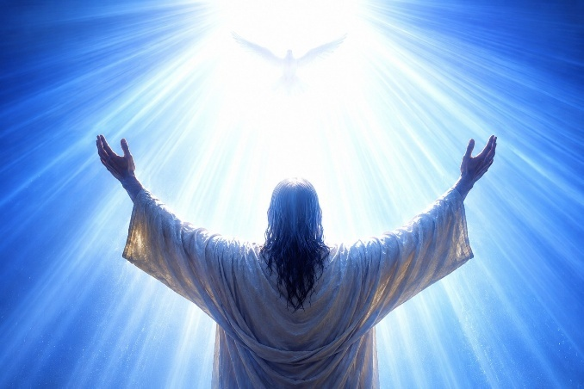

(Ring the chime once)

GATHERING HYMN – Voices United #395 Come In, Come In and Sit Down
https://www.youtube.com/watch?v=LkdDy14aKTI

WELCOME & ANNOUNCEMENTS
Welcome to Covenant United Church! We gather here in all of our diversity to pray and praise, to sing and share stories, and grow in community so that we may be effective in the ministries where we are called and sent in the name of Jesus, our guide and our friend.


There are no Sunday worship services on Aug. 23rd and Aug. 30th 2026. Services will resume in September.

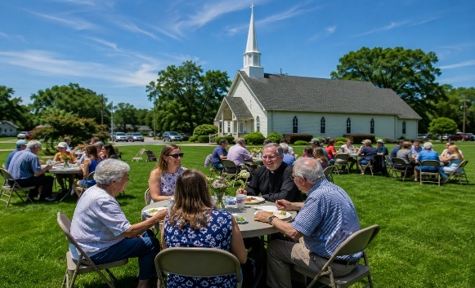

LUNCH ON THE LAWN – will be held in the foyer, on Thursday, August 20th at 12 noon. Bring a friend, and something to share for lunch. Lemonade and water will be provided.


The office is closed for the remainder of August.
(ring the chime)

LIGHT THE CHRIST CANDLE

We light this Christ candle as a symbol of Christ’s presence
here with us today.
and with us always,
wherever we go.

A BODY PRAYER

CALL TO WORSHIP - with refrain
More Voices #62 There is room for all
https://www.youtube.com/watch?v=7NTrdvDPUjI (instrumental version)

There is room for all in the shadow of God’s wing;
There is room for all, sheltered in God’s love,
And I rejoice and sing,
“My refuge and my rock, in whom I trust.”
There is room for all,
There is room for all!

Chacun a sa place
À l'abri sous l'aile de Dieu ;
Chacun a sa place
En l'amour de Dieu.
De joie, je chanterai :
« Mon refuge en lequel je me confie. »
Chacun a sa place,
chacun a sa place.

God calls us to worship
and welcomes us with abundant grace.
There is room for all in the shadow of God’s wing;
There is room for all, sheltered in God’s love,
And I rejoice and sing,
“My refuge and my rock, in whom I trust.”
There is room for all,
There is room for all!

God calls us into community
and welcomes us with forgiveness and joy.
Chacun a sa place
À l'abri sous l'aile de Dieu ;
Chacun a sa place
En l'amour de Dieu.
De joie, je chanterai :
« Mon refuge en lequel je me confie. »
Chacun a sa place,
chacun a sa place.

God calls us to love and to serve,
with heart, soul, mind, and strength!
There is room for all in the shadow of God’s wing;
There is room for all, sheltered in God’s love,
And I rejoice and sing,
“My refuge and my rock, in whom I trust.”
There is room for all,
There is room for all!

In this time and place, as people of the one Creator, we gather to worship, to pause in the swirls or silence of our lives, and to know ourselves as beloved and part of the company of saints. We come because God calls us, and God says:
Welcome one another!

PRAYER OF APPROACH

WORD FOR ALL AGES – EQUIP and PREPARE

ALL SING: More Voices #18 Lord, Prepare Me
https://www.youtube.com/watch?v=48WpmdUUZxY

PRAYER OF CONFESSION

WORDS OF ASSURANCE

God is with us
We are not alone
Thanks be to God!

CENTERING

PRAYER FOR ILLUMINATION– in unison

Living God, in hopeful prayer, we ask that you open our spirits, our minds, and our hearts as we listen with all of our senses for your life-giving message in scripture today. Amen.



MINUTE FOR MISSION – Faithful Futures 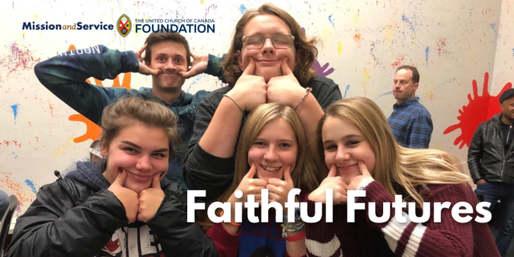
Across Southern Ontario, The Hub Community Network is creating welcoming spaces where youth and young adults can find connection, community, and a deeper understanding of God's inclusive love. Supported by Mission and Service, The Hub is helping young people discover spaces where they can explore faith, build relationships, and find their place in the church.
Every generation faces its own challenges, and many young people today are carrying significant pressures. Rising costs, uncertainty about the future, and increased feelings of isolation can make it difficult to find a sense of stability and belonging. For many youth and young adults, finding a community where they feel welcomed, known, and accepted can make a meaningful difference.
The Hub responds to this need by creating opportunities for young people to gather and connect. Through churches, camps, small groups, worship services, and online spaces, The Hub brings youth and young adults together in environments where they can ask questions, share experiences, and grow in faith alongside others.
These gatherings are more than events on a calendar. A shared meal, a conversation with a mentor, or time spent with peers can become an important moment of connection. These relationships help young people feel supported as they navigate life’s challenges and continue discovering who they are and who they are becoming.
The Hub also works alongside congregations, helping churches strengthen their youth ministries and develop lasting relationships with young people. By supporting communities in creating spaces of welcome and inclusion, The Hub helps congregations move beyond the initial invitation to attend and grow toward building meaningful connections where young people know they belong.
Our Mission and Service gifts help make this ministry possible. Through this support, The Hub Community Network can continue creating spaces where youth and young adults experience community, explore faith, and encounter the inclusive love of God.
Our gifts through Mission and Service support ministries that walk alongside young people and create places of belonging. Let's give generously so youth and young adults can continue being welcomed into spaces of connection and community.

SCRIPTURE READINGS

ALL SING: Voices United p.856, Psalm 133 Behold How Pleasant
https://www.youtube.com/watch?v=rR75xAV8X_M

Matthew 15:10-20 – Good News Translation
RESPONSE: Let us respond together, saying:
May God bless to our learning and understanding
These words from the scriptures.

Matthew 15:21-28 – A Woman's Faith
RESPONSE:
Thanks be to God for the word!
Let all who have ears to hear
Rejoice in what they have heard.

HYMN – More Voices #145 Draw the Circle Wide
https://www.youtube.com/watch?v=lAE2rTOFtJc

REFLECTION



HYMN – Voices United #575 I’m Gonna Live So God Can Use Me https://www.youtube.com/watch?v=Hrtdl1Fyejw

I’m gonna live so God can use me anywhere, Lord, any time,
I’m gonna live so God can use me anywhere, Lord, any time!
(twice)
2. Work 3. Pray 4. Sing 5. Live

OFFERING INVITATION

DOXOLOGY – More Voices #185 Every Day is a Day of Thanksgiving https://www.youtube.com/watch?v=DrOaM8HCiqQ
Ev’ry day is a day of thanksgiving.
God you’ve been so good to me.
Ev’ry day you’re blessing me.
Ev’ry day is a day of thanksgiving.
I will glorify you, O my Lord, today!

You keep blessing me, blessing me, blessing me.
You opened the door that I might see, you’re blessing me.

And you keep blessing me, blessing me,
blessing me. I will glorify you, O my Lord, today!

PRAYERS OF THANKSGIVING AND DEDICATION

Creating God, our skills feel like a loaf and a fish
The needs feel overwhelming.
In the same way you fed 5000 people
From a small basket of food
We ask that you magnify and multiply our gifts
To reach the world with your love.

PRAYERS OF THE PEOPLE

HYMN – the People’s Choice

COMMISSIONING AND BLESSING

EXTINGUISH THE CHRIST CANDLE



SENDING SONG – More Voices #214 May God’s Sheltering Wings https://www.youtube.com/watch?v=Ql2cbcNeP0M

May God’s sheltering wings,
her* gathering wings protect you.
May God’s nurturing arms,
her cradling arms sustain you,
and hold you in her love,
and hold you in her love.

*her, his, their…God is beyond any definition we might choose, so use the pronouns of your choice

Resources used in this service: are available on request

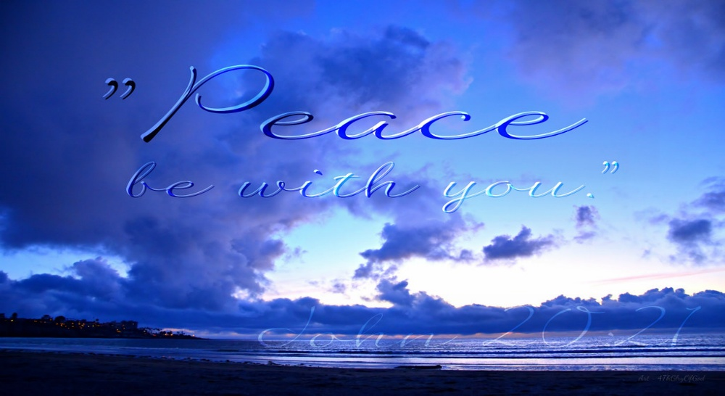

Covenant United Church
230 Eighth Ave
Timmins, ON
(705) 264-5518
covenanttimmins@ntl.sympatico.ca

