Covenant
The United Church of Canada
a safe place for all people to worship
Minister: Rev. Laura Hutchison

COVENANT UNITED CHURCH
Sunday, July 26th, 2026
9th After Pentecost
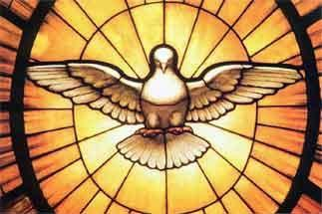

(ring the chime once)

WELCOME & ANNOUNCEMENTS
Welcome to Covenant United Church. We are a community of faith that has grown from three founding communities – First United Church, Trinity United Church and South Porcupine United Church, and before that, from Byrnes Presbyterian Church.
From diverse beginnings, we welcome all who enter this space, and all who are reached by our lives and God’s message when we go out from this sanctuary.


LUNCH ON THE LAWN- Laura will be away on July 30th 2026.


Office hours are Wednesdays from 9:30am – 4:00pm. Except for the 29th of July, the office will be closed as Crystal is away that week.



LIGHTING THE CHRIST CANDLE

The light of Christ
inspires our prayers.
The light of Christ
brings joy to our singing.
The light of Christ
finds purpose in God’s word.
The light of Christ
illumines the needs of the world.
So we will
(all sing)
let it shine, let it shine, let it shine!

(ring the chime)

WORD FOR ALL AGES- based on Genesis 29:15–28

HYMN – More Voices #14 Where Two or Three are Gathered in My Name
https://www.youtube.com/watch?v=ZxADfVDVlc0

Where two or three are gathered in my name,
I am there, I am there.

CALL TO WORSHIP
This is the day that the Lord has made.
Let us rejoice and be glad.

After six days of work, God rested.
Therefore, today shall remain holy.

You are invited to take part in the Sabbath.
We come into the sanctuary seeking refuge.

God offers this sacred space for all people.
Let us join together as the body of Christ.

And let us be refreshed and rejuvenated
by the Holy Spirit as we worship together.

PRAYER OF APPROACH – for Romans 8:26–39

Great and wonderful God,
through the movement of the Spirit,
you experience the cries of our hearts,
even when we don’t have words or ways
to express what we are feeling.

You feel the vibrations
of the shouts of our celebration.
You note our tears of sadness,
even when we don’t have words
or ways to express what we are feeling.

Bless our cries, our shouts, our tears.
Bless our words and our actions.
Bless them with your love, through the gift of the Spirit. Amen.

WORDS OF ASSURANCE

For the word of God in scripture,
for the word of God among us,
for the word of God within us,
thanks be to God.

CENTERING

PRAYER FOR ILLUMINATION

Living God, in hopeful prayer, we ask that you open our spirits, our minds, and our hearts as we listen with all of our senses for your life-giving message in scripture today. Amen.

MINUTE FOR MISSION – Pursuing Peace
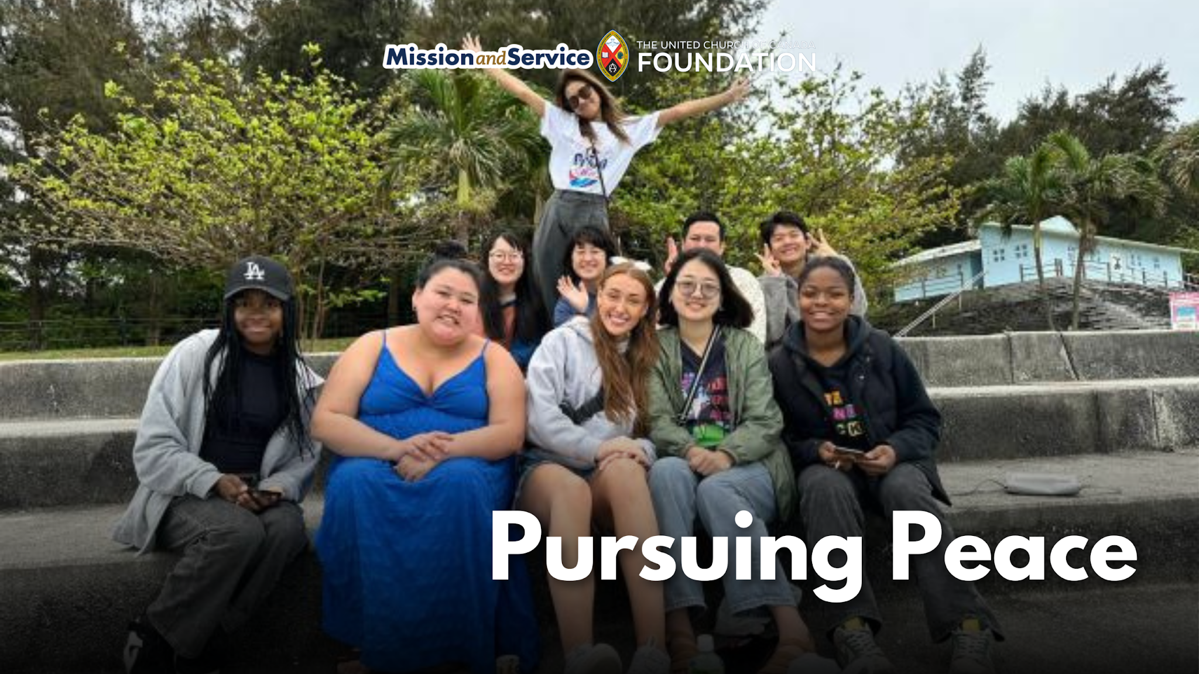

The following was written by Ashley Keeping, one of two United Church young adults selected to attend the 2024 Minority Youth Forum in Miyakojima, Japan, hosted by the Center for Minority Issues and Mission. The Youth Forum is an ecumenical initiative of churches in Japan, supported by The United Church of Canada and Mission and Service. Our generosity through Mission and Service helps programs that inspire peace and learning.

Just like Miyako residents, I live on an island and can relate to their everyday lives on their island, as it was small and humble just like here in Newfoundland. There was one prominent difference. The majority of the residents are seeking peace from their own government, something we don’t have to worry about here in Canada. God called upon me to see how the people of Miyako Island are living, and to share with everyone their struggle for peace.

The Minority Youth Forum program brought together young adults from Canada, Japan, and Taiwan. The Youth Forum experience showed me how powerful it is to bring youth together to share our culture, to share our faith, and to share our stories. To be able to have discussions with youth from other cultures about how we can change the world gives me so much hope for our future.

This trip filled my heart with joy, hope, and love for the wonderful people that I can now forever call friends. It also taught me that you need to find, keep, and treasure peace, as well as pursue it for the rest of your time, and that I will do. Thank you, Miyako, for everything you taught me.

Read Ashley’s full blog: Pursuing Peace from the Atlantic to the Pacific.
The views contained within these blogs are personal and do not necessarily reflect those of The United Church of Canada or The United Church of Canada Foundation.

SCRIPTURE READINGS
Romans 8:26-39 – Good News Translation

RESPONSE: (to be led by the person reading the passage)
Let us respond together, saying:
May God bless to our learning and understanding
These words from the scriptures.

GOSPEL READING
Matthew 13:31-33 – The Message
Matthew 13:44-52

RESPONSE:
Thanks be to God for the word!
Let us respond together saying:
Let all who have ears to hear,
Rejoice in all we have heard!

HYMN – Voices United #382 Breathe on Me, Breath of God
https://www.youtube.com/watch?v=82pTUUhLYu4

Breathe on me, breath of God,
Fill me with life anew,
That I may love what thou dost love,
And do what thou wouldst do.

Breathe on me, breath of God,
Until my heart is pure,
Until my will is one with thine,
To do and to endure.

Breathe on me, breath of God,
Till I am wholly thine,
Until this earthly part of me
Glows with the fire divine.

Breathe on me, breath of God;
So shall I never die,
But live with thee the perfect life
Of thine eternity.”

REFLECTION



HYMN – More Voices #144 Like a Healing Stream
https://www.youtube.com/watch?v=gmehfPn4aso

Like a healing stream in a barren desert,
Spirit water bringing life to dusty earth,
God is trickling through our lives as in a dream unfolding,
Promising revival and rebirth…
Like a healing stream.

Like a gentle rain on a thirsty garden,
Spirit water come to nourish tiny seed,
God is bubbling through the soil to coax a new creation,
Yearning for an end to want and need…
Like a gentle rain.

Like a river strong with a restless current,
Spirit water rushing on to distant shore,
God is carving out a channel in a new direction,
Calling for an end to hate and war…
Like a river strong.

Like a mighty sea reaching far horizons,
Spirit water with a love both deep and wide,
God is working in our hearts to shape a new tomorrow;
God will always challenge and provide!
Like a mighty sea,
Like a river strong,
Like a gentle rain,
Like a healing stream.

OFFERING INVITATION – in unison

With joy and gratitude we present and dedicate our offerings of time, talent and treasure to God’s work here, and through all of creation.

DOXOLOGY – Voices United #361 Small Things Count
https://www.youtube.com/watch?v=eHlaKHS6Qcw

Small things count, so Jesus said:
Cups of water, crumbs of bread,
Small things done because we’re kind
Count as big things in God’s mind.

Small things make the big things grow:
Grains of yeast inside the dough,
Puffs that fill a big balloon,
Notes that made a happy tune.

Every hair that’s on our head,
Every sparrow, Jesus said,
God takes care of, counts and knows,
God loves us from top to toes!

PRAYERS OF THANKSGIVING AND DEDICATION

Holy Giver,
you have given all that you are, to bring us life
and to bring us into relationship with you and with one another.
We give you now of ourselves and our gifts
to be used to spread your words of truth, life, and love.
We are grateful for you, for one another, for our families and friends,
and for this world you love so much. Amen!

PRAYERS OF THE PEOPLE– Our prayers of the people were written for today, based on the epistle we read: Romans 8:26–39. The scriptures are one of the ways the Holy Spirit provides us with guidance for our prayers.
… we recall how many times and in how many places, people have gathered and shared with one voice the prayer that Jesus taught his followers,

Our Father, who art in heaven,
Hallowed be thy name.
Thy kingdom come, Thy will be done,
On earth as it is in heaven.
Give us this day our daily bread,
and forgive us our trespasses,
as we forgive them that trespass against us;
and lead us not into temptation,
but deliver us from evil.
For thine is the kingdom, the power and the glory,
forever and ever. Amen.

HYMN – Voices United #713 I See a New Heaven
https://www.youtube.com/watch?v=r1LqrWzs4As

I see a new heaven, I see a new earth
as the old one will pass away,
Where the fountain of life flows
and without price goes
to all people who abide in the land.
There, there on the banks of a river bright and free,
Yielding her fruit, firm in her root,
The Tree of Life will be.

I see a new heaven, I see a new earth
as the old one will pass away,
Where the fountain of life flows
and without price goes
to all people who abide in the land.
There, there where death dies and our lives are born again,
Body and soul, struggling but whole
Life flowers after the rain.

I see a new heaven, I see a new earth
as the old one will pass away,
Where the fountain of life flows
and without price goes
to all people who abide in the land.
There, there where the darkness brings visions from above.
There where the night, bearing new light,
Reveals the promise of love.

I see a new heaven, I see a new earth
as the old one will pass away,
Where the fountain of life flows
and without price goes
to all people who abide in the land.
There, there where we work with the love of healing hands.
Labour we must, true to our trust
To build a promised new land.

I see a new heaven, I see a new earth
as the old one will pass away,
Where the fountain of life flows
and without price goes
to all people who abide in the land.

COMMISSIONING AND BLESSING

EXTINGUISH THE CHRIST CANDLE

SENDING SONG - More Voices #212 Sent Out in Jesus Name
https://www.youtube.com/watch?v=TmyROZEZgrg

Sent out in Jesus’ name, our hands are ready now
To make the world the place in which the kingdom comes.
Repeat

The angels cannot change a world of hurt and pain
Into a world of love, of justice and of peace.
The task is ours to do, to set it really free.
O, help us to obey, and carry out your will.
Repeat

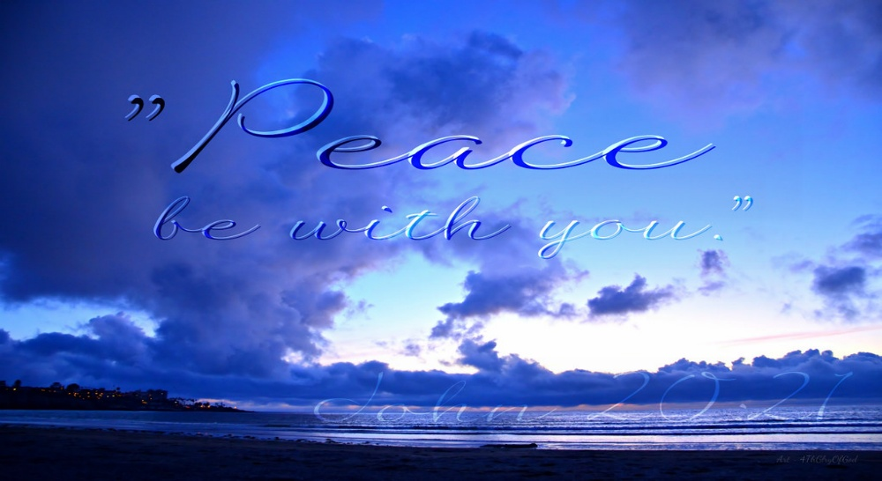

Resources adapted for and used in this service are available on request.
Covenant United Church
230 Eighth Ave
Timmins, ON
(705) 264-5518
covenanttimmins@ntl.sympatico.ca

