Covenant
The United Church of Canada
a safe place for all people to worship
Minister: Rev. Laura Hutchison

COVENANT UNITED CHURCH
Sunday, July 19th, 2026
8th After Pentecost with the Sacrament of Communion
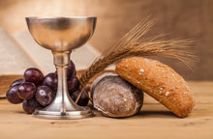
(ring the chime once)

WELCOME & ANNOUNCEMENTS
Welcome to Covenant United Church! We gather here in all of our diversity to pray and praise, to sing and share stories, and grow in community so that we may be effective in the ministries where we are called and sent in the name of Jesus, our guide and our friend.

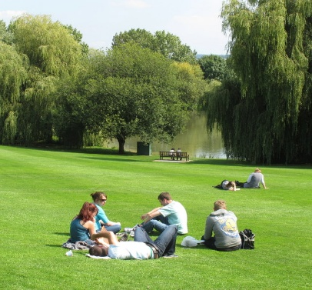

Lunch on the Lawn with Laura – Thursday, July 23 at 12 noon
Bring something to share for lunch, lemonade and water will be provided. You may want to bring a lawn chair. If weather permits, we will sit by the garden, if the weather is not cooperative, we will eat in the foyer of the church.
All are welcome.


Office hours are Wednesdays from 9:30am – 4:00pm. Except for the 29th of July, the office will be closed as Crystal is away that week.

LIGHTING THE CHRIST CANDLE

The light of Christ
inspires our prayers.
The light of Christ
brings joy to our singing.
The light of Christ
finds purpose in God’s word.
The light of Christ
illumines the needs of the world.
So we will
(all sing)
let it shine, let it shine, let it shine!

(ring the chime)

WORD FOR ALL AGES- PRESENCE

HYMN – More Voices #14 Where Two or Three are Gathered in My Name
https://www.youtube.com/watch?v=ZxADfVDVlc0

Where two or three are gathered in my name,
I am there, I am there.

CALL TO WORSHIP– for Matthew 13:24–30, 36–43
and PRAYER OF APPROACH

People of noble heart, virtuous, caring, and thoughtful,
who do what’s right without thinking,
such people are blessings from God,
to whom we give thanks.

People of broken spirit, deeply flawed,
selfish or foolish, who cause pain without thinking,
these too can be blessings from God,
unknowing agents of grace,
vehicles for the Spirit’s work.

We ourselves are a mixture,
both flawed and virtuous,
turned to God sometimes,
sometimes turned away,
sometimes descending in sin,
sometimes aspiring to holiness.

And so we pray:
O God, bless us and shape us.
Use us for the making of your reign in this your beloved world.
Bless us as we gather.
Bless us as we worship.
In Christ and through Christ. Amen.

CENTERING

PRAYER FOR ILLUMINATION

Living God, in hopeful prayer, we ask that you open our spirits, our minds, and our hearts as we listen with all of our senses for your life-giving message in scripture today. Amen.

MINUTE FOR MISSION – SHARED WONDER
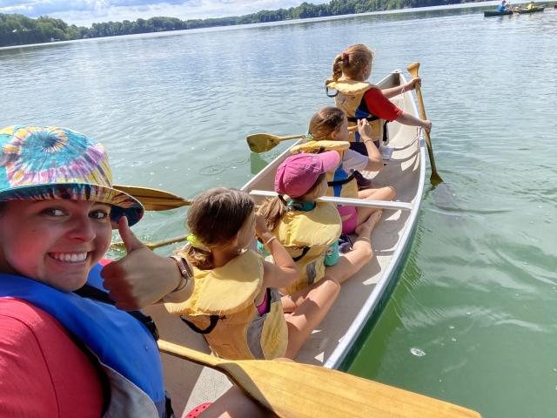
Nestled along the Niagara Escarpment, Cave Springs Camp offers children and youth something that can be hard to find in today's world: space to slow down, explore, and to connect with creation, one another, and God.

A child crouching down beside a forest trail suddenly shouts, “I found a salamander!”

Within moments, a group gathers around, curious and excited. For a few minutes, nothing else matters. Not phones, schedules, or other distractions that fill our days. Just a small creature, a shared discovery, and a sense of wonder.
Moments like these happen every day at United Church camps.
Surrounded by towering trees and winding trails, campers spend their days discovering the natural world, sharing meals, singing around campfires, and building friendships. Amidst all the activity, something deeper takes root: camp becomes a place of belonging.

For some children, it may be the first time they feel fully accepted for who they are. For others, it may be the first time they experience the quiet beauty of creation or feel comfortable asking questions about faith. Away from the pressures and distractions of everyday life, campers can be fully present. They get to be themselves in a supportive community, with God's presence all around them.

The lessons learned at camp often stay with them long after summer ends. A love of creation. A sense of confidence. New friendships. A growing faith. These gifts are carried home, and woven into the lives of young people as they continue to grow.
Through Mission and Service, we help make these experiences possible. Together, we support United Church camps that nurture faith, foster community, and invite young people to encounter God's love in meaningful ways.

Let’s give generously to continue helping create spaces where children and youth can discover wonder, belonging, and the joy of being part of God's creation.

SCRIPTURE READINGS

Genesis 28:10-19 – Good News Translation
RESPONSE: (to be led by the person reading the passage)
Let us respond together, saying:
May God bless to our learning and understanding
These words from the scriptures.

GOSPEL READING
Matthew 13:24-30 – Good News Translation
RESPONSE:
Let us respond together saying:
Let all who have ears to hear,
Rejoice in all we have heard!

HYMN – Voices United #307 Touch the Earth Lightly
https://www.youtube.com/watch?v=CLmJb4v2fq8

Touch the earth lightly,
use the earth gently,
nourish the life of the world in our care:
gift of great wonder,
ours to surrender,
trust for the children tomorrow will bear.

We who endanger,
who create hunger,
agents of death for all creatures that live,
we who would foster
clouds of disaster—
God of our planet, forestall and forgive!
Let there be greening,
birth from the burning,
water that blesses and air that is sweet,
health in God’s garden,
hope in God’s children,
regeneration that peace will complete.

God of all living,
God of all loving,
God of the seedling, the snow and the sun,
teach us, deflect us,
Christ reconnect us,
using us gently, and making us one.

REFLECTION



HYMN – Voices United #606 In Christ There is No East of West
https://www.youtube.com/watch?v=oGU4uwlhIB4

In Christ there is no east or west,
in him no south or north,
But one great family of love
throughout the whole wide earth.

In him shall true hearts everywhere
their high communion find;
His service is the golden cord
close binding humankind.

Join hands, then, people of the faith,
whate’er your race may be;
All children of the living God
are surely kin to me.

In Christ now meet both east and west,
in him meet south and north;
All Christ-like souls are one in him
throughout the whole wide earth.

OFFERING INVITATION – in unison

With joy and gratitude we present and dedicate our offerings of time, talent and treasure to God’s work here, and through all of creation.

DOXOLOGY – Voices United #361 Small Things Count
https://www.youtube.com/watch?v=eHlaKHS6Qcw

Small things count, so Jesus said:
Cups of water, crumbs of bread,
Small things done because we’re kind
Count as big things in God’s mind.

Small things make the big things grow:
Grains of yeast inside the dough,
Puffs that fill a big balloon,
Notes that made a happy tune.

Every hair that’s on our head,
Every sparrow, Jesus said,
God takes care of, counts and knows,
God loves us from top to toes!

PRAYERS OF THANKSGIVING AND DEDICATION

Holy Giver,
you have given all that you are, to bring us life
and to bring us into relationship with you and with one another.
We give you now of ourselves and our gifts
to be used to spread your words of truth, life, and love.
We are grateful for you, for one another, for our families and friends,
and for this world you love so much. Amen!

PRAYERS OF THANKSGIVING AND DEDICATION

Holy Giver,
you have given all that you are, to bring us life
and to bring us into relationship with you and with one another.

We give you now of ourselves and our gifts
to be used to spread your words of truth, life, and love.
We are grateful for you, for one another, for our families and friends, and for this world you love so much. Amen!

COMMUNION LITURGY

May the Listening God be with you.
May God also be with you.
Let us open our hearts to the One who hears us.
We offer them to our God.
Shout for joy, people of God, and sing glad praises.
We join in praising the One who is always with us.
Into the emptiness of chaos, you flung the seeds of creation.
All this beauty and goodness you fashioned in your image,
but we sought instead weapons and power to dominate rather than to be stewards of Creation. Prophets came to call us back home, yet we persisted in believing that our old, comfortable, ways were the best ways.

You sent Jesus to plant resurrection in our lives.
With all the Created World in its majesty and wonder
we sing our joy to you:
Holy, holy, holy are you, God who hears us.
All creation remembers your gifts.
Hosanna in the highest!
Blessed is the One who scatters your seeds.

Walking ancient roads, Christ leads us into your kingdom;
as we sleep, he gives us fresh visions from you.
When we awaken, take us by the hand to show us your wonder; Visions of accepting everyone as sisters and brothers, teach us the power of resurrection.

On the night before he died it was Jesus who took a loaf of bread, (lift bread)
gave you thanks, broke it, and said, “Take and eat; whenever you do this, remember me.” (break the bread)
Likewise, after supper, he took the cup, (lift the cup)
saying, “This is the new covenant; remember me.” (pour the cup)
As we remember his life, ministry, and death, as we celebrate the gifts of his table, we speak of the mystery we call faith:

Christ died, so the old creation could begin to pass;
Christ was raised, the new creation growing in our midst;
Christ will come, so everyone will be made new.

PRAYERS OF THE PEOPLE

Let us pray in the words of the prayer Jesus taught his disciples:
Our Father, who art in heaven,
hallowed be thy name.
Thy kingdom come, Thy will be done,
on earth as it is in heaven.
Give us this day our daily bread,
and forgive us our trespasses,
as we forgive those who trespass against us;
and lead us not into temptation,
but deliver us from evil.
For thine is the kingdom, the power and the glory,
forever and ever. Amen.

Pour out your Spirit upon the gifts of the bread and the cup.
The bread, that has been broken (lift up the broken bread),
becomes the seeds of hope planted in despair,
of joy planted in grief, of kindness planted in cruelty.

The cup which is poured out (lift up the cup)
becomes the grace which nurtures those
who welcome the forgotten,
those who become justice so all might find welcome and home.
Gather us home, Lord, from our far-flung places,
so we can join every sister and brother around your Table of Grace.
Amen.
Come. For all things are now ready.
If you need help with the elements, just raise your hand and someone will come to assist you. There is no hurry, so please take as much time as you like
PRAYER AFTER COMMUNION

Let us pray: thank you, Resurrected One, for this feast of life.
We are fed by your love; we are strengthened by your life.
We are sent forth into this world to live your way and share your joy.
We are now commissioned to feed as we have been fed,
forgive as we have been forgiven, love as we have been loved.
Thanks be to God. Amen.

HYMN – More Voices #27 Creator God, You Gave Us Life
https://www.youtube.com/watch?v=Z9ZOmMQeYmU

Creator God you gave us life,
your image formed within our soul,
yet through the mist of time and space,
we search for that which makes us whole.

Refrain: Through hands that paint majestic skies,
and voices chanting melody,
with words that reach beyond the page,
we comprehend your mystery.

In ev’ry flow’r and ev’ry tree,
we see your great diversity,
yet greater still we see your love,
expressed in our humanity. Refrain

When with our hearts, our hands our minds,
we share our gifts with all the world,
our spirits soar beyond the veil,
to touch the very face of God. Refrain

Refrain: Through hands that paint majestic skies,
and voices chanting melody,
with words that reach beyond the page,
we comprehend your mystery.

COMMISSIONING AND BLESSING

EXTINGUISH THE CHRIST CANDLE

SENDING SONG - More Voices #212 Sent Out in Jesus Name
https://www.youtube.com/watch?v=TmyROZEZgrg

Sent out in Jesus’ name, our hands are ready now
To make the world the place in which the kingdom comes.
Repeat

The angels cannot change a world of hurt and pain
Into a world of love, of justice and of peace.
The task is ours to do, to set it really free.
O, help us to obey, and carry out your will.
Repeat



Resources:
Call to Worship/Prayer of Approach, Rod Sykes, Calgary, Alta.
Commissioning and Blessings: Cindy Randall
Offering: Susan Girard, Riverview U.C., Atikokan, Ont.
Sacrament of Communion setting by Thom M. Shuman, lectionaryliturgies.blogspot.com © 2018.
Covenant United Church
230 Eighth Ave
Timmins, ON
(705) 264-5518
covenanttimmins@ntl.sympatico.ca

