Covenant
The United Church of Canada
a safe place for all people to worship
Minister: Rev. Laura Hutchison

COVENANT UNITED CHURCH
Sunday, July 12th, 2026
7th After Pentecost
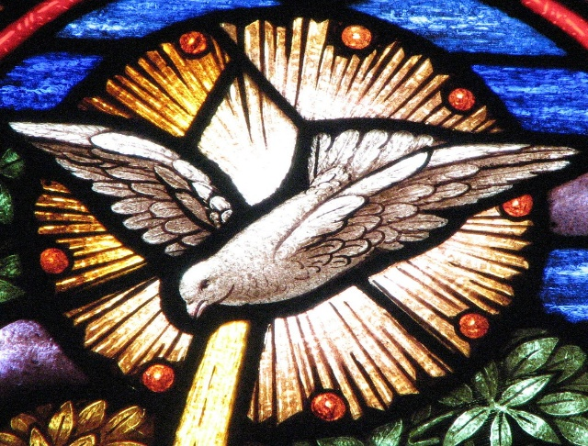

(ring the chime once)

WELCOME & ANNOUNCEMENTS
Welcome to Covenant United Church! We gather here in all of our diversity to pray and praise, to sing and share stories, and grow in community so that we may be effective in the ministries where we are called and sent in the name of Jesus, our guide and our friend.

Fundraising Continues for the replacement tree at Gillies Lake - Total amount fundraised to date is $150.50



Lunch on the Lawn with Laura – Thursday, July 16 at 12 noon
Bring something to share for lunch, lemonade and water will be provided. You may want to bring a lawn chair. If weather permits, we will sit by the garden, if the weather is not cooperative, we will eat in the foyer of the church.
All are welcome.



Finances – Heather Laverdiere & Susan Boisvert
January 1, 2026 to June 30, 2026
- General Fund: Revenue $ 52,383.16
Expenses $ 57,055.98
From Investment $ 0
- Building Funds: Revenue $ 5,085.00
Expenses $ 3,848.85
- M&S: Revenue $ 3,135

Account balances are now: General Fund: $ 23,109 Building Fund $ 10,087 Outreach $ 77
Investments $120726.21 (as of March 31, 2026)


Office hours are Wednesdays from 9:30am – 4:00pm. Except for the 29th of July, the office will be closed as Crystal is away that week.

LIGHTING THE CHRIST CANDLE

We light this candle as a visible reminder that we are committed to working toward creative change in the world.
We turn to the Christ light as we worship with a spirit of love.

(ring the chime)

WORD FOR ALL AGES

HYMN – More Voices #14 Where Two or Three are Gathered in My Name
https://www.youtube.com/watch?v=ZxADfVDVlc0

Where two or three are gathered in my name,
I am there, I am there.

CALL TO WORSHIP

You called out to Mary and Joseph in Bethlehem,
and they heard you.

You called out to 12 disciples in Galilee,
and they served you.

You called out to Paul in Damascus,
and he spoke about you.

You called out to St. Francis in Rome,
and he loved you.

You called out to Martin Luther King Jr. in Atlanta,
and he followed you.
Your voice has called to us throughout the ages.

Your voice is heard all over the earth.
Be with us as we listen today.

Thanks be to God who calls us closer.
Let us worship in response to that call.

PRAYER OF APPROACH

Come, O Holy Spirit,
break into our world, we need you.

Come, O Holy Spirit,
dance your way into the corners of our lives
where we are overwhelmed and angered
by the tragedy, injustice, and horrors unfolding in this world.

Where we are grieving, questioning, wondering, and waiting.
Caress us with your comfort.
Mend our broken spirits.
Tickle us with your joy.
Inspire us with God’s vision.
Come, O Holy Spirit.
We need you. The world needs you. Amen.
PRAYER OF CONFESSION

We turn from spreading ourselves too thinly,
hoping that you, O God, will spread your grace.

We turn from cultivating affluence,
hoping that you, O Spirit, will cultivate your passion in us.

We turn from our work, honouring a needed time for rest,
hoping that you, O Christ, will live in us each day.

Grow in us and through us to bless this world you love.
Amen.

WORDS OF ASSURANCE

The Good News of Jesus Christ is this:
Jesus came to show us God’s way,
and God’s is a way of forgiveness and renewal. Amen.

CENTERING

MINUTE FOR MISSION
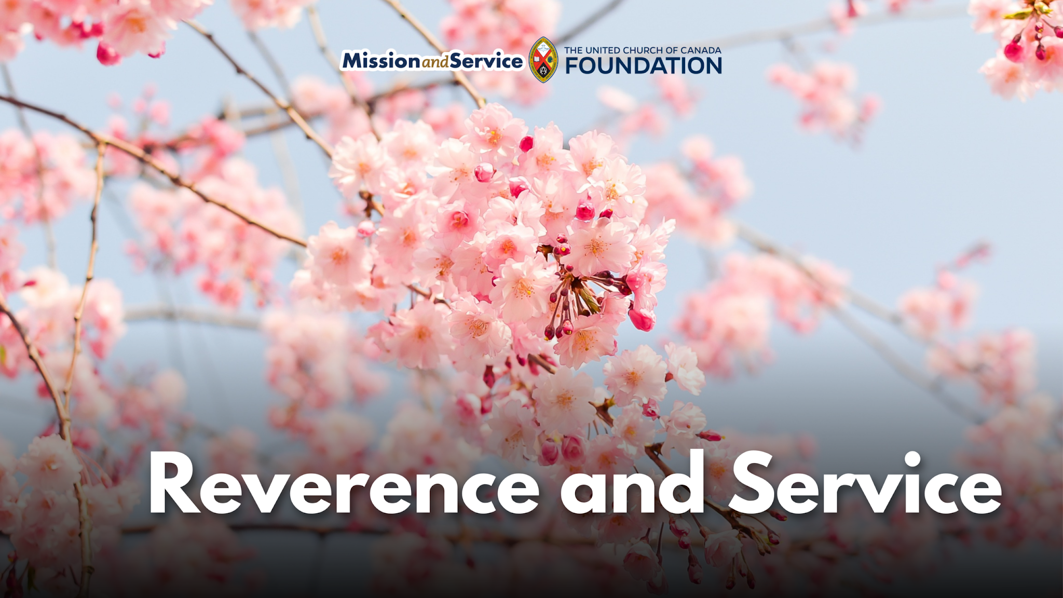

We would like to share a blog written by Rev. Won Hur, who works as the Global Partnership Program Coordinator for Asia in the General Council’s Church in Mission Unit:
One of the biggest challenges in my thirty years as a congregational minister was not knowing whether I was making any difference at all. Unlike bricklayers, butchers, or teachers, there were no concrete indicators to measure the impact of my ministry. This also holds true when we give, practice generosity, and support Mission and Service. We often want to know what difference it makes.

In reality, our offerings do make a difference in ways we cannot even imagine, and often in very concrete ways.

There are many partners of The United Church of Canada who do incredible work in Canada and around the world. One of them is Toyo Eiwa Jogakuin, a private Christian girls’ school in Tokyo, Japan. The school was founded in 1884 by Ms. Martha Cartmell (1845–1945), the first woman missionary of the Canadian Methodist Church, a predecessor of The United Church of Canada.

At a time when girls were often denied education, she started a school for them, beginning with just two students. Today, the school has grown to an enrollment of over 4,200, with students from kindergarten through high school and into graduate school. It has retained its core Christian identity—the school day begins with worship, and students take classes on Christianity while living into the school’s motto, “Reverence and Service.” Over its history, more than 140 members of the United Church have answered the call to serve this school.

One of the more famous graduates of Toyo Eiwa is Hanako Muraoka, who graduated in 1913. During her time at the school, she enjoyed the library and read many books in English; she became a writer and translator. Later in life a Canadian friend, Loretta Leonard Shaw, gave her a copy of Anne of Green Gables, by Lucy Maud Montgomery. Hanako fell in love with the book and its main character, Anne, and went on to translate it into Japanese. The translation became a bestseller and has since become a cultural phenomenon—Japanese tourists regularly visit Prince Edward Island to see the Anne of Green Gables Museum, as Toyo Eiwa students each year do.

Another notable graduate is Rev. Shoko Aminaka, General Secretary of the United Church of Christ in Japan (UCCJ), who attended the school from grade one through grade 12. Having grown up in this environment and been immersed in Christian faith, she began to think deeply about life and she found freedom in entrusting herself to God. After being baptized in grade nine, she discerned her call, was ordained, and eventually rose to the highest office in the UCCJ. Currently, four ordained women clergy in the United Church of Christ in Japan are graduates of Toyo Eiwa.
It is often difficult to see or fully understand the impacts of our faith at work in the world. Like fruit trees in an orchard, they take time to grow, blossom, and bear fruit for all to enjoy. Such is the work of ministry and service—it is often hidden from our eyes, yet it is growing and flourishing.

Among Toyo Eiwa students and alumni, there is immense gratitude toward Ms. Martha Cartmell and The United Church of Canada. They raised funds to plant about 100 cherry blossom trees in Centennial Park in Dundas, near Hamilton, Ontario, and in Lakeview Cemetery in Thorold, Ontario—Ms. Cartmell’s hometown. In 2014, for the school’s 130th anniversary, they visited Dundas to celebrate the tree-planting ceremony.

Thanks to your contributions to Mission and Service, The United Church of Canada continues to support partners around the world in ways that are not always visible. Yet those partners—and God—appreciate our generosity and our shared commitment to a more just and peaceful world.

PRAYER FOR ILLUMINATION

Living God, in hopeful prayer, we ask that you open our spirits, our minds, and our hearts as we listen with all of our senses for your life-giving message in scripture today. Amen.

SCRIPTURE READINGS

Psalm 119:105–112 (VU p. 841)
Refrain: Your Word is a lamp for my feet,
and a light for my path.

Your Word is a lamp for my feet, and a light for my path.
I have sworn an oath and confirmed it
to keep your righteous judgements.
I am in deep distress,
give me life, O God, according to your Word.
Accept, O God, the willing tribute of my lips,
and teach me your decrees. R.

I take my life into my hands continually,
yet I never forget your Way.
The wicked have laid a snare for me.
but I have not strayed from your precepts.
Your testimonies are my heritage forever,
the very joy of my heart.
I have set my heart to fulfill your statutes,
forever, even to the end. R.

Genesis 25:19-34 – Good News Translation
Romans 8:1-11 – Good News Translation

RESPONSE: (to be led by the person reading the Epistle)
Let us respond together, saying:
May God bless to our learning and understanding
These words from the scriptures.

Matthew 13:1-9; 18-23 – The Voice

RESPONSE:
Let us respond together saying:
Let all who have ears to hear,
Rejoice in all we have heard!

HYMN – More Voices #156 Dance with the Spirit
https://www.youtube.com/watch?v=fz8q-UNkZ54

Dance with the Spirit early in the mornin’,
walk with the Spirit throughout the long day.
Work and hope for the new life a-bornin’,
listen to the Spirit to show you the way.

Clap with the Spirit early in the mornin’,
Sing with the Spirit throughout the long day.
Work and hope for the new life a-bornin’,
listen to the Spirit to show you the way.

Jump with the Spirit early in the mornin’,
Move with the Spirit throughout the long day.
Work and hope for the new life a-bornin’,
listen to the Spirit to show you the way.

Dance with the Spirit early in the mornin’,
walk with the Spirit throughout the long day.
Work and hope for the new life a-bornin’,
listen to the Spirit to show you the way.

REFLECTION



HYMN – Voices United #381 Spirit of Life (twice)
https://www.youtube.com/watch?v=TLiER-UMX4s

Spirit of Life, come unto me.
Sing in my heart all the stirrings of compassion.
Blow in the wind, rise in the sea;
move in the hand, giving life the shape of justice.
Roots hold me close; wings set me free;
Spirit of Life, come to me, come to me.

OFFERING INVITATION – in unison

With joy and gratitude we present and dedicate our offerings of time, talent and treasure to God’s work here, and through all of creation.

DOXOLOGY – Voices United #361 Small Things Count
https://www.youtube.com/watch?v=eHlaKHS6Qcw

Small things count, so Jesus said:
Cups of water, crumbs of bread,
Small things done because we’re kind
Count as big things in God’s mind.

Small things make the big things grow:
Grains of yeast inside the dough,
Puffs that fill a big balloon,
Notes that made a happy tune.

Every hair that’s on our head,
Every sparrow, Jesus said,
God takes care of, counts and knows,
God loves us from top to toes!

PRAYERS OF THANKSGIVING AND DEDICATION

Holy Giver,
you have given all that you are, to bring us life
and to bring us into relationship with you and with one another.
We give you now of ourselves and our gifts
to be used to spread your words of truth, life, and love.
We are grateful for you, for one another, for our families and friends,
and for this world you love so much. Amen!

PRAYERS OF THE PEOPLE

God of all good blessings, we approach you this morning with hearts filled with gratitude. We humbly bring our concerns and joys to you as we gather here for praise and worship.
Receive our prayers, and in your love, answer. Be with us in all our mornings and guide our thoughts in all our days…

HYMN – More Voices #174 Soil of God, You and I
https://www.youtube.com/watch?v=xCjMlbt_vHk

“Soil of God, you and I, stand ready to bear
Seeds of faith nourished by God’s tender care.
Growing in everyone for here God is found.
All stand together, we are…
Holy ground.

Soil of God, you and I, now ready to be
Part of God’s promise, for others to see.
Open to everyone for here God is found.
All stand together, we are…
Holy ground.

Soil of God, you and I, now called to rebirth,
Joining as partners with all of the earth.
Living in harmony for here God is found.
All stand together, this is…
Holy ground.

EXTINGUISH THE CHRIST CANDLE

COMMISSIONING AND BLESSING

SENDING SONG - More Voices #212 Sent Out in Jesus Name
https://www.youtube.com/watch?v=TmyROZEZgrg

Sent out in Jesus’ name, our hands are ready now
To make the world the place in which the kingdom comes.
Repeat

The angels cannot change a world of hurt and pain
Into a world of love, of justice and of peace.
The task is ours to do, to set it really free.
O, help us to obey, and carry out your will.
Repeat

Resources used in this service are available on request.


Covenant United Church
230 Eighth Ave
Timmins, ON
(705) 264-5518
covenanttimmins@ntl.sympatico.ca

