Covenant
The United Church of Canada
a safe place for all people to worship
Minister: Rev. Laura Hutchison

COVENANT UNITED CHURCH
Sunday, June 28th, 2026
5th After Pentecost
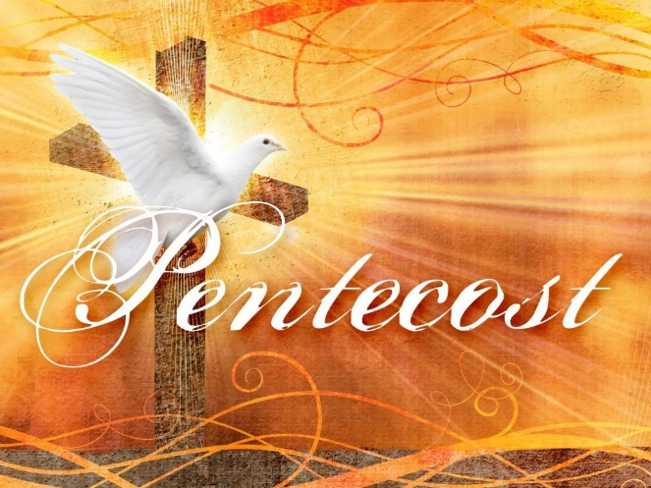
(ring the chime once)

WELCOME & ANNOUNCEMENTS
Welcome to Covenant United Church! We gather here in all of our diversity to pray and praise, to sing and share stories, and grow in community so that we may be effective in the ministries where we are called and sent in the name of Jesus, our guide and our friend.
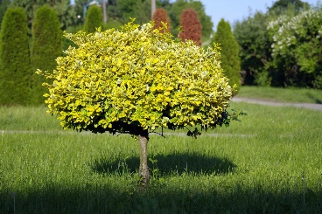
Fundraising Continues for the replacement tree at Gillies Lake - Total amount fundraised to date is $120.50


Broadview Subscriptions are due for renewal. If interested please pay ASAP. Last Call!


Office hours are Wednesdays from 9:30am – 4:00pm.

(ring the chime)

LIGHTING THE CHRIST CANDLE
(begin by lighting the candle)
The candle is lit,
and we honour our diversity:
young and old,
downhearted and joyful,
queer and straight,
a rainbow of genders,
each of us differently abled,
strong in faith and searching for a faith.
The candle is lit for us all,
and in the light of Christ,
our service begins.

WORD FOR ALL AGES

CHILDREN’S HYMN – VU #577 I’ve Got Peace Like a River
https://www.youtube.com/watch?v=L2dROBiW1Mk

- I've got peace like a river,
I've got peace like a river,
I've got peace like a river in-a my soul,
repeat

- I've got joy like a fountain,
I've got joy like a fountain,
I've got joy like a fountain in-a my soul,
repeat

- I've got love like an ocean,
I've got love like an ocean,
I've got love like an ocean in-a my soul,
repeat

- I’ve got peace like a river
I’ve got joy like a fountain
I’ve got love like an ocean in my soul,
repeat

CALL TO WORSHIP
Jesus calls us from the busyness of our everyday lives.
Jesus calls us to new life in him.

We gather together, each carrying different burdens,
We come bearing unique gifts.

Siblings in Christ, through Jesus, we are children of God.
Let’s gather to worship and rejoice in our unity!

PRAYER OF APPROACH (in unison)

We are amazed, Jesus,
that you call people like us
to do work like yours!
Forgive our arrogance
when we ignore you or refuse to ask for help.
May this time of worship and this community of faith
equip us to live our discipleship.
Grant us the wisdom and courage
to be your neighbour in the world. Amen.

WORDS OF ASSURANCE

PRAYER OF CONFESSION– for Romans 6:12–23

THE LORD’S PRAYER – a Paraphrase VU p.916
Eternal Spirit,
Earth-maker, Pain Bearer, Life-Giver,
Source of all that is and that shall be.
Father and Mother of us all,
Loving God, in whom is heaven:
The hallowing of your name echo through the universe!
The way of your justice be followed by the peoples of the world!
Your heavenly will be done by all created beings!
Your commonwealth of peace and freedom sustain our hope and come on earth.
With the bread we need for today, feed us.
In the hurts we absorb from one another, forgive us.
In times of temptation and test, strengthen us.
From trials too great to endure, spare us.
From the grip of all that is evil, free us.
For your reign in the glory of the power that is love, now and forever. Amen.

CENTERING

MINUTE FOR MISSION – Caring for Caregivers
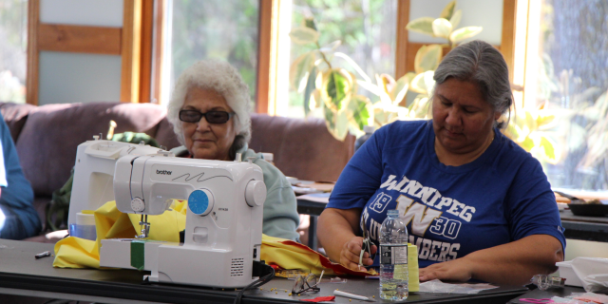

Across Northern communities, Indigenous ministers are carrying extraordinary burdens. They walk alongside families through heartbreaking loss and hold space for grief that often has no easy words. It is sacred work. But it is also exhausting work. And too often, it is carried alone.

“When I started in the United Church, we buried a lot of elderly people,” says Rev. Grant Queskekapow. “But now we bury a lot of youth who die as a result of suicide.”

Rev. Queskekapow was a participant in the first Northern Indigenous Ministers Retreat, held in 2024 at Sandy-Saulteaux Spiritual Centre in Manitoba. For many, including Rev. Queskekapow, it was the first time they had gathered in this way with fellow ministers.
With support from our gifts (opens in a new tab) to Mission and Service, the Northern Indigenous Ministers Retreat is entering its third year. The retreat offers a much-needed opportunity to pause, to grieve, and to find healing. Ministers receive trauma-informed support and opportunities for rest, and have spoken about how important it is to experience a space where they do not need to carry everything on their own.

The retreat includes sharing circles, a sweat lodge, and opportunities for rest and relaxation. Participants also spend time making star blankets, moccasins, ribbon skirts, and beadwork together. These activities create space for conversation, reflection, and connection, while also supporting cultural and spiritual healing.

The need continues to grow. Wildfires and ongoing crises in Northern communities have only deepened the strain many ministers are carrying. Plans are now underway for the 2026 Northern Indigenous Ministers Retreat, where even more ministers will be welcomed into a circle of healing and renewal.
"Bear one another’s burdens, and in this way you will fulfill the law of Christ.” —Galatians 6:2
Through Mission and Service, our gifts help cover travel costs, support facilitators, and create space for ministers to receive care themselves. Let’s give generously.

SCRIPTURES
Romans 6:12-23 – Good News Translation
Matthew 10:40-42 – The Voice Translation

HYMN – MV #79 Spirit Open My Heart
https://www.youtube.com/watch?v=TUy4kas8WR8

Refrain: Spirit, open my heart to the joy and pain of living.
As you love may I love, in receiving and in giving,
Spirit, open my heart.heart

- God, replace my stony heart
with a heart that’s kind and tender.
All my coldness and fear
to your grace I now surrender. R

- Write your love upon my heart
as my law, my goal, my story.
In each thought, word, and deed,
may my living bring you glory. R

- May I weep with those who weep,
share the joy of sister, brother.
In the welcome of Christ,
may we welcome one another. R

REFLECTION



HYMN – VU #672 Take Time to be Holy
https://www.youtube.com/watch?v=1i7wFOg24wU

Take time to be holy, speak oft with your Lord;
Abide in him always, and feed on his word.
Make friends of God’s children, help those who are weak,
Forgetting in nothing his blessing to seek.

Take time to be holy, let him be your guide,
And run not before him, whatever betide.
In joy or in sorrow, still follow the Lord,
And, looking to Jesus, still trust in his word.

Take time to be holy, be calm in your soul,
Each thought and each motive beneath his control.
Thus led by his spirit to fountains of love,
You soon shall be fitted for service above.
OFFERING
With joy and gratitude we present and dedicate our offerings of time, talent and treasure to God’s work here, and through all of creation.

DOXOLOGY – Voices United #540 Grant Us, God, the Grace
https://www.youtube.com/watch?v=dM2dUqmLPek

Grant Us, God, the grace of giving,
With a spirit large and free,
That ourselves and all our living
We may offer faithfully.

PRAYERS OF THANKSGIVING AND DEDICATION
Creator God, you loved us into being, blessing us with gifts of diversity and abundance.
Draw us together as a community, in gratitude and grace.

Christ Jesus, you came among us, infusing the ordinary with holiness.
Open our hearts to your extravagant love.

Spirit Song, you dance with and through us, inspiring possibility and hope.
Enliven our faith and embolden our justice.

Blessed Trinity, we bring our gifts to be infused with your blessing.
May they inspire possibility and hope. Amen.

PRAYERS OF THE PEOPLE – please feel free during moments of silence in the prayer to pray aloud, or in silence; these are the prayers of all the people, and all voices are welcome

HYMN – MV #4 All Who Are Thirsty https://www.youtube.com/watch?v=xaR-yhsrGr8

All who are thirsty
All who are weakall who are thirst
Come to the fountain
Dip your heart in the streams of life
Let the pain and the sorrow
Be washed away
In the waves of his mercy
As deep cries out to deep, we sing

Come Lord Jesus, come
Come Lord Jesus, come
Come Lord Jesus, come
Come Lord Jesus, come

All who are thirsty
All who are weakall who are thirst
Come to the fountain
Dip your heart in the streams of life
Let the pain and the sorrow
Be washed away
In the waves of his mercy
As deep cries out to deep, we sing

Holy Spirit, come
Holy Spirit, come
Holy Spirit, come
Holy Spirit, come

COMMISSIONING AND BLESSING

Go from here, assured that God is at work in the world and in your life. Trust that God is watching over you, with a love too deep for words, too broad for comprehension, enduring and sustaining, and that nothing in all Creation can separate you from the love of God in Christ Jesus. Amen.

EXTINGUISH THE CHRIST CANDLE

SENDING SONG – More Voices #218 May the Love of the Lord (twice)
https://www.youtube.com/watch?v=NWi8rt3P6A0

May the love of the Lord rest upon your soul.
May God's love dwell in you, throughout every day.
May God's countenance shine upon you
and be gracious to you.
May God's Spirit be upon you
as you leave this place.

References used in this service:
Commissioning: Gill Le Fevre, Walton Memorial U.C., Oakville, Ont.
Prayer of Approach: Wetaskiwin Writers, Grace Lutheran Church and First U.C., Wetaskiwin, Alta.
Call to Worship: Donnie Morrison, The United Protestant Church of Sydney River, Sydney River, N.S.
Adapted for this use by LH
Assurance: Eric Hebert-Daly, Executive Minister, Eastern Ontario Outaouais Regional Council
Confession: Wanda Winfield, Tupperville P.C., Tupperville, Ont.


Covenant United Church
230 Eighth Ave
Timmins, ON
(705) 264-5518
covenanttimmins@ntl.sympatico.ca

