Covenant
The United Church of Canada
a safe place for all people to worship
Minister: Rev. Laura Hutchison

COVENANT UNITED CHURCH
Sunday, June 21st, 2026
National Indigenous Day of Prayer
Father’s Day
3rd Sunday in Pride Month



(ring the chime once)

WELCOME & ANNOUNCEMENTS
Welcome to Covenant United Church! We gather here in all of our diversity to pray and praise, to sing and share stories, and grow in community so that we may be effective in the ministries where we are called and sent in the name of Jesus, our guide and our friend.

Fundraising Continues for the replacement tree at Gillies Lake - Total amount fundraised to date is $120.50


Broadview Subscriptions are due for renewal. If interested please pay $ by June 21st.


June 21 is recognized as National Indigenous Peoples Day. It is also the summer solstice, the longest day of the year. For generations this day has carried significance for Indigenous Peoples.

In 1971, the 24th General Council of the United Church of Canada named June 21st as the “National Indian Day of Prayer”. In 2017, Prime Minister Justin Trudeau took steps to rename this day “National Indigenous People’s Day”. As part of this special day, communities of faith are invited to focus on prayer, as was originally intended in 1971.
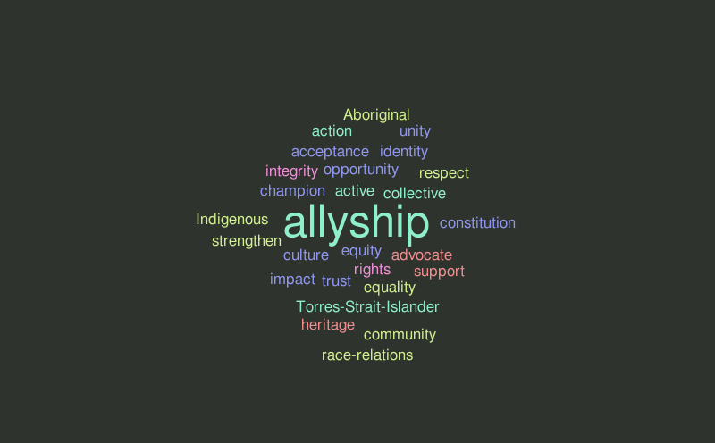Allyship 101

As a Settler, how do I Begin Reconciliation
with Indigenous Peoples and Communities?
Tuesday, June 23, 2026
7:30 p.m. to 8:30 p.m.
Join a Zoom conversation hosted by the Canadian Shield and Shining Waters Regional Council’s Living into Right Relations Teams. This one-hour conversation will introduce settler-Canadians on how to begin right relationships with Indigenous Peoples.

Office hours are Wednesdays from 9:30am – 4:00pm.

(ring the chime)

LIGHTING THE CHRIST CANDLE
(begin by lighting the candle)
The candle is lit,
and we honour our diversity:
young and old,
downhearted and joyful,
queer and straight,
a rainbow of genders,
each of us differently abled,
strong in faith and searching for a faith.
The candle is lit for us all,
and in the light of Christ,
our service begins.

WORD FOR ALL AGES – Taking Responsibility – Story “You be the Pilot” by the Rev. Bruce Kakakaway

CHILDREN’S SONG.
Jesus said, “I’m with you.
You’re never alone.
You’re never alone.”
Jesus said, “I’m with you.
You’re never alone, my friend.”

CALL TO WORSHIP
based on A New Creed, The United Church of Canada, 1968

We are called to be the Church,
not only on Sunday mornings as we gather, not only when it suits us, but always and in every place.

We are called to celebrate God’s presence,
through song, through prayer, through action and care for one another, within these four walls and beyond.

We are called to live with respect in creation.
Though the voice of creation comes to us in many languages and forms, we are called to be attentive, to collaborate, and to follow.

We are called to love and serve others,
and we do this, not because of our own rules and laws, but because it is God who asks us to do it, by Christ’s example.

We are called to seek justice and resist evil.
We do so every time we intentionally take time to notice injustice, because evil does not always take the shape we expect. Yet love and service are always in season.

We are called to proclaim Jesus, crucified and risen, our judge and our hope.
Our hope rests in the knowledge that pain, suffering, and even death are only parts of a bigger journey. We trust that Christ will heal our brokenness and that as those who follow Christ, it is possible to celebrate our freedom from bondage.

We are called to be the church.
God is with us. We are not alone.
Let us worship.

PRAYER OF APPROACH
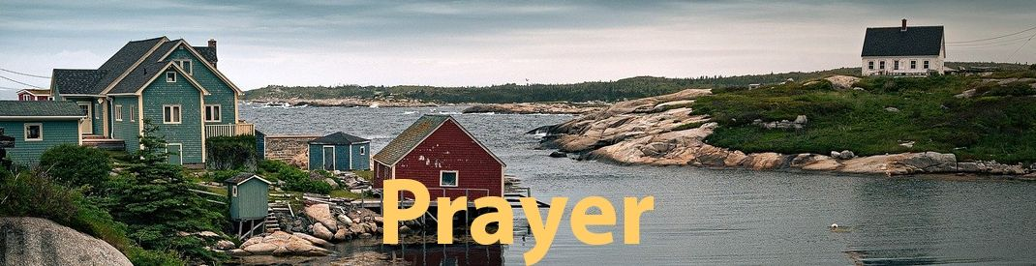
Again and again, God, we come to this time and place with a song!

Each day you give us a chance to begin anew: to drink deeply of your Spirit, to boldly follow in the Way of Jesus, and to dare to seek justice as we seek relationship with our neighbours and you.

Again and again, God, you call us out of our old lives and into your new day.
And so, as we celebrate the 101st anniversary of The United Church of Canada, help us to reflect back with clarity upon all that deserves to be celebrated, all that deserves to be lamented, and all that deserves to be let go.
The church is not perfect, God,
but we are yours,
and we trust that you are with us every day.
This day, and always,
help us to be good grain
that is planted and tended by your love,
so that in the year to come,
the United Church may flourish
in this time and place. Amen.
adapted from The United Church of Canada Centennial Service 2024

PRAYER OF CONFESSION
inspired by Psalm 139 and by Teresa of Avila
You may follow my actions during the prayer

Accepting my shortcomings,
realizing I am not perfect,
I make this confession:

I confess that I am child of God.
I confess that I was made in God’s image.
I confess that I have been given holy orders.

Here in this time and in this place, I am God’s hands.
Hands that hug and hold.
These hands are God’s hands.
(Look at your own hands.)
Hands that plant and harvest.
These are God’s hands.
My hands are God’s hands.
Look at your own hands.
Hands that help and hands that heal.
Our hands are God's hands.
The work of a thousand, often unseen, hands helps me every day.
And I say, ”Thank you, God!”

Here on this beautiful planet, my feet are God’s feet.
These feet journey beside those who are lonely.
These feet move to where they are needed.
They take me to beautiful places.
I confess that from the top of my head to the tip of my toes,
I am fearfully and wonderfully made.
And I say, ”Thank you, God!”
And all the people said,
Amen.

CENTERING

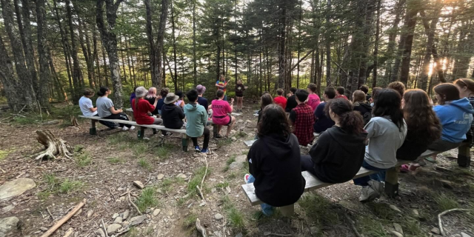
MINUTE FOR MISSION – Campfires and Confidence

For 60 years, Arthur Kidston Memorial Camp has been a place where children and youth can unplug from screens, connect with nature, and discover new strengths in themselves. In 2026, the camp is celebrating six decades of outdoor adventure, friendship, and belonging on the shores of Long Lake in Nova Scotia.

At Camp Kidston, children and youth spend their days canoeing and kayaking, trying slack lines and bog-walking, exploring the outdoors, making crafts, and building confidence through games and leadership opportunities. Campers are encouraged to try new things, build friendships, and simply enjoy being kids.
Our gifts through Mission and Service help make these experiences possible by providing specialized recreational equipment and supplies that go beyond the basics. New life vests for paddling programs, updated sports equipment, and nature exploration kits help make camp safer, more engaging, and more accessible for every child.

These gifts are about more than equipment. They help children build confidence as they learn new skills and discover what they are capable of. They help ensure that every camper, regardless of background, can fully participate in the fun, learning, and adventure that camp offers. And they help create memories that young people carry with them long after summer ends.

Even during the challenges of the summer of 2025, including extreme heat and a region-wide fire ban, Camp Kidston was filled with joy and creativity. Campers enjoyed waterfront adventures, theme days, team-building activities, and imaginative campfire alternatives created by staff. Leadership programs for teens continued to grow, and families spoke about the sense of belonging their children experienced at camp.

As Camp Kidston celebrates its 60th anniversary, our gifts through Mission and Service are helping ensure that children and youth can continue to experience the wonder, friendship, and confidence-building that camp makes possible for years to come.

HYMN – More Voices #138 My Love Colours Outside the Lines https://www.youtube.com/watch?v=adDuYifMoa8

- My love colours outside the lines,
Exploring paths that few could ever find;
And takes me into places where I’ve never been before,
And opens doors to worlds outside the lines.

- My Lord colours outside the lines,
Turns wounds to blessings, water into wine;
And takes me into places where I’ve never been before
And opens doors to worlds outside the lines.

Bridge: We’ll never walk on water
if we’re not prepared to drown,
Body and soul need a soaking from time to time.
And we’ll never move the gravestones
if we’re not prepared to die,
And realize there’s a world outside the lines.

- My soul longs to colour outside the lines,
Tear back the curtains, sun, come in and shine;
I want to walk beyond the boundaries
where I’ve never been before,
Throw open doors to worlds outside the lines.

Bridge: We’ll never walk on water
if we’re not prepared to drown,
Body and soul need a soaking from time to time.
And we’ll never move the gravestones
if we’re not prepared to die,
And realize there’s a world outside the lines.

- My soul longs to colour outside the lines,
Tear back the curtains, sun, come in and shine;
I want to walk beyond the boundaries
where I’ve never been before,
Throw open doors to worlds outside the lines.

SCRIPTURE READINGS
Genesis 21:8-21 – Good News Translation

Psalm 86:1-10; 16-17 Voices United p.803
Refrain: In the day of my trouble I shall call unto you for you will answer me.

Turn your ear to me, O God, and answer me,
For I am poor and in misery.
Preserve my life for I am faithful,
Save your servant for I trust in you.

Be merciful to me, my lord,
For I call to you all day long.
Gladden the heart of your servant,
For to you I lift up my soul.

For you, my lord, are good and forgiving,
And great in mercy to all who call on you.
Give heed, O God, to my prayer,
And listen to my cry of supplication. R.

Among the Gods there is none like you, my lord,
Nor can the deeds of any be compared to yours.
All the nations you have made
Shall come and bow before you.

They shall glorify your name, my lord,
For you are great and do marvelous things,
You alone are God. R.

Turn to me then, and have mercy;
Give your strength to your servant.
Save your handmaiden’s child;
Give me a sign of your favour!

Then those who hate me will see and be ashamed,
For you, God, have helped and comforted me. R.

Matthew 10:24-39 – The Voice

HYMN – Voices United #402 We are One (verses 1,2) https://www.youtube.com/watch?v=n4PU7hTaDSU (instrumental)

- We are one as we come, as we come, joyful to be here,
in the praise on our lips there’s a sense that God is near.
We are one as we sing, as we seek, we are found;
and we come needful of God’s grace
as we meet, together in this place.

- We are one as we share; as we share brokenness and fear,
in the touch of a hand there’s a sense that God is here.
We are one as we care, as we heal, we are healed;
and we share warmth in God’s embrace
as we pray together in this place.

REFLECTION



A SILENT MOMENT (to reflect on what we have heard)

OFFERING
With joy and gratitude we present and dedicate our offerings of time, talent and treasure to God’s work here, and through all of creation.

DOXOLOGY – Voices United #540 Grant Us, God, the Grace
https://www.youtube.com/watch?v=dM2dUqmLPek

Grant Us, God, the grace of giving,
With a spirit large and free,
That ourselves and all our living
We may offer faithfully.

PRAYERS OF THANKSGIVING AND DEDICATION
Creator God, you loved us into being, blessing us with gifts of diversity and abundance.
Draw us together as a community, in gratitude and grace.

Christ Jesus, you came among us, infusing the ordinary with holiness.
Open our hearts to your extravagant love.

Spirit Song, you dance with and through us, inspiring possibility and hope.
Enliven our faith and embolden our justice.

Blessed Trinity, we bring our gifts to be infused with your blessing.
May they inspire possibility and hope. Amen.

PRAYERS OF THE PEOPLE

HYMN – More Voices #62 There is Room for all (Twice)
https://www.youtube.com/watch?v=uyjmb6ZGRLs

There is room for all in the shadow of God’s wing;
There is room for all, sheltered in God’s love,
And I rejoice and sing, “My refuge and my rock, in whom I trust.”
There is room for all,
There is room for all!

Chacun a sa place
á l'abri sous l'aile de Dieu;
Chacun a sa place en l'amour de Dieu.
De joie, je chanterai:
"Mon refuge en lequel je me confie”.
Chacun a sa place, chacun a sa place.

COMMISSIONING AND BLESSING

EXTINGUISH THE CHRIST CANDLE

SENDING SONG – More Voices #218 May the Love of the Lord (twice)
https://www.youtube.com/watch?v=NWi8rt3P6A0

May the love of the Lord rest upon your soul.
May God's love dwell in you, throughout every day.
May God's countenance shine upon you
and be gracious to you.
May God's Spirit be upon you
as you leave this place.



Resources used in this service available upon request.
Covenant United Church
230 Eighth Ave
Timmins, ON
(705) 264-5518
covenanttimmins@ntl.sympatico.ca

