Covenant
The United Church of Canada
a safe place for all people to worship
Minister: Rev. Laura Hutchison

COVENANT UNITED CHURCH
Sunday, June 14th, 2026
Annual Wrap-Up & Communion
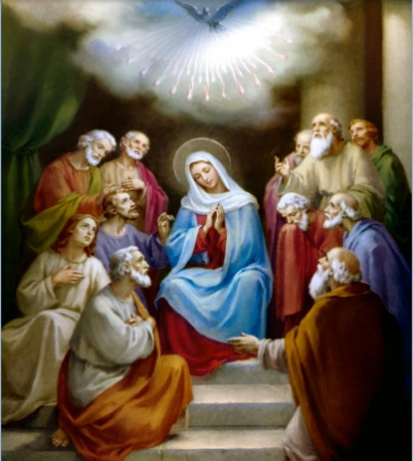

(ring the chime once)

WELCOME & ANNOUNCEMENTS
Welcome to Covenant United Church! We gather here in all of our diversity to pray and praise, to sing and share stories, and grow in community so that we may be effective in the ministries where we are called and sent in the name of Jesus, our guide and our friend.


Coffee Volunteers: June 14th: Annual Windup lunch: hosted by Heather & Veronica (sponsored by Gary and Fran).


Fundraising Continues for the replacement tree at Gillies Lake - Total amount fundraised to date is $120.50

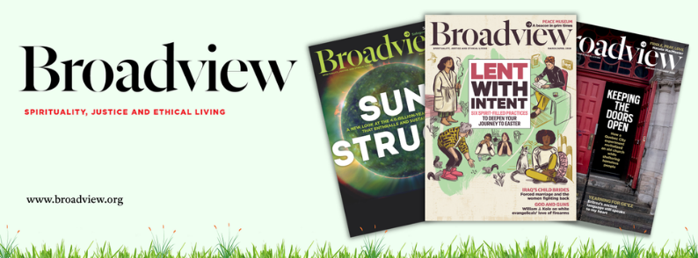
Broadview Subscriptions are due for renewal. If interested please pay $ before June 21st.


Office hours are Wednesdays from 9:30am – 4:00pm.
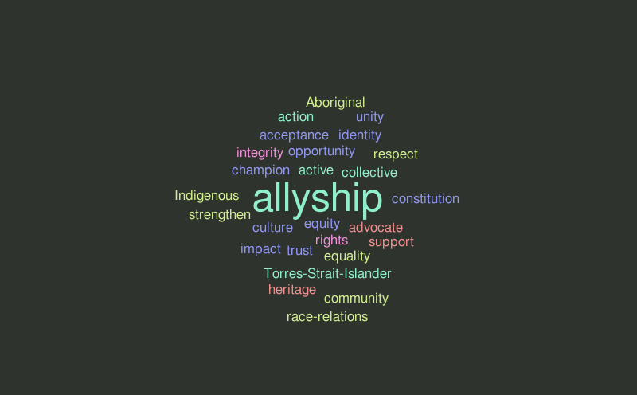Allyship 101

As a Settler, how do I Begin Reconciliation
with Indigenous Peoples and Communities?
Tuesday, June 23, 2026
7:30 p.m. to 8:30 p.m.
Join a Zoom conversation hosted by the Canadian Shield and Shining Waters Regional Council’s Living into Right Relations Teams. This one-hour conversation will introduce settler-Canadians on how to begin right relationships with Indigenous Peoples.
To register go to View this email in your browser


Finances – Heather Laverdiere & Susan Boisvert
January 1, 2026 to May 31, 2026
- General Fund: Revenue $ 43556.16
Expenses $ 48754.53
From Investment $ 0
- Building Funds: Revenue $ 4930.00
Expenses $ 3848.85
- M&S: Revenue $ 2615.00

Account balances are now: General Fund: $ 22651 Building Fund $ 9932 Outreach $ 62
Investments $120726.21 (as of March 31, 2026)

(ring the chime)

LIGHTING THE CHRIST CANDLE
(begin by lighting the candle)
The candle is lit,
and we honour our diversity:
young and old,
downhearted and joyful,
queer and straight,
a rainbow of genders,
each of us differently abled,
strong in faith and searching for a faith.
The candle is lit for us all,
and in the light of Christ,
our service begins.

CALL TO WORSHIP
God calls us to worship and welcomes us with abundant grace.

All Sing: More Voices #62 There is Room for All
https://www.youtube.com/watch?v=BfMDusRvPA0

There is room for all in the shadow of God’s wing;
there is room for all, sheltered in God’s love.
And I rejoice and sing,
“My refuge and my rock, in whom I trust.”
There is room for all, there is room for all!

God calls us into community and welcomes us with forgiveness and joy.

All Sing: More Voices #62 There is Room for All
https://www.youtube.com/watch?v=BfMDusRvPA0

There is room for all in the shadow of God’s wing;
there is room for all, sheltered in God’s love.
And I rejoice and sing,
“My refuge and my rock, in whom I trust.”
There is room for all, there is room for all!

God calls us to love and to serve, with heart, soul, mind, and strength!

All Sing: More Voices #62 There is Room for All
https://www.youtube.com/watch?v=BfMDusRvPA0

There is room for all in the shadow of God’s wing;
there is room for all, sheltered in God’s love.
And I rejoice and sing,
“My refuge and my rock, in whom I trust.”
There is room for all, there is room for all!

God says:
Welcome one another!

If you’re over 90, under nine, or in between, God says:
Welcome one another!

If you’re a regular, reluctant, just visiting, or not sure, God says:
Welcome one another!
If you’d rather be golfing, or camping, or sleeping in, God says:
Welcome one another!

In this time and place, as people of the one Creator, we gather to worship, to pause in the swirls or silence of our lives, and to know ourselves as beloved and part of the company of saints. We come because we are called and:
We welcome one another!

PRAYER OF APPROACH
O God, you call us
out of our busy lives,

away from our never-ending thoughts,
into a place of welcome, inclusion, and acceptance,

into a space made sacred by our prayers and your presence,
into a community that is humbly trying to follow the Way of Christ.

May our words bring healing and wholeness.
May our songs bring joy and transformation.

May our time together this morning lead us to new ways of thinking, doing, and being:
May we live into the vision of becoming a people who live with Deep Spirituality, Bold Discipleship, and Daring Justice.
We come to worship you, our God!
Alleluia! Amen.

CENTERING


MINUTE FOR MISSION
Making Joyful Noise – Throughout scripture, music is part of how people express joy, hope, grief, and praise. From the Psalms to songs of celebration and courage, music has long helped people connect with God, one another, and themselves.

At First-St. Andrew’s United Church in London, Ontario, two music programs, the “Treblemakers” and “Reverberations” programs, help children and youth discover that same gift today.
For many young people, music is more than something to listen to. It can build confidence, reduce stress, strengthen learning skills, and create a sense of belonging. But as the cost of living continues to rise, many families are finding it harder to afford opportunities like music lessons, instruments, or arts programs for their children.

First-St. Andrew’s music programs help to ensure young people do not miss out.
Open to children and youth aged 3 to 17, the weekly programs offer a welcoming space where participants can explore music, creativity, and community together for a low fee. Each gathering begins with a shared meal, providing nourishment before children move into activities like singing, handbells, chimes, and drama.

The impact goes far beyond learning notes or rhythms.
Programs like Treblemakers and Reverberations help young people develop confidence by trying new things and performing together. They encourage teamwork, creativity, and self-expression while offering a safe place and a reliable meal. Music also supports cognitive development, memory, focus, and emotional well-being—benefits that can shape a child’s growth.

For some families, programs like this may be among the few accessible extracurricular opportunities available to their children. By lowering financial barriers and creating an inclusive environment, First-St. Andrew’s aims to ensure every child has the chance to grow and shine.

In a world where many young people are carrying stress, isolation, or uncertainty, spaces of creativity and belonging matter deeply. Through music, meals, laughter, and shared experiences, children and youth are discovering not only new skills, but also confidence, friendship, and joy.

Through Mission and Service, we support communities and ministries that nurture young people in body, mind, and spirit. Together, we are helping create spaces where children and youth can discover their gifts, build confidence, and know they belong. Make your gift to Mission and Service today.

SCRIPTURE READINGS
Genesis 18:1-15 – The Message
Genesis 21:1-7 – The Message
Romans 5:1-5 – New Revised Standard Version Updated Edition
RESPONSE: May God bless to our learning and understanding these words from the scriptures.

HYMN – More Voices #79 Spirit, Open My Heart
https://www.youtube.com/watch?v=TUy4kas8WR8

Refrain: Spirit, open my heart
to the joy and pain of living.
As you love may I love,
in receiving and in giving,
Spirit, open my heart.

God, replace my stony heart
with a heart that’s kind and tender.
All my coldness and fear
to your grace I now surrender. Refrain

Write your love upon my heart
as my law, my goal, my story.
In each thought, word, and deed,
may my living bring you glory. Refrain

May I weep with those who weep.
share the joy of sister, brother.
In the welcome of Christ,
may we welcome one another. Refrain

REFLECTION



OFFERING

DOXOLOGY – Voices United #540 Grant Us, God, the Grace
https://www.youtube.com/watch?v=dM2dUqmLPek

Grant Us, God, the grace of giving,
With a spirit large and free,
That ourselves and all our living
We may offer faithfully.

PRAYERS OF THANKSGIVING AND DEDICATION
Creator God, you loved us into being, blessing us with gifts of diversity and abundance.
Draw us together as a community, in gratitude and grace.

Christ Jesus, you came among us, infusing the ordinary with holiness.
Open our hearts to your extravagant love.

Spirit Song, you dance with and through us, inspiring possibility and hope.
Enliven our faith and embolden our justice.

Blessed Trinity, we bring our gifts to be infused with your blessing.
May they inspire possibility and hope. Amen.

COMMUNION HYMN – Voices United #467 One Bread, One Body
https://www.youtube.com/watch?v=70FsA9VPUFs

Refrain: One bread, one body, one Lord of all,
One cup of blessing which we bless
And we, though many, throughout the earth,
We are one body in this one Lord

Gentile or Jew, servant or free,
Woman or man, no more. Refrain

Many the gifts, many the works,
One in the Lord, of all. Refrain

Grain for the fields, scattered and grown,
Gathered to one, for all. Refrain
COMMUNION LITURGY
May God be with you.
And also with you.
Lift up your hearts.
We lift them up to God.
Let us give thanks to the Lord our God.
It is right to give God thanks and praise.
We gather at this table today with questions and anxieties about how we will go forward in the midst of all that is happening in our world.
We wonder about what lies ahead for us.
We so want to trust your promises, O God, promises of new beginnings.
When we look at how you have dealt with your people, we are both grateful and humbled. You called Abraham and Sarah from their fear to generate a new nation. You blessed them so that they would be a blessing. You placed a rainbow in the sky providing assurance to Noah. Reshaping a life spent captive to a foreign nation, you guided Moses in leading the people of Israel to a promised land. You spoke through prophets who were seldom accepted or understood. When the time was right, you chose a poor peasant girl to bear your child, who, by speaking truth to power, brought about a new creation.
Jesus showed us that your prophets continue to be misunderstood, ignored, and maligned. But you continue to work through prophets of today, people who challenge injustice and share possibility.
You continue to bless people so that they may be a blessing in this world.
You continue to bless us that we may be your blessing in this world.
For there is no gender, sexual orientation, body type, race, colour, place of origin, or way of being in the world that is not worthy of your blessing.
Each one is blessed to be a blessing, blessed so that Jesus’ love may be shared through us.

PRAYERS OF THE PEOPLE (community prayers)

Now, following his example, we remember Jesus’ words on the night before he died. After giving thanks to God, Jesus broke the bread (the bread is broken) and said, “Take and eat. Be strengthened in my name as you share this bread.” Then Jesus poured the cup (the cup is poured) and said, “Take and drink. Be strengthened in my name as you share this cup.”
Remembering his life and all the lives before and after his, through which God’s promises of new beginnings were and are fulfilled, we offer to you, O God, these symbols of remembrance: the bread and the cup. Send your Holy Spirit upon them and us, so that we may come alive in Christ again to be co-creators of whatever new beginnings await us.
Through Christ, with Christ, and in Christ, in unity with the Holy Spirit, all honour and power are yours, God most holy. Amen.

The Lord’s Prayer –
Our Father, who art in heaven,
hallowed be thy Name,
thy kingdom come,
thy will be done,
on earth as it is in heaven.
Give us this day our daily bread.
And forgive us our trespasses,
as we forgive those
who trespass against us.
And lead us not into temptation,
but deliver us from evil.
For thine is the kingdom,
and the power, and the glory,
for ever and ever. Amen.

Elevation, and Distribution
(as the broken bread is lifted)
The gifts of God, freely given.
(as the poured cup is lifted)
The life of Christ shared openly and fully.
We receive these gifts
With gratitude and joy.

Take, and eat.
All things are now ready.

Post Communion Prayer (all)
Having been refreshed and renewed at your table,
O God, we commit ourselves anew
to the work of servant leadership,
welcoming and including all.
Having been refreshed and renewed at your table,
may we go from here remembering
that like Abraham and Sarah,
we are blessed to be the blessing. Amen.

HYMN – Voices United #468 Let Us Talents and Tongues Employ
https://www.youtube.com/watch?v=LCoJWEV6-Yw

Let us talents and tongues employ,
Reaching out with a shout of joy:
Bread is broken, the wine is poured,
Christ is spoken and seen and heard.
Jesus lives again, earth can breathe again,
pass the Word around: loaves abound!

Christ is able to make us one,
At the table he sets the tone,
Teaching people to live to bless,
Love in word and in deed express.
Jesus lives again, earth can breathe again,
pass the Word around: loaves abound!

Jesus calls us in, sends us out,
Bearing fruit in a world of doubt,
Gives us love to tell, bread to share:
God (Immanuel) everywhere!
Jesus lives again, earth can breathe again,
pass the Word around: loaves abound!

COMMISSIONING AND BLESSING – (adapted from “Liturgies from Below”)

EXTINGUISH THE CHRIST CANDLE

SENDING SONG – More Voices #218 May the Love of the Lord (twice)
https://www.youtube.com/watch?v=NWi8rt3P6A0

May the love of the Lord rest upon your soul.
May God's love dwell in you, throughout every day.
May God's countenance shine upon you
and be gracious to you.
May God's Spirit be upon you
as you leave this place.



Resources used in this service available upon request:
Call to Worship: Wetaskiwin Writers, Grace Lutheran Church and First U.C., Wetaskiwin, Alta.
Christ Candle: Author David Sparks
Prayer of Approach: Joy Cowan, Trinity U.C., Ingersoll, Ont.
Communion Liturgy: Catherine Tovell, Kilworth U.C., London, Ont.
Covenant United Church
230 Eighth Ave
Timmins, ON
(705) 264-5518
covenanttimmins@ntl.sympatico.ca

