Covenant
The United Church of Canada
a safe place for all people to worship
Minister: Rev. Laura Hutchison

COVENANT UNITED CHURCH
Sunday, May 24th, 2026
CELEBRATION OF THE
DAY OF PENTECOST
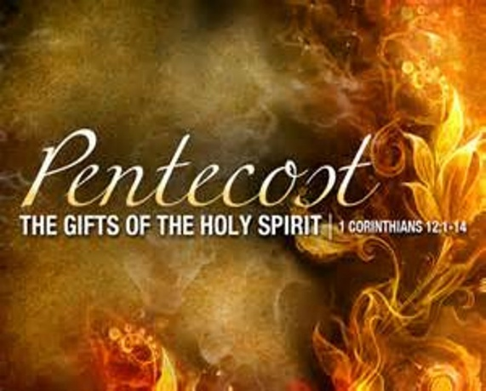

(ring the chime once)

WELCOME & ANNOUNCEMENTS
Welcome to Covenant United Church. Welcome to believers, to questioners, and to questioning believers. Welcome to young and old, and everyone in between. To people of all colours, cultures, gifts and abilities. No matter who you are, how you identify or whom you love, you are welcome here.
For this is God’s house and God welcomes everyone.



Coffee Volunteers: June 14th: Annual Windup lunch: hosted by Heather & Veronica (sponsored by Gary and Fran). If you are willing to help out for this fellowship opportunity, please contact Heather.


Fundraising Continues for the replacement tree at Gillies Lake - Total amount fundraised to date is $120.50



A great BIG Thank you to our Anonymous Donor and to Arlene Caswell for their generous donations for the Pump for the heating system!! No further donations are needed for the pump. Thank you!!


Office hours are Wednesdays from 9:30am – 4:00pm.


Today is a very special day. Today we celebrate the birthday of the Church!
– not just this Church; this Community of Faith – but, the Church in all thew world. Let us sing Happy Birthday to the Church.
The words are a little different, but they are printed on the screen.

Happy Birthday to you,
To Jesus be true.
May God’s richest blessings
Descend upon you!

(ring the chime)

LIGHTING THE CHRIST CANDLE – Bill Perry, Belleville, Ont.

We light this Christ candle as a symbol of the presence of Jesus who was the Christ with us on our journey of life and discipleship: Jesus Christ, the light of life for us.
Today, Pentecost Sunday, we acknowledge that we need help to transform that symbol into our daily living and serving.

Today, we embrace the presence of Jesus and the Holy Spirit, inviting them to empower us as disciples and to nurture our growing discipleship.

The candle is lit.

WORD FOR ALL AGES – PENTECOST

CHILDREN’S HYMN – More Voices #13 O, Let the Power Fall on Me! (repeat as many times as your musician plays it)
https://www.youtube.com/watch?v=be8GNTd3gro

O let the power fall on me, my Lord,
let the power fall on me.
O let the power from heaven fall on me,
let the power fall on me.

For we want justice and truth and love,
my Lord, we want justice and truth and love
For we want justice and truth and love,
my Lord, we want justice and truth and love

Children may go to Sunday School.
CALL TO WORSHIP and PRAYERS OF APPROACH
Cheryl Stenson, Glebe Road U.C., Toronto, Ont. for “the gathering”
MV #4 All Who Are Thirsty
https://www.youtube.com/watch?v=xaR-yhsrGr8

Choir:
All who are thirsty,
all who are weak,
come to the fountain.
Dip your heart in the stream of life.
Let the pain and the sorrow be washed away
in the waves of his mercy as deep cries out to deep.

ALL: Come, Lord Jesus, come.
Come, Lord Jesus, come.
Come, Lord Jesus, come.
Come, Lord Jesus, come.

God of creation and blessing, we celebrate your presence in each of our lives and in the life of this community. Far from remote, your Holy Spirit works in and around us each moment of each day, in the peace available to open hearts and willing souls, in the power that breaks through our human barriers.
We have felt your Spirit within us. We have witnessed your Spirit among us.

We know you are the Spirit of inspiration and strength, through whom we accomplish our daily tasks and face our greatest challenges. When we are most fearful and vulnerable, you surprise us and we are carried on the Holy Wind of possibility.
We have felt your Spirit within us. We have witnessed your Spirit among us.
Safe in this place and in these hearts, safe in your embrace, we acknowledge pain. We experience disease of mind, body, and spirit. We fear for ourselves and for others. But the Good News of Jesus’ gospel is realized in the people we are blessed to have in our lives, people who shepherd us and hold us fast. When we are weak, we borrow from them what we cannot find in ourselves.
We have felt your Spirit within us. We have witnessed your Spirit among us.

Rooted in the ancient, we seek to manifest your kingdom in the present. Inspired by your Spirit, we reach out in inclusive love and generosity to others, not burdened by obligation but privileged to bring your comfort as well as to receive it.
We have felt your Spirit within us. We have witnessed your Spirit among us.

We align with your purpose when we move side by side with one another in loving solidarity, when it’s not convenient, when it’s not easy. We bring ourselves closer to your kingdom when we overcome denial and fear by demanding that your love be manifested in justice.
We have felt your Spirit within us. We have witnessed your Spirit among us.

Vital Spirit, you inspire our best thoughts, you influence our highest actions. In micro-moments of epiphany, you encourage us and, in grand revelation, you ground us. You act in and through each of us and all of us. We know you are here.
We have felt your Spirit within us. We have witnessed your Spirit among us.
Thanks be to God. Amen.
https://www.youtube.com/watch?v=xaR-yhsrGr8
Choir:
All who are thirsty,
all who are weak,
come to the fountain.
Dip your heart in the stream of life.
Let the pain and the sorrow be washed away
in the waves of his mercy as deep cries out to deep.

ALL: Come, Lord Jesus, come.
Come, Lord Jesus, come.
Come, Lord Jesus, come.
Come, Lord Jesus, come.

Holy Spirit, come.
Holy Spirit, come.
Holy Spirit, come.
Holy Spirit, come.

PRAYER OF CONFESSION – Tabitha Carey, Dorchester U.C., Dorchester, Ont.

Gracious God, we often live without relying on the Holy Spirit. We forget how much you desire for the Spirit to be an active presence in our lives. You love us as we are but you have given us the Holy Spirit to teach us, guide us, empower us, and encourage us.

We know the times when we have not allowed the Spirit to move within us. May we be ever more sensitive to what the Spirit has to offer us. We ask that you mold and make us into the people you want us to be through the power of the Spirit. Show us our spiritual gifts and give us a passion to serve according to the gifts we have received. Make us a blessing and renew a right spirit within us. Amen.

MINUTE FOR MISSION
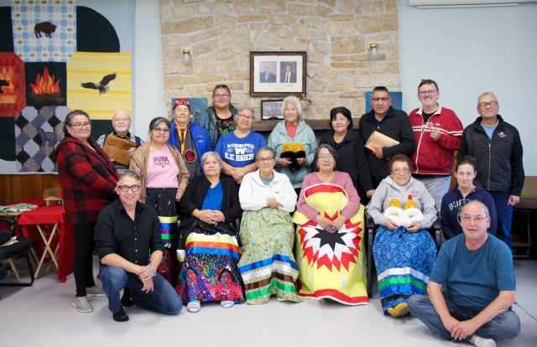
Across Northern Canada, Indigenous ministers are serving communities where grief is a constant presence. They walk with families through loss, often leading funerals for young people, holding space for pain that has no easy words. It is sacred work, but it is also heavy work. And too often, it is carried alone.

In many of these communities, distance and isolation make support hard to find. Ministers are expected to be present for others in moments of deep crisis, while having few places for themselves to turn for rest, understanding, or care.

For the past two years, through Mission and Service, something small but powerful has taken place. Northern Indigenous ministers have gathered for a retreat. The retreat is a space for Northern Indigenous ministers to step back from having to lead and give, and step into receiving care and connection.

In Fall 2025, 16 ministers came together with facilitators for five days of rest and renewal. They shared meals and stories, sewed and beaded, and participated in ceremony. These moments provide space to breathe, grieve, and to be among others who deeply understand the weight of this work.

One minister reflected on how meaningful it can be to simply sit in a room with others who know that reality. What it means to not carry everything alone.

That is what the Northern Indigenous Ministers Retreat offers. Not a simple resolution, but something just as important: space. Space where burdens can be shared, even for a little while. Space where healing can begin.

Scripture reminds us to “bear one another’s burdens.” At this retreat, that call becomes real, through presence, community, and care.
This year, a third retreat is being planned at Fisher River Cree Nation, and retreat facilitators hope to welcome even more ministers into healing. The need continues, as does the opportunity to respond.

Through Mission and Service, our gifts help make this possible. They help cover travel, support facilitators, and create space for rest and healing.
When we give, we remind Northern Indigenous ministers that they are not alone. Make your gift to Mission and Service through The United Church of Canada Foundation today.

CENTERING

SCRIPTURE READINGS
Numbers 11:24-30 – NRSV(UE)
1 Corinthians 12:4-13 – NRSV(UE)

RESPONSE: Voices United #198 Come, O Spirit, Dwell Among Us
https://www.youtube.com/watch?v=zKBknyxNkyQ

Come, O Spirit, dwell among us,
come with pentecostal power;
give the church a stronger vision,
help us face each crucial hour.
Built upon a firm foundation,
Jesus Christ, the cornerstone,
still the church is called to mission
that God's love shall be made known.

We would raise our hallelujahs
for the grace of yesteryears;
for tomorrow's unknown pathway,
hear, O God, our humble prayers.
In the church's pilgrim journey
you have led us all the way,
still in presence move before us,
fire by night and cloud by day.
Come, O Spirit, dwell among us;
give us words of fire and flame.
Help our feeble lips to praise you,
glorify your holy name.
God, all holy, Son and Spirit,
three in one: what mystery!
We would sing our loud hosannas
now and through eternity.

Acts 2:1-21 – NRSV(UE)

HYMN – More Voices #23 Come, O Holy Spirit
https://www.youtube.com/watch?v=HkfziVY2kLY

Come, O Holy Spirit, set the Church on fire;
strike it as the lightning hits a posing spire.
Burn away the structures and consume
the sham of our holy systems:
Come, in Jesus’ name!

Refrain:
Come, come, come, in Jesus name!
Take our hearts by storm.
All the world lies open
Pentecost is now!
I said a - Repeat refrain

Blow away the cobwebs of our stubborn past.
Come, send flying from us myths unfit to last.
Wind of change, refresh us and disturb our calm;
teach us what true love is,
take our hearts by storm. R

Free us from the babble of our Babel mind;
spark in us a language all can understand.
Lighten then our darkness,
Come and show us how, all the world lies open:
Pentecost is now! R

REFLECTION



HYMN – More Voices #142 O A Song Must Rise

Refrain: Oh, a song must rise for the spirit to descend
Oh, a song must rise once again
Singing out God’s praises and glory, the faithful voices blend, Oh a song must rise for the spirit to descend.

From the mountains to the valleys,
from the desert to the sea,
A song must rise once again.
From the voices of our leaders,
the voice of you and me,
A song must rise for the spirit to descend. R

From poverty and riches,
from the voice of young and old,
A song must rise once again.
From the free and the imprisoned,
the timid and the bold,
A song must rise for the spirit to descend.

From ev’ry house of worship,
in ev’ry faith and tongue,
A song must rise once again.
From the villages and cities
a new song must be sung,
A song must rise for the spirit to descend.

OFFERING – As our offerings are brought forward, let us sing of the Spirit dwelling with us and in us, empowering us to do surprising and wonderful things in Jesus’ name.

OFFERING HYMN – Voices United #381 Spirit of Life
https://www.youtube.com/watch?v=ddYL-Ghj0Fg

Spirit of Life, come unto me.
Sing in my heart all the stirrings of compassion.
Blow in the wind, rise in the sea;
move in the hand, giving life the shape of justice.
Roots hold me close; wings set me free;
Spirit of Life, come to me, come to me.

PRAYERS OF THANKSGIVING AND DEDICATION –
Gord Dunbar, Kincardine P.C., Kincardine, Ont.

We offer to you, Transforming Spirit, these gifts.

May the financial resources we bring become the sails that catch your wind, enabling you to fill our sails with your direction.

May the time we freely donate become the rigging securing those sails, providing the controls by which we can maximize your will among us.

May the talents we share generously become the masts for the sails, raising the framework by which we can best follow your Way.

Bless us and all we give, dedicating these gifts to the work of Christ. Amen.

PRAYERS OF THE PEOPLE

HYMN – Voices United #509 Here I Am, Lord
https://www.youtube.com/watch?v=s_1E_T-29EI

I, the Lord of sea and sky,
I have heard my people cry.
All who dwell in deepest sin
my hand will save.
I who made the stars of night,
I will make the darkness bright.
Who will bear my light to them?
Whom shall I send?

Refrain:
Here I am, Lord. Is it I, Lord?
I have heard you calling in the night.
I will go, Lord, if you lead me.
I will hold your people in my heart.

I, the Lord of snow and rain,
I have borne my people’s pain,
I have wept for love of them;
they turn away.
I will break their hearts of stone,
give them hearts for love alone.
I will speak my word to them.
Whom shall I send? R

I, the Lord of wind and flame,
I will tend the poor and lame,
I will set a feast for them;
my hand will save.
Finest bread I will provide
till their hearts be satisfied.
I will give my life to them.
Whom shall I send? R

COMMISSIONING AND BLESSING
Breath of Life, who fills our souls, we ask you to move in us.
Change us. Blow us to the places you need us to be.

Help us to carry Christ’s peace. Help us to carry the Creator’s love.
Help us to carry your joy — into our lives,
into the world, into all of creation.
Bless us and bless all that lives, Holy Spirit! Amen!

Richard Bott, Grace U.C., Burlington, Ont.

EXTINGUISH THE CHRIST CANDLE

SENDING SONG – GO NOW IN PEACE
https://www.youtube.com/watch?v=YubJLU7N1Ug

Go now in peace, never be afraid.
God will go with you each hour of every day.
Go now in faith, steadfast, strong and true.
Know God will guide you in all you do.
Go now in love, and show you believe.
Reach out to others so all the world can see.
God will be there filling you with love.
Go now in peace, in faith, and in love.
Amen. Amen. Amen.


Covenant United Church
230 Eighth Ave
Timmins, ON
(705) 264-5518
covenanttimmins@ntl.sympatico.ca

