Covenant
The United Church of Canada
a safe place for all people to worship
Minister: Rev. Laura Hutchison

COVENANT UNITED CHURCH
SUNDAY, OCTOBER 12, 2025
THANKSGIVING
CREATION 6
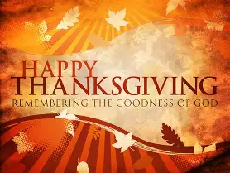

(Ring the chime once)

WELCOME & ANNOUNCEMENTS
Welcome to Covenant United Church! You are welcome here where the ordinary is sanctified, where humanity is celebrated in all of its diversity, and compassion is expected. In this place together, we make it a holy place where love can dwell.

 Regional Gathering -- October 18th & 19th. You are invited to an opportunity for fellowship and learning, like an old time Presbytery meeting.
Saturday, October 18th from 10 am to 3 pm at Covenant United Church, 230 Eighth Ave, Timmins. Coffee, tea and muffins from 9:45 am. Lunch will be provided. Keynote Speaker Jeff Crittenam -- Training and Support of Lay Leadership
Afternoon workshops with Callin Lau, Melody Duncanson Hales and Diane Matheson Jimanez. A poster will be distributed from the Regional Office soon with information for Free Registration.
Sunday, October 19th the morning worship will be at Porcupine United Church, 122 Queen St, Porcupine, ON at 10:30 am, with lunch to follow at 11:45 am. All are welcome.
There will be no service here at Covenant United on October 19th.


Finances – Heather Laverdiere & Susan Boisvert
January 1, 2025 to September 30, 2025
- General Fund: Revenue $ 92851
Expenses $ 79748
From Investment $ 0
- Building Funds: Revenue $ 1552
Expenses $ 4023
- M&S: Revenue $ 5215
Account balances are now: General Fund: $ 18685 Building Fund $ 10668 Outreach $ 814
Investments $132599.76 (as of June 30, 2025)

 October is Sockoctober month sponsored by Kinettes. Donations of socks would be appreciated. There is a box in the foyer for socks. Lets beat last year’s number of 58 pairs (we already have 6 pair). Thank you for donations. Outreach Committee

 We are looking for volunteers to host our coffee hours. If you are willing to help, please contact Heather.
 Office hours are Wednesdays from 9:00 – 3:30.

ACKNOWLEDGING THE TERRITORY – adapted from Whitney Bruno, Manitoulin Island
Today we gather on land that is called Timmins, Mattagami Region, Cochrane District Northeastern Ontario.
This is Treaty Land, specifically Treaty #9
All: We offer our thanks to the people who have cared for this land for thousands of years.
We offer our thanks to the land itself for nourishing us.
We offer our thanks to God for all Creation.
Today we speak of thankfulness.

(ring the chime)

LIGHTING THE CHRIST CANDLE
Red like maple leaves, yellow like birch leaves, orange like oak leaves; the colours of fall are the colours of fire.
We light this Christ candle in gratitude for the love of Christ, in gratitude for the Body of Christ, in gratitude for the changing seasons, in gratitude for this day.
(the candle is lit)

GATHERING MUSIC – VU Page # 820 Psalm 100 Make a Joyful Noise https://www.youtube.com/watch?v=H5hoeObqNGc

Make a joyful noise all the earth!
Worship your God with gladness.
Make a joyful noise all the earth!
Come to this place with a song!
Know that your God has made you.
Know it’s to God we belong.
And come to this place with joyfulness and praise.
Worship your God with a song! (R)

Enter these gates, thanks giving.
Enter these courts with praise.
Sing thanks to your God and bless the holy Name.
Worship your God with a song! (R)

Ages through endless ages,
seasons of endless years,
the love of our Maker ever shall endure.
Worship your God with a song! (R)

STORY TIME

PRAYER
Thank you for the world so sweet
Thank you for the food we eat
Thank you for the birds that sing
Thank you God for everything!
Amen!

CHILDREN’S HYMN – VU #412 This is the Day (verses 1 and 3) https://www.youtube.com/watch?v=6fFAE_UbAB4&list=PLJ5l-D6vQ_mm4u_ZkFJ1A8xcrqy9TLalH&index=15
This is the day, this is the day
that our God has made, that our God has made;
we will rejoice, we will rejoice,
and be glad in it, and be glad in it.
This is the day that our God has made,
we will rejoice and be glad in it.
This is the day, this is the day
that our God has made.

You are our God, you are our God,
we will praise your name, we will praise your name;
we will give thanks, we will give thanks,
for your faithfulness, for your faithfulness.
You are our God, we will praise your name,
we will give thanks for your faithfulness.
You are our God, you are our God,
we will praise your name.

CENTERING

MINUTE FOR MISSION
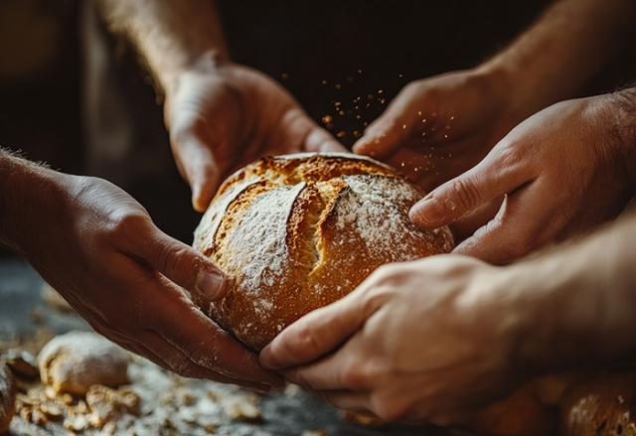
At Thanksgiving, many of us gather around tables filled with food, and share familiar traditions and prayers of gratitude. In the Bible, food is more than just sustenance: it’s manna in the wilderness, a feast shared among thousands, and a table where all are welcome. Again and again, food is a sign of God’s care and abundance.
But we know that not everyone has the blessing of a full table or loved ones to gather with. Hunger remains a painful reality for far too many. These are not just numbers or statistics: these are our neighbours, making impossible choices between heat and dinner.
Through Mission and Service partners, your generosity is part of God’s response. Together, we are helping farmers in India care for their livestock, families in Zimbabwe grow food in drought conditions, and communities in Northern Canada access nutritious food despite high costs. Across Canada, ecumenical campus ministries and community centres serve weekly dinners where everyone is welcome. These meals don’t just ease hunger, they help reduce stress, support learning, and bring people together where everyone has a place at the table.
This Thanksgiving, may gratitude fill our hearts. May that gratitude ripple outward, becoming generosity that helps set more tables, share more bread, and create more moments of joy. Because when we share what we have, God’s promise of abundance comes to life, not just as a symbol, but as a feast of hope and possibility for all.
Thank you for the difference you make through Mission and Service.
PRAYER FOR ILLUMINATION
One: …
All: Open our eyes, and our ears
Open our hearts and our lives
To hear the word of truth from the scriptures
To teach us to be thankful
That we may be FILLED with gratitude
This day, and every day. Amen.

SCRIPTURE READINGS
Deuteronomy 26:1-11 – Good News Translation
Philippians 4:4-9 – NRSV (UE)

RESPONSE: VU #249 Rejoice in the Lord Always (round)
Rejoice in the Lord always
and again I say rejoice! (clap, clap)
Rejoice in the Lord always
and again I say rejoice! (clap, clap)
Rejoice, rejoice, and again I say rejoice!
Rejoice, rejoice, and again I say rejoice!

John 6:25-35 – NRSV (UE)

RESPONSE: MV #194 Bread of Life, Feed My Soul
https://www.youtube.com/watch?v=YOrzHHcHyLo

Bread of life, feed my soul,
as the presence of the Spirit makes me whole.
Bread of life, fill my heart
with the grace and mercy you impart.

I have heard your voice calling,
“Come, my friend, and share
in the feast that is laid out for you
to show how much I care.”

Bread of life, help me live
a life as pure and true as Jesus did.
Bread of life, help me see
the boundless love of Christ for you and me.

I have heard your voice calling,
“Come, my friend, and share
in the feast that is laid out for you
to show how much I care.”

Bread of life, feed my soul,
as the presence of the Spirit makes me whole.
Bread of life, fill my heart
with the grace and mercy you impart

REFLECTION

HYMN – PEOPLE’S CHOICE
Choose a familiar hymn of thanks and praise

OFFERING INVITATION
Everything we have is a gift from God, so we in return offer some of these gifts back to God, in gratitude.

OFFERING SONG – VU #519 Sing to the Lord of Harvest
https://www.youtube.com/watch?v=Y3kADJ-qVDM
Sing to the Lord of harvest,
sing songs of love and praise,
with joyful hearts and voices
your hallelujahs raise;
by whom the rolling seasons
in fruitful order move;
sing to the Lord of harvest
a joyous song of love.

God makes the clouds drop fatness,
the deserts bloom and spring,
the hills leap up in gladness,
the valleys laugh and sing.
God fills them all with fullness,
all things with large increase;
and crowns the year with goodness,
with plenty and with peace.

Bring to this sacred altar
all things God's goodness gave,
the golden sheaves of harvest,
the souls Christ died to save:
your hearts lay down before him
when at his feet you fall,
and with your lives adore him
who gave his life for all.

PRAYER OF THANKSGIVING AND DEDICATION
Great Giver, God of the Harvest, Creator of all,
With whom we have become co-creators
Thank you for this day.
Thank you for the harvest.
Thank you for your love.
Let our commitments be blessed by you
And let all we give and receive be in love.
Amen.

PRAYERS OF THE PEOPLE

HYMN – VU #227 For the Fruit of All Creation
https://www.youtube.com/watch?v=7FDx-MwLdt0
For the fruit of all creation, thanks be to God.
For the gifts to every nation, thanks be to God.
For the ploughing, sowing, reaping,
silent growth while we are sleeping;
future needs in earth’s safekeeping, thanks be to God.

In the just reward of labour, God’s will is done.
In the help we give our neighbour, God’s will is done.
In our world-wide task of caring
for the hungry and despairing,
in the harvests we are sharing, God’s will is done.

For the harvests of the Spirit, thanks be to God.
For the good we all inherit, thanks be to God.
For the wonders that astound us,
for the truths that still confound us,
most of all that love has found us, thanks be to God.

COMMISSIONING AND BLESSING
Go into the world in the power of the Holy Spirit
To fulfill your calling as the Body of Christ
May God bless and keep you.
May God's face shine on you and be gracious to you.
May God look on you with kindness and give you peace.

EXTINGUISH THE CHRIST CANDLE

SENDING SONG – MV #218 May the Love of the Lord https://www.youtube.com/watch?v=NWi8rt3P6A0
May the love of the Lord rest upon your soul.
May God's love dwell in you, throughout every day.
May God's countenance shine upon you and be gracious to you.
May God's Spirit be upon you as you leave this place.

Covenant United Church
230 Eighth Ave
Timmins, ON
(705) 264-5518
covenanttimmins@ntl.sympatico.ca

