**Covenant**

***The United Church of Canada***

a safe place for all people to worship

Minister: Rev. Laura Hutchison

**COVENANT UNITED CHURCH**

**SUNDAY, SEPTEMBER 21, 2025**

**CREATION 3**



*(Ring the chime once)*

**WELCOME & ANNOUNCEMENTS**

Welcome to Covenant United Church! You are welcome here where the ordinary is sanctified, where humanity is celebrated in all of its diversity, and compassion is expected. In this place together, we make it a holy place where love can dwell.

 **Thank you** to everyone for helping make Welcome Back Sunday a success.  A special 🙏 to our sponsors for the event, Gary Tremblay and Fran Sahler and to Pat, Veronica and Heather for sandwiches and set up and to Tim for the beautiful fruit tray and 🙏 to those who helped after the event.

 We are looking for volunteers to host our coffee hour. Our next coffee will be on October 19th. If you are willing to help, please contact Heather.

 **Finances – Heather Laverdiere & Susan Boisvert**

January 1, 2025 to August 31, 2025

* General Fund: Revenue $ 82666

        Expenses $ 74023

From Investment $ 0

* Building Funds: Revenue $ 1367

Expenses $ 3786

* M&S: Revenue $ 4545

Account balances are now: General Fund: $ 14991 Building Fund $ 10720  Outreach $ 814

Investments $132599.76 (as of June 30, 2025)

 Office hours are Wednesdays from 9:00 – 3:30.

 Sunday, September 21, we are all invited to the Lions Club Hall, at the McIntyre Arena.to join in the celebration of International Peace Day. "Come march for peace, share in the joy, and celebrate unity!" Lunch will be served. All are welcome.

 The Lord’s Kitchen is requesting donations of coats, toques, scarves, mitts, socks and boots in preparing ahead for the winter months for their clients in need. There will be a marked bin (The Lord’s Kitchen) in the cloak room for donations. Your donations will be appreciated. Help Covenant reach out to those in need.

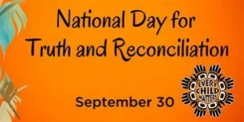 Tuesday, September 30 is the National Day for Truth and Reconciliation. On Sunday, September 28th, we encourage you to participate in "Orange Shirt Day" as a visible sign of solidarity, and of our engagement in the ongoing work of reconciliation in Canada. Not everyone has an orange shirt, but perhaps you have an orange scarf, hat, work safety vest, or other accessory.

**LIGHTING THE CHRIST CANDLE --** *Anita Rowland*

This is the light of Christ, **a promise of Love.**

This light shines for us, **and for all of creation.**

For this we give thanks. **Hallelujah!**

*(ring the chime)*

**CALL TO WORSHIP and PRAYER OF APPROACH**

Today, …

In this time of worship,

we join our hearts in prayer, seeking wisdom, truth and community

**Grant to us a willing spirit,**

**open to learning new things;**

* **new ways to nourish the planet, and all life on it**
* **new ways to seek justice, and share compassion and guide us in teaching and equipping the next generations**

**Equip us to be healers and helpers**

* **bringing justice and joy wherever we go.**

**Amen. May it be so.**

**INTROIT – VU # 307 Touch the Earth Lightly**

<https://www.youtube.com/watch?v=CLmJb4v2fq8>

Touch the earth lightly, use the earth gently,

nourish the life of the world in our care:

gift of great wonder, ours to surrender,

trust for the children tomorrow will bear.

We who endanger, who create hunger,

agents of death for all creatures that live,

we who would foster clouds of disaster—

God of our planet, forestall and forgive!

Let there be greening, birth from the burning,

water that blesses and air that is sweet,

health in God’s garden, hope in God’s children,

regeneration that peace will complete.

God of all living, God of all loving,

God of the seedling, the snow and the sun,

teach us, deflect us, Christ reconnect us,

using us gently, and making us one.

**STORY TIME**

**CHILDREN’S HYMN – Love is Something if You Give It Away**

Love is something if you give it away

Give it away, give it away

Oh, love is something if you give it away

You end up having more.

For it’s just like a magic penny

Hold it tight and you won’t have any.

Lend it, spend it and you’ll have so many

They’ll roll all over the floor

For…

Love is something if you give it away

Give it away, give it away

Oh, love is something if you give it away

You end up having more.

**CENTERING**

**MINUTE FOR MISSION**

Bread for the journey

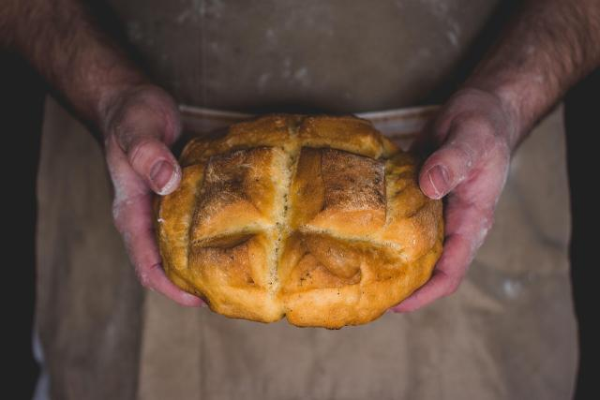

Bread shows up often in the Bible in important ways—manna in the wilderness, Jesus feeding the crowds, and the bread broken at the Last Supper. Again and again, bread is a sign of God’s care and provision.

That care continues today, through the hands of people willing to share what they have. And yet, hunger is still a daily reality for far too many people. Here in Canada, millions struggle to put food on the table. Around the world, nearly a third of the global population faces food insecurity. These aren’t just numbers—these are our neighbours, here and far away, who are making impossible choices between paying rent or buying groceries, between keeping the lights on or feeding their families.

Through Mission and Service, we are part of the response. Together, we’re helping farmers in India care for their livestock so they can keep their animals and their livelihoods healthy. We’re helping families in Zimbabwe use climate-smart farming techniques so they can grow food even in drought conditions. We’re supporting Indigenous Elders in Alberta with grocery cards, and helping offset the high cost of groceries in Northern Canada through the Food for the North program.

As we give thanks for the food we share in our own homes, may we also remember those for whom a full plate is never certain. And may our gratitude move us to action—so that bread is not just a symbol of God’s promise, but a daily reality for all.

Thank you for the difference you make through Mission and Service.

**SCRIPTURE READINGS**

**1 Timothy 2:1-7** – The Message

**Luke 16:1-13** – New Revised Standard Version Updated Edition

**HYMN – VU #376 Spirit of the Living God**

<https://www.youtube.com/watch?v=qoUtpATjWBo>

Spirit of the living God, fall afresh on me.

Spirit of the living God, fall afresh on me.

Melt me, mold me, fill me, use me.

Spirit of the living God, fall afresh on me.

Spirit of the living God, move among us all,

make us one in heart and mind, make us one in love;

humble, caring, selfless, sharing

Spirit of the living God, fill our lives with love!

**REFLECTION**

**HYMN –** **MV #27 Creator God You Gave Us Life**

<https://www.youtube.com/watch?v=Z9ZOmMQeYmU>

Creator God you gave us life,

your image formed within our soul,

yet through the mist of time and space,

we search for that which makes us whole.

**Through hands that paint majestic skies,**

**and voices chanting melody,**

**with words that reach beyond the page,**

**we comprehend your mystery.**

In ev’ry flow’r and ev’ry tree,

we see your great diversity,

yet greater still we see your love,

expressed in our humanity. **(R)**

When with our hearts, our hands our minds,

we share our gifts with all the world,

our spirits soar beyond the veil,

to touch the very face of God. **(R)**

**OFFERING INVITATION --** *Beth W. Johnston, Bridging Waters, Sask.*

**OFFERING SONG – VU #538 For the Gift of Creation**

<https://www.youtube.com/watch?v=iIdQaBbIfEE>

For the gift of creation, the gift of your love,

and the gift of the Spirit by which we live,

we thank you and give you the fruit of our hands.

May your grace be proclaimed by the gifts that we give.

**PRAYERS OF THANKSGIVING AND DEDICATION** –*Whitney Bruno, Little Current*

**Abundant God, Bless our commitments. Let our gifts of love multiply and shower the world with love. Let us be each other’s encouragement and building up. Amen.**

**PRAYERS OF THE PEOPLE**

**HYMN – VU #382 Breathe on Me Breath of God**

<https://www.youtube.com/watch?v=82pTUUhLYu4>

Breathe on me, breath of God,

fill me with life anew,

that I may love what thou dost love,

and do what thou wouldst do.

Breathe on me, breath of God,

until my heart is pure,

until my will is one with thine,

to do and to endure.

Breathe on me, breath of God,

till I am wholly thine,

until this earthly part of me

glows with the fire divine.

Breathe on me, breath of God;

so shall I never die,

but live with thee the perfect life

of thine eternity.

**COMMISSIONING AND BLESSING**

May God who creates you fill you with light;

May God who sustains you make you wise;

May God who protects you give you joy,

May God who dwells in you give you peace.

**EXTINGUISH THE CHRIST CANDLE**

**SENDING SONG – VU #260 God Who Gives to Life It’s Goodness**

<https://www.youtube.com/watch?v=Fnc5rHKJmXA>

God who gives to life its goodness,

God creator of all joy,

God who gives to us our freedom,

God who blesses tool and toy;

teach us now to laugh and praise you,

deep within your praises sing,

till the whole creation dances

for the goodness of its King.

God who fills the earth with beauty,

God who binds each friend to friend,

God who names us co-creators

God who wills that chaos end;

grant us now creative spirits,

minds responsive to your mind,

hearts and wills your rule extending

all our acts by Love refined.